# UniHub: University Community Extension Hub with Client Satisfaction Survey

______________________________

A Capstone Project Presented to the Department of

Information Technology

Cebu Technological University - Tuburan Campus

Tuburan Cebu

______________________________

In Partial Fulfillment

of the Requirements for the Degree of

Bachelor of Science in Information Technology

______________________________

By

**Bandilao, Angel**

**Goopio, April Mae**

**Nuñez, Joe Myka**

# Ople, Jennyline

December 2025

# APPROVAL SHEET

This capstone project entitled **“UniHub: University Community Extension Hub with Client Satisfaction Survey”** prepared and submitted by **“Bandilao, Angel Goopio, April Mae Nuñez, Joe Myka Ople, Jennyline”** in partial fulfillment of the requirements for the degree of **Bachelor of Science in Information Technology** has been examined and recommended for Oral Examination.

# CAPSTONE PROJECT COMMITTEE

Naomi A. Bajao, PECE, PhD Catherine P. Loseñara, MIT

Project Adviser Methodologiest

Johnrel M. Paglinawan, MIT Alyssa Marie M. Paglinawan, MIT

Statistician Subject Instructor (Co-Chair)

Jae-an S. Buhia, MIT

Panel Chairperson

**___________________________________________________________________________**

# PANEL OF EXAMINERS

Naomi A. Bajao, PECE, PhD Catherine P. Loseñara, MIT

Project Adviser Methodologiest

Johnrel M. Paglinawan, MIT Alyssa Marie M. Paglinawan, MIT

Statistician Subject Instructor (Co-Chair)

Jae-an S. Buhia, MIT ______________________

Panel Chairperson Censor

**ACCEPTED AND APPROVED** in partial fulfillment of the requirements for the degree of Bachelor of Science in Information Technology.

Design Hearing: May 6, 2025 Grade: PASSED

Oral Defense: December 10, 2025 Grade: ______

Recommending Approval:

|  |  |
| --- | --- |
| **JAE-AN S. BUHIA, MIT** | **FERNANDO N. MANGUBAT JR., MEng-ECE** |
| Chairperson, BSIT Department | Dean, College of Technology |
| Approved by: |  |
| **FLORIEZA M. MANGUBAT, Ph.D.,Ed.D.** | **MA. CARLA Y. ABAQUITA,Dev.Ed.D, RChE** |
|  | Campus Director |
| Chair, Research and Development |  |

# ACKNOWLEDGEMENT

The researchers sincerely extend their gratitude to all individuals and institutions who supported them throughout the completion of this study. The guidance,

encouragement, and assistance were vital to our success.

First and foremost, we offer our highest praise to **Almighty God**, whose wisdom, strength, and guidance sustained us through every challenge of this journey.

We express our deep appreciation to our research advisor, **Mrs. Allysa Mae Paglinawan**, for her unwavering support, valuable insights, and guidance, and to our project adviser, **Mrs. Naomi A. Bajao** , for her mentorship, constructive feedback, and encouragement. We are also thankful to all faculty members who shared their knowledge and assisted us during the research process.

We acknowledge **Cebu Technological University – Tuburan Campus**, particularly the **(Bachelor of Science in Information Technology) BSIT Department**, for providing the resources, technical training, and learning environment essential to the completion of this study.

To our parents, families, and friends, we extend heartfelt thanks for your love, understanding, and support, which strengthened us throughout this demanding journey. Finally, we recognize that this study would not have been possible without the collective support, guidance, and inspiration of everyone who helped us along the way.

# ABSTRACT

Managing university community extension programs often involves fragmented systems, manual processes, and limited mechanisms for measuring community impact and

satisfaction. Traditional methods of organizing projects, tracking beneficiary participation, and collecting feedback are time-consuming and prone to errors. With the increasing emphasis on community engagement in higher education, an integrated platform is needed to connect project leaders, beneficiaries, student volunteers, and administrators while systematically assessing project effectiveness.

UniHub: University Community Extension Hub with Client Satisfaction Survey was developed to address these challenges by providing a centralized system for creating, managing, and monitoring extension initiatives while capturing beneficiary feedback.

The platform enables project leaders to create and manage project profiles, allows participants to register as beneficiaries, implements automated email announcements, integrates a client satisfaction survey tool, tracks attendance during project activities, and provides administrators with comprehensive dashboards.

Built using modern web technologies, including React.js and Vite for the frontend, Node.js and Express.js for the backend, and PostgreSQL with Prisma ORM for data management, key components include project creation modules, beneficiary registration portals, survey forms with analytics, and attendance tracking. User feedback highlighted the system's effectiveness in streamlining program management, with high ratings for usefulness (4.81), ease of use (4.7), ease of learning (4.55), and overall satisfaction (4.84).

The results demonstrate that UniHub efficiently bridges the gap between university extension programs and community needs, enhances engagement, improves program documentation, and ensures accountability through systematic feedback collection.

**Keywords:** *Community extension programs, university hub platform, beneficiary management, client satisfaction survey, attendance tracking*

# TABLE OF CONTENTS

|  |  |  |  |  |  |
| --- | --- | --- | --- | --- | --- |
| **Approval Sheet** |  | **i** | | | |
| **Acknowledgement** |  | **ii** | | | |
| **Abstract** |  | **iii** | | | |
| **Table of Contents** |  | **iv** | | | |
| **List of Figures** |  |  |  | **v** | |
| **List of Tables** |  |  |  |  | **vi** |
| **1 Introduction** |  |  |  |  | **1** |
| **2 Materials and Method** |  |  |  |  | **4** |
| Requirement Analysis |  |  |  |  | 4 |
| Product Perspective |  |  |  |  | 5 |
| Functional Requirements |  |  |  |  | 11 |
| **3 Results and Discussion** |  |  |  |  | **13** |
| Development Process |  |  |  |  | 13 |
| Development Software Platforms |  |  |  |  | 14 |
| Development Environment and Tools |  |  |  |  | 15 |
| Features of the Developed System |  |  |  |  | 15 |
| Data Dictionary |  |  |  |  | 25 |
| Testing of the System |  |  |  |  | 49 |
| Usability and Satisfaction of System Users | |  |  |  | 54 |
| **4 Conclusion** | |  |  |  | **59** |
| **Appendices** | |  |  |  | **61** |
| Bibliography | |  |  |  | 61 |
| Definition of Terms | |  |  |  | 62 |
| System User's Manual | |  |  |  | 63 |
| Grammarian Certificate | |  |  |  | 75 |
| Plagiarism Test Certificate | |  |  |  | 76 |
| Usability and Satisfaction Survey Questionnaires | | |  |  | 77 |

Letter Requests

Research Forms

Research Form 1: Thesis/Research Title Approval Sheet

Research Form 2: Requests for Design Hearing/Oral Defense

Research Form 3: Certificate of Acceptability

Research Form 4: Request for the Utilization of School Facilities/Supplies

Research Form 5: Criteria for Thesis/Research Presentation

Research Form 6: Evaluation of Thesis/Research Presentation

Research Form 7: Thesis/Case Study/Research Committee Recommendations

Research Form 8: Thesis/Research Committee Recommendations Compliance Form (Oral Defense)

Research Form 9: Approval for Printing

Curriculum Vitae

# LIST OF FIGURES

Software Development Life Cycle (SDLC) Model 4

System Flowchart 6

Project Leader Flowchart 6

Beneficiaries Flowchart 6

Administrator Flowchart 9

System Architecture Diagram 10

Entity Relationship Diagram (ERD) 12

Project Leader’s Use Case Diagram 13

Participant’s Use Case Diagram 14

Admin’s Use Case Diagram 15

Login Page 15

Registration Page 16

Manual Feeding Page 18

User Management 19

Create/View Projects 19

Update/Delete Projects 20

Create/View Activities 20

Update/Delete Activities 21

Join/Apply Activity 21

Manage Applications 22

Manage Announcements 22

Manage Surveys 23

Respond Survey 23

Manage Attendance 24

Create/Schedule Email 24

Send/View Status Email 25

View Activities/Participants 25

Export Activities/Participants 26

View All Projects/Users 26

Notifications 27

Participants/Project Leader’s Dashboard 27

Search Projects/Activities 28

Login Form 71

Register Page 72

Onboarding Form 72

Participant/Beneficiary/Project Leader’s Dashboard 73

View Activities 74

Activity Details 74

Apply/Request Join to Activity 75

Participant’s Applicaitons 75

View Announcements 76

Respond to Survey 77

View Notifications 77

Project Leader Dashboard 78 Create Project 79

View Projects 79

Create Activtiy 80

Create Announcement 81

Attendance Management 81

Create Survey 82

View Survey Results 83

Email Blasts Management 83

**LIST OF TABLES**

Developement Software Platforms 16

Development Environment and Tools 16

Data Dictionary 29

User Acceptance Test Results 60

Numeric Rating Interpretation Table 61

Usefulness Responses 61

Ease of Use Response 64

Eaase of Learning Response 64

Satisfaction Response 65

# INTRODUCTION

Community extension is a fundamental mandate of higher education institutions (HEIs), serving as an essential channel through which universities contribute to social development, community engagement, and public service. These programs deliver capacity-building, livelihood training, health initiatives, environmental awareness, and other community-centered interventions that strengthen institutional social responsibility while providing practical learning experiences for students. Recent studies affirm that well-designed extension initiatives create notable improvements in beneficiary empowerment, productivity, and access to opportunities. For instance, Esteban (2025) highlighted that university-led extension programs significantly enhance satisfaction, effectiveness, and relevance in partner communities, demonstrating measurable social impact. Similarly, Liotta (2023) emphasized that digitalization and inclusive access to information technologies play a crucial role in enabling marginalized groups to participate in development programs, underscoring the importance of accessible and well-structured community service systems.

Despite the value of these initiatives, many HEIs continue to rely on manual documentation and decentralized workflows. Challenges such as fragmented records, inconsistent reporting, and communication gaps remain common across extension programs (Esteban, 2025). Garcia and Uy (2025) also pointed out that implementers struggle with unstructured beneficiary registration processes and inefficient feedback collection, resulting in limited visibility of project outcomes and delayed decision-making. These barriers hinder the ability of institutions to demonstrate impact, coordinate activities, and ensure continuity of services. This pattern of inefficiency mirrors issues observed in broader sectors undergoing digital transformation, where legacy systems and poor data integration impede progress. As Othen et al. (2025) noted, organizations with outdated workflows face substantial obstacles in digital maturity, highlighting the need for structured frameworks and strategically aligned information systems.

To address these long-standing limitations, recent research has increasingly explored the development of web-based community extension management systems. Sablawon et al. (2025) demonstrated that centralized digital platforms significantly improve documentation, monitoring, communication, and reporting within HEI extension programs. Ching and Orozco (2025) further emphasized that digitized community-service platforms enhance accessibility and transparency, particularly for institutions shifting toward technology-driven public service delivery. This broader transition aligns with the findings of Aquino et al. (2025), who observed that digital transformation across higher education improves operational efficiency, stakeholder engagement, and governance, enabling institutions to adopt data-driven and user-centered approaches.

An important dimension of digital modernization is the integration of automated client satisfaction and feedback systems. Banawa and De Jesus (2025) showed that web-based satisfaction tools—especially those enhanced with natural language processing—enable institutions to gather accurate community insights and enhance service delivery. Likewise, Goh et al. (2025) demonstrated how sentiment analysis tools integrated into web platforms strengthen evaluation mechanisms and provide real-time evidence of program effectiveness.

Collectively, these developments justify the creation of **UniHub: University Community Extension Hub with Client Satisfaction Survey**, a comprehensive digital platform designed to address persistent workflow gaps in HEI extension programs. By integrating centralized registration, project documentation, attendance monitoring, communication tools, and automated feedback collection, UniHub aims to enhance efficiency, transparency, and evidence-based evaluation. This system aligns with contemporary research advocating for digital transformation, improved data practices, and inclusive service delivery—ultimately supporting universities in achieving stronger community impact and more sustainable extension operations.

Guided by these insights, the **UniHub: University Community Extension Hub with Client Satisfaction Survey** is proposed as a centralized web-based platform designed to streamline the creation, management, and evaluation of community extension projects. UniHub integrates beneficiary registration, project monitoring, structured satisfaction survey collection, and automated communication features into a single system. By digitizing workflows and centralizing project information, UniHub aims to improve operational efficiency, enhance transparency, strengthen community engagement, and enable universities to better document and demonstrate their social impact.

This study aimed to:

1. To allow Project Leaders to create and manage extension project profiles.
2. To allow participants to view and register as beneficiaries in extension projects, and enable administrators to generate and manage a list of beneficiaries for each project.
3. To implement an email blast feature that enables the sending of announcements, reminders, and activity-related updates to specific groups of beneficiaries or registered users.
4. To integrate a client satisfaction survey tool that collects structured participant feedback, supports real-time analysis, and helps organizers improve future community extension efforts.
5. To provide attendance tracking of beneficiaries during project activities.

## 2 MATERIALS AND METHODS

REQUIREMENT ANALYSIS

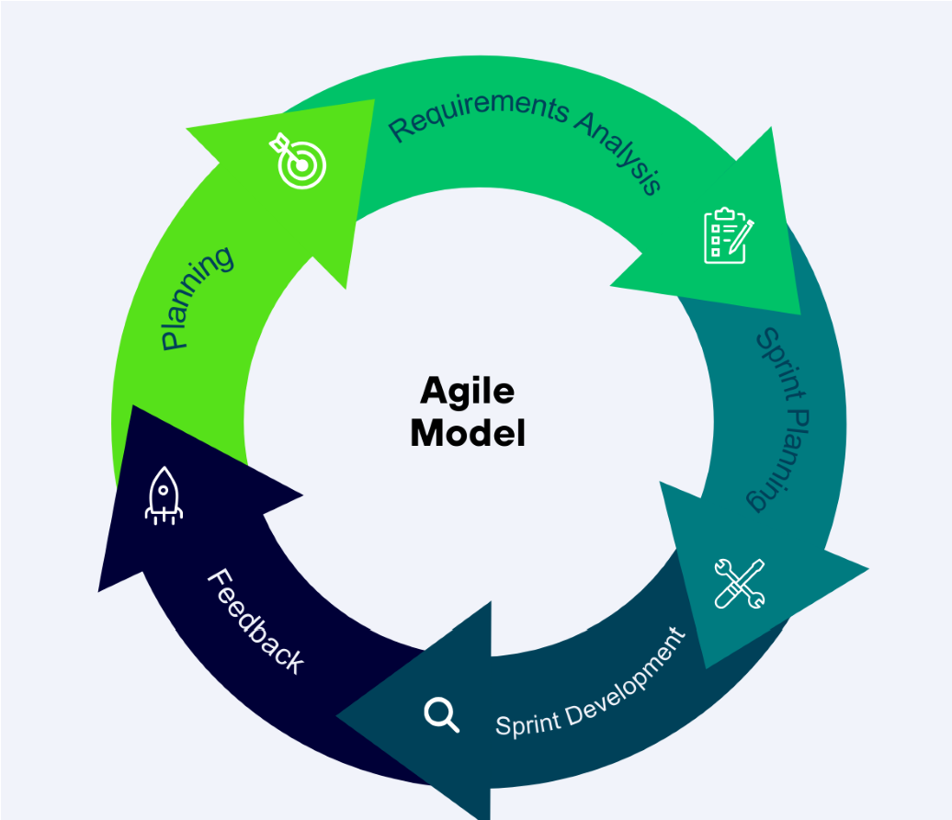

## Figure 1. AGILE MODEL

The Agile SDLC was chosen for UniHub because it is iterative, adaptive, and feedback-driven, making it well-suited to evolving requirements. Agile breaks development into sprints, enabling continuous refinement based on feedback from university stakeholders, project leaders, and participants.

**Planning:** In planning, we set the direction, goals, and scope of UniHub to align with the university community engagement needs. We identified the primary purpose: to streamline project and activity management, improve communication, and standardize satisfaction data collection. We met with stakeholders—faculty, project leaders, and participants—to understand workflows, pain points, and expectations. This led to defining essential functions: project and activity creation, participant registration, attendance tracking, survey deployment, and notification systems. We also defined user roles (Participant, Project Leader, Admin), system constraints, and acceptance criteria.

**Requirement Analysis:** During requirements analysis, we converted planning ideas into structured requirements. We documented functional and non-functional requirements using use case diagrams, user stories, and workflow mapping. Functional requirements included project and activity management, participant registration, survey management, automated notifications, and dashboards. Non-functional requirements emphasized accessibility, data privacy, secure authentication, system reliability, and scalable database design. We prioritized using MoSCoW, ensuring critical components—project management, activity participation, attendance tracking, and surveys—were addressed in early sprints.

**Sprint Planning:** During sprint planning, we broke prioritized requirements into actionable tasks for each sprint. Each sprint had clear deliverables and acceptance criteria. We organized requirements into the sprint backlog and estimated effort using story points. Planning sessions included selecting user stories (e.g., authentication, project creation, survey module) and assigning roles. We identified risks, dependencies, and testing requirements per sprint to ensure smooth progress.

**Sprint Development:** Sprint development involved designing, coding, and implementing features selected during planning. Each sprint produced a functional increment. This included developing user interfaces for all roles, backend features for project and activity management, participant registration, attendance tracking, and the survey module with customizable question types. Daily stand-ups helped track progress and address challenges. We applied continuous integration to ensure new components worked with existing modules. At the end of each sprint, we produced a working version, reviewed it, and demonstrated it to stakeholders for early feedback.

**Feedback:** After every sprint, we gathered feedback from UniHub users—project leaders, participants, and administrators. They shared their thoughts about how straightforward the interface was, how easy it was to register, how smooth the survey process felt, and how well the overall workflow worked for them. Many of them suggested ways to make navigation easier, add more precise instructions, improve notification timing, and include more relevant indicators.

We reviewed all this feedback and updated the product backlog, adding the suggested improvements to the next sprints. This ongoing feedback loop helped us continuously refine UniHub, making sure it better supports community engagement activities and provides an accurate picture of program impact.

# PRODUCT PERSPECTIVE

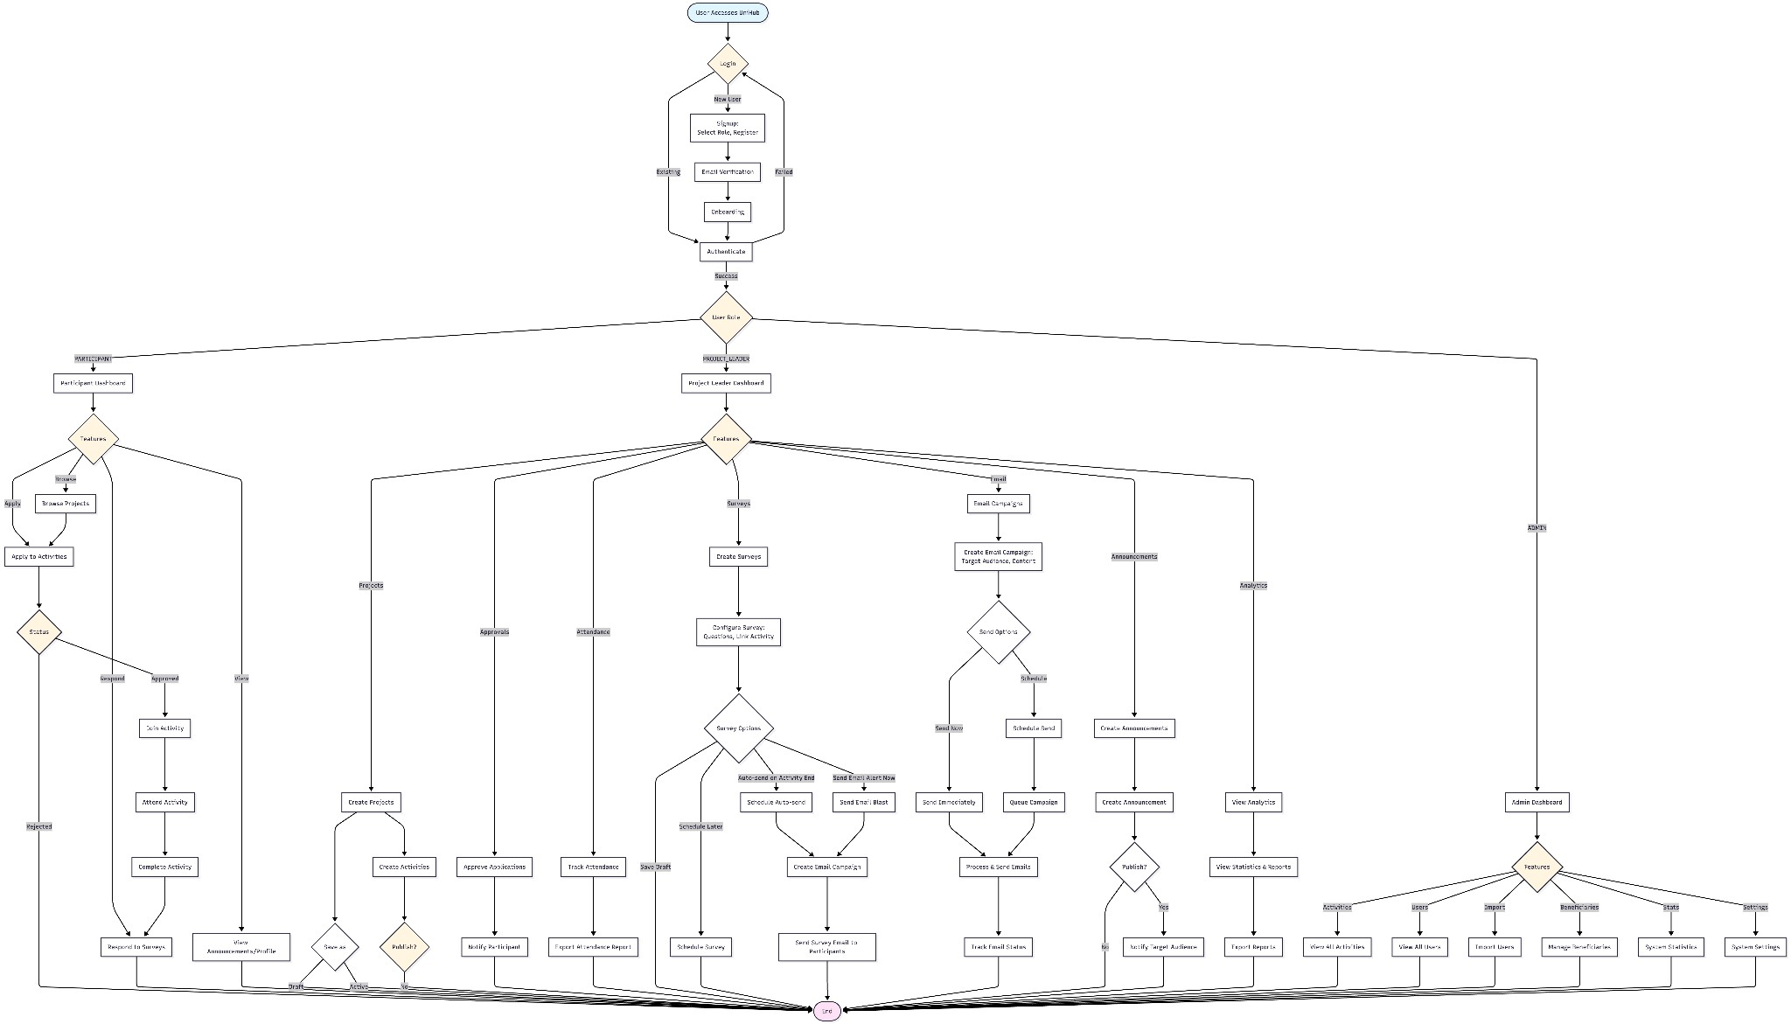

## Figure 2: SYSTEM FLOWCHART

This flowchart illustrates the comprehensive workflow of the UniHub platform, specifically designed to manage university community extension projects with integrated client satisfaction surveys. The process begins with user authentication, where users log in with their credentials and are directed to role-specific dashboards based on their user type (Extension Coordinator/Project Leader, Community Beneficiary, or Administrator).

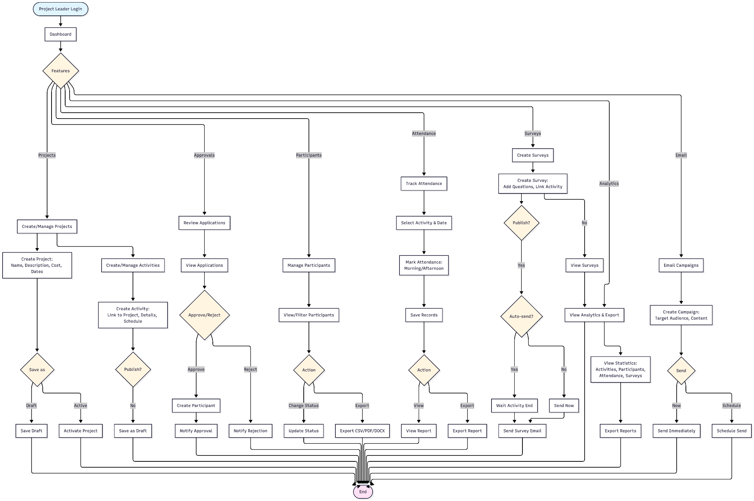

## Figure 3: PROJECT LEADER FLOWCHART

The system guides project leaders through the creation and management of extension projects. Leaders can create new projects by inputting comprehensive details, including the project title, community need being addressed, target beneficiary demographics, objectives aligned with community development goals, schedule, location, required resources, and expected outcomes. Once published, the project becomes visible to potential beneficiaries through the community beneficiary portal. Leaders can also manage existing projects by updating information, monitoring beneficiary registrations, tracking attendance during implementation, deploying satisfaction surveys after activities, and reviewing aggregated survey results and feedback to inform continuous improvement.

For attendance and project management, the project leader manually verifies attendance and approves or denies beneficiary participation as necessary. Attendance data is automatically recorded in the system’s database, ensuring real-time updates and accuracy. Administrators can then access this information and export it as needed. By combining project creation, event management, attendance tracking, and survey deployment, the system empowers project leaders to efficiently manage all aspects of their extension activities while ensuring accurate documentation and continuous improvement.

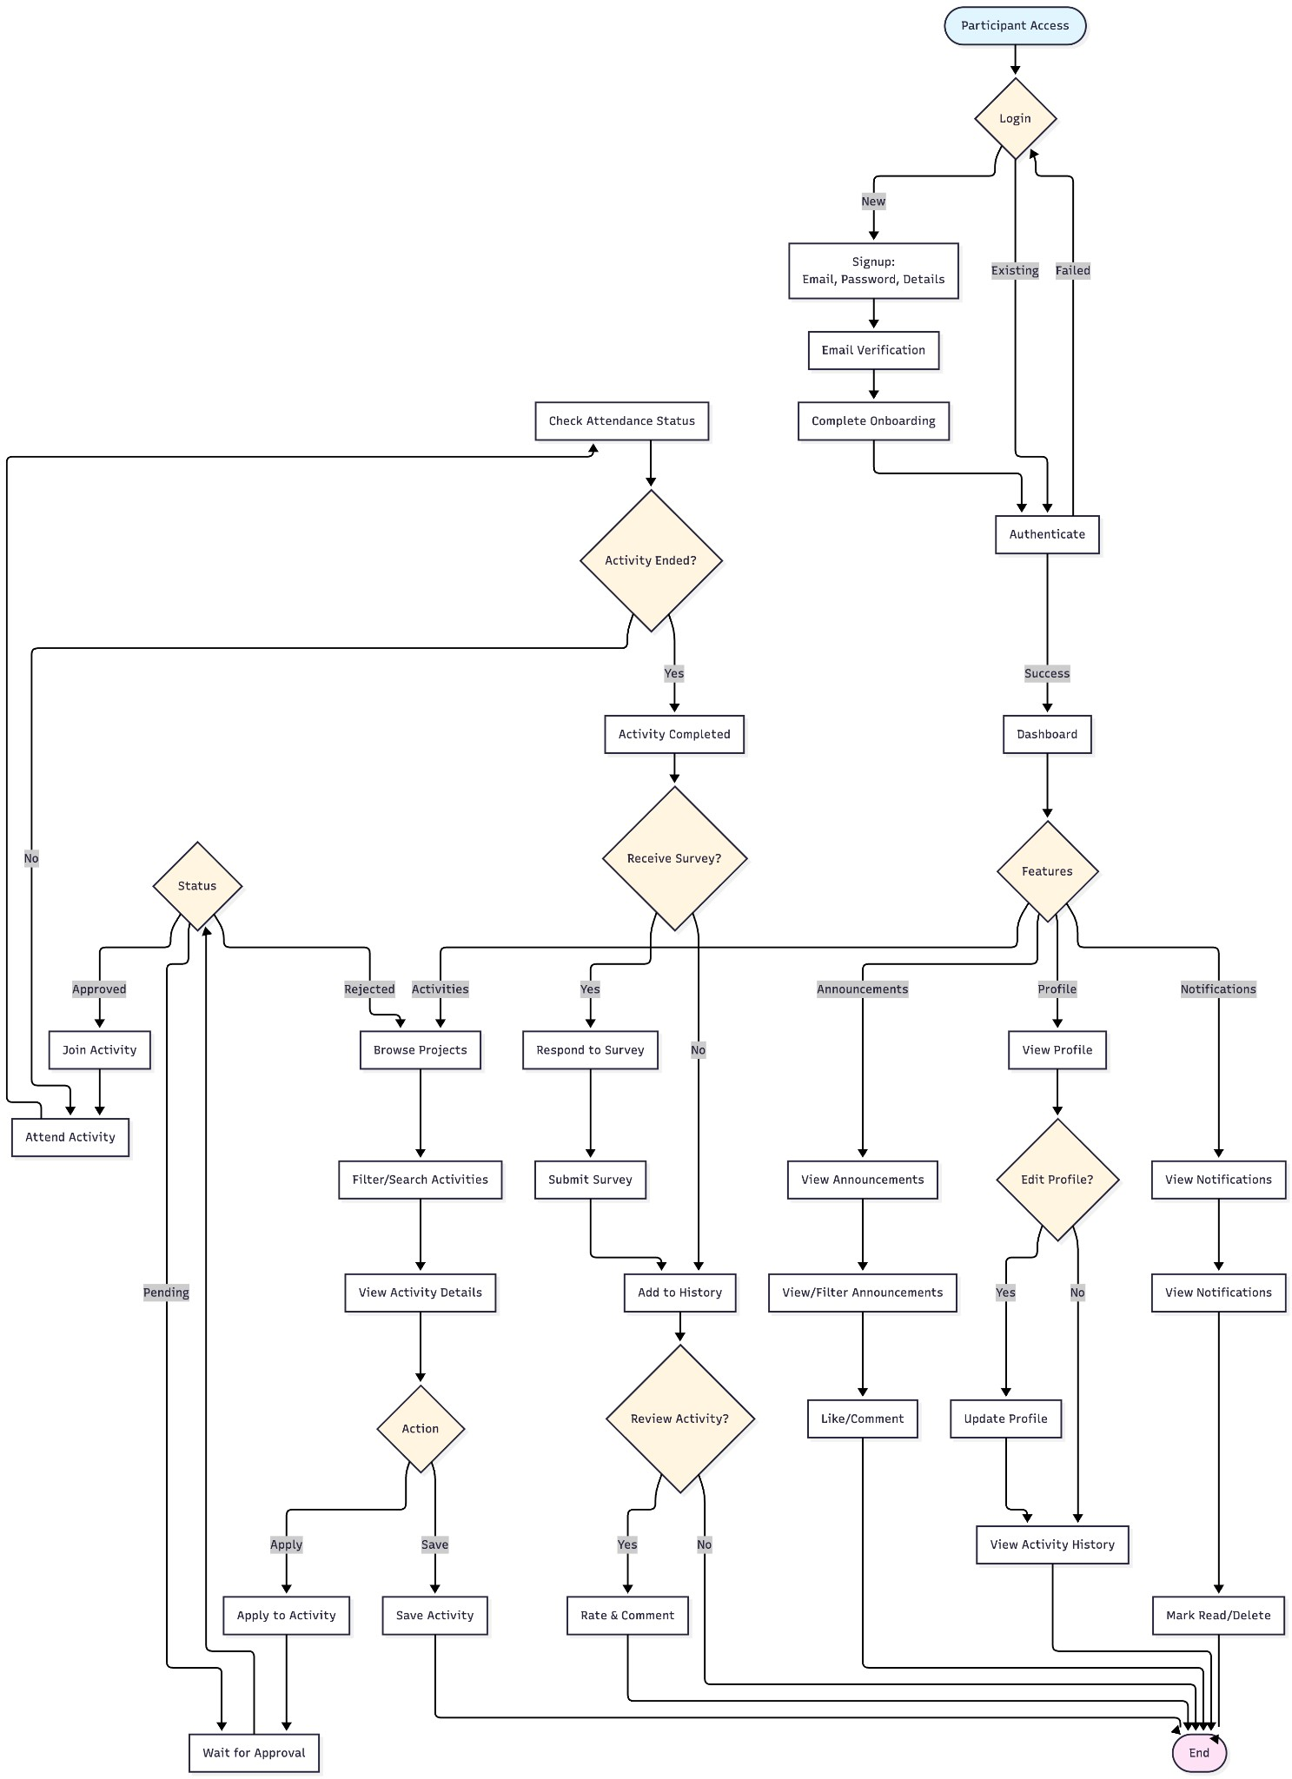

## Figure 4: BENEFICIARIES FLOWCHART

After a simplified registration or login process, they can browse available extension projects filtered by location, type of program (health, education, livelihood, environment, etc.). When they find a suitable program that addresses their needs or interests, they can view detailed information about the project objectives, schedule, and what to expect. They can then register to participate in the activity under the project created by the project leaders. Beneficiaries receive automated reminders before scheduled activities. After project completion, beneficiaries automatically receive a satisfaction survey invitation, which they can complete through a user-friendly web interface page. The survey collects their feedback on program quality, relevance, facilitator effectiveness, learning outcomes, and suggestions for improvement.

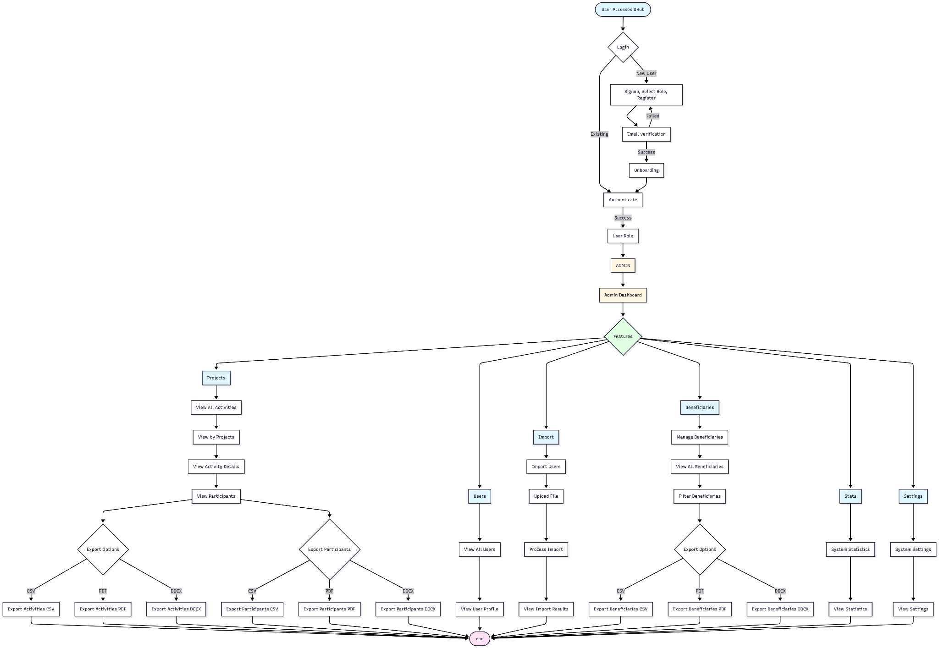

## Figure 5: ADMINISTRATOR FLOWCHART

The Admin flowchart illustrates the complete user journey and workflow for administrators within the UniHub platform. The flow begins with user authentication (login or signup with email verification) and progresses through role-based access control to the Admin Dashboard. Once authenticated as an admin, the system provides access to six primary feature areas: Activities, Users, Import, Beneficiaries, Statistics, and Settings. The Activities section allows admins to view all activities organized by projects, examine activity details and participants, and export data in multiple formats (CSV, PDF, DOCX). The Users section enables viewing all registered users and their profiles, while the Import feature facilitates bulk user importation through file uploads. The Beneficiaries section provides comprehensive management capabilities including filtering and exporting beneficiary data. The Statistics and Settings sections offer system-wide analytics and configuration viewing respectively. All workflows are designed with a read-only approach (except for user import), ensuring data integrity while providing comprehensive oversight and export capabilities for administrative reporting and analysis.

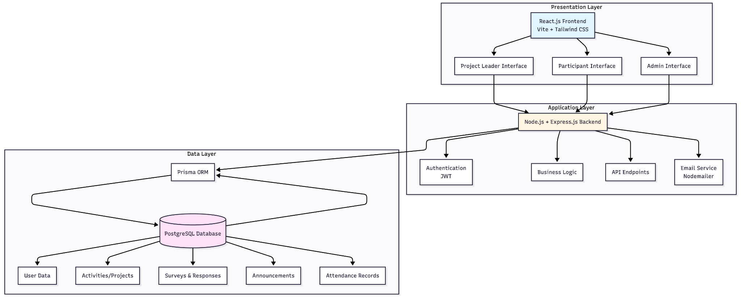

## Figure 6: SYSTEM ARCHITECTURE DIAGRAM

UniHub uses a three-tier architecture for activity management, project coordination, and survey administration:

**Presentation Layer (Frontend):** Built with React.js and Vite, this layer provides responsive interfaces for three user types. The Project Leader interface includes project and activity management, attendance tracking, survey creation, and email campaign tools. The Participant interface focuses on accessibility with easy navigation, activity registration, announcement viewing with comments, and mobile-optimized survey interfaces. The Administrator interface provides system-wide analytics, data export (CSV, PDF, DOCX), user management, and bulk import. All interfaces use Tailwind CSS for responsive design across devices.

**Application Layer (Backend):** Powered by Node.js and Express.js, the backend handles business logic for activity and project management. Functions include processing activity and project creation with validation, managing participant registration, coordinating automated email notifications and campaigns, implementing survey deployment logic, processing and aggregating survey responses, generating reports, managing attendance tracking, handling announcements with engagement features, and serving as a secure intermediary between frontend and database with JWT-based role-based access control. The backend uses Prisma ORM for type-safe database interactions.

**Data Layer (Database):** PostgreSQL organizes all system data in a clear, structured way. The database schema covers everything the platform needs—user profiles with role-based permissions, project and activity records with schedules and status updates, participant registrations, attendance logs, survey questions and responses, announcements with engagement data, email campaign history, and analytics.

Using Prisma migrations, the database structure stays consistent and easy to maintain. It also supports complex queries to generate detailed reports, such as linking participation data to satisfaction scores. This makes it possible to produce meaningful insights and support evidence-based improvements for the program.

The architecture is designed for scalability, reliability, security through JWT authentication and role-based access control, and accessibility for diverse user populations.

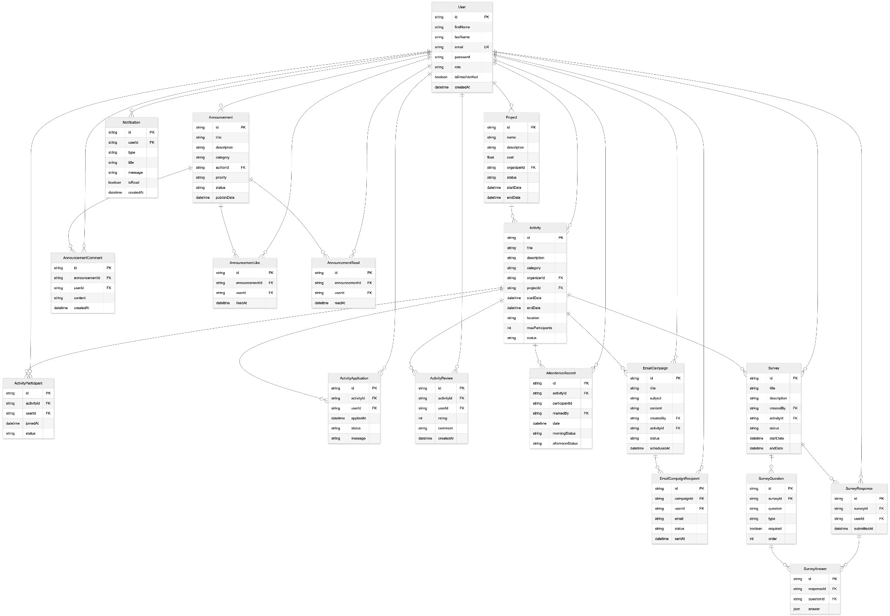

## Figure 7: ENTITY RELATIONSHIP DIAGRAM (ERD)

12

The entity-relationship diagram (ERD) presents how UniHub’s data is structured and interconnected across the platform. It covers core elements such as users with role-based permissions, projects and their linked activities, and participant involvement tracked through participation records, applications, reviews, and attendance logs. The ERD also includes announcements and their engagement metrics, survey instruments with questions and user responses, email campaigns with delivery tracking, and system notifications. These relationships—such as the one-to-many links between projects and activities or the many-to-many connections managed through junction tables—provide a clear map of how data flows within UniHub, ensuring efficient project management, activity coordination, and comprehensive reporting.

# FUNCTIONAL REQUIREMENTS

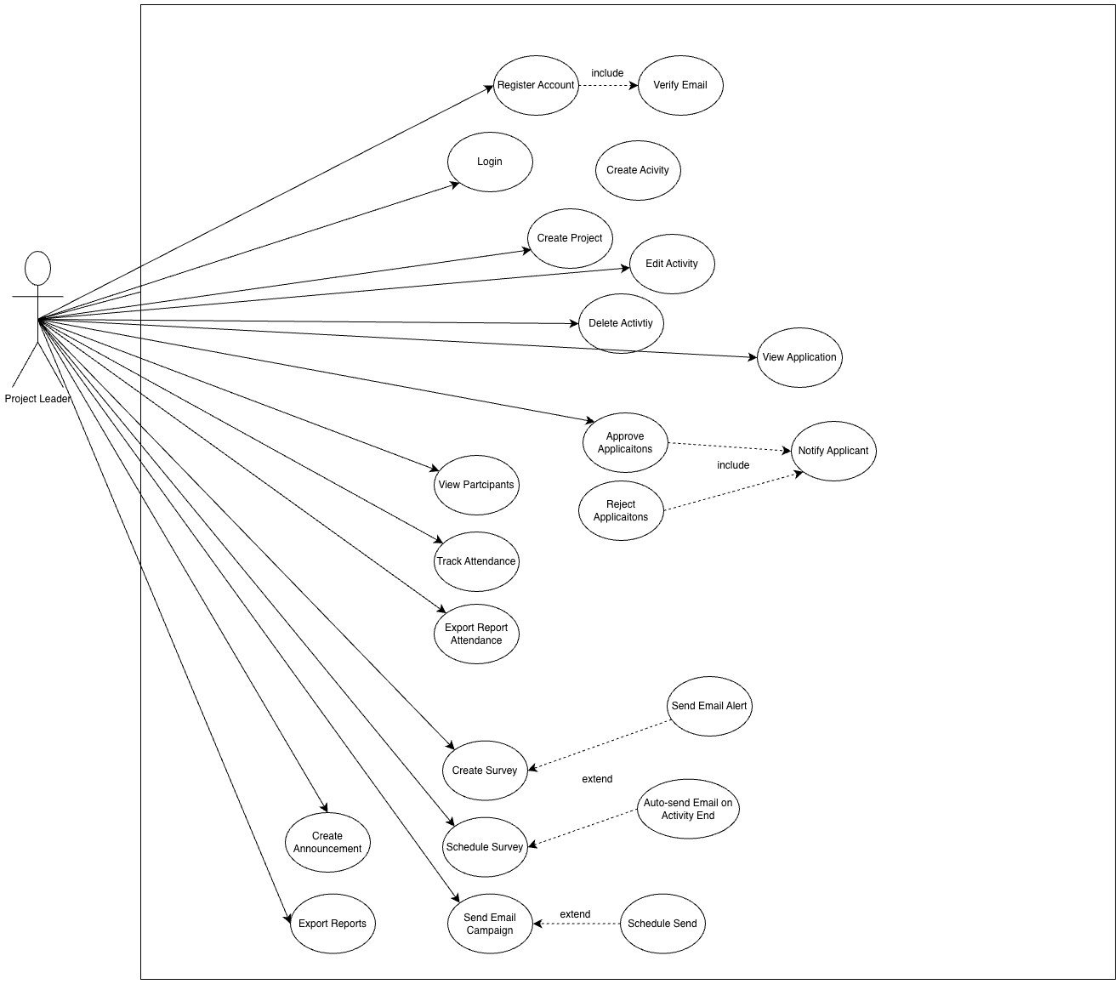

## Figure 8: PROJECT LEADER’S USE CASE DIAGRAM

The Project Leader use case diagram for the UniHub system demonstrates the management capabilities available to project organizers through seventeen primary use cases: Register

Account, Login, Create Project, Create Activity, Edit Activity, Delete Activity, View

Application, Approve Applications, Reject Applications, View Participants, Track Attendance,

Export Report Attendance, Create Survey, Schedule Survey, Create Announcement, Send Email Campaign, and Export Reports. The Project Leader actor connects to all use cases via association relationships, enabling project leaders to establish and manage extension projects and activities, process participant applications with approval or rejection workflows, monitor attendance and generate attendance reports, create and schedule satisfaction surveys, publish announcements, execute email blasts, and export comprehensive reports. The diagram includes three mandatory include relationships where Register Account requires Verify Email, and both Approve Applications and Reject Applications require Notify Applicant, ensuring essential communication and verification processes. Additionally, three optional extended relationships are present: Create Survey may optionally Send Email Alert, Schedule Survey may optionally Auto-send Email on Activity End, and Send Email Campaign may optionally Schedule Send, providing flexible automation options for project leaders to enhance their communication and survey deployment strategies.

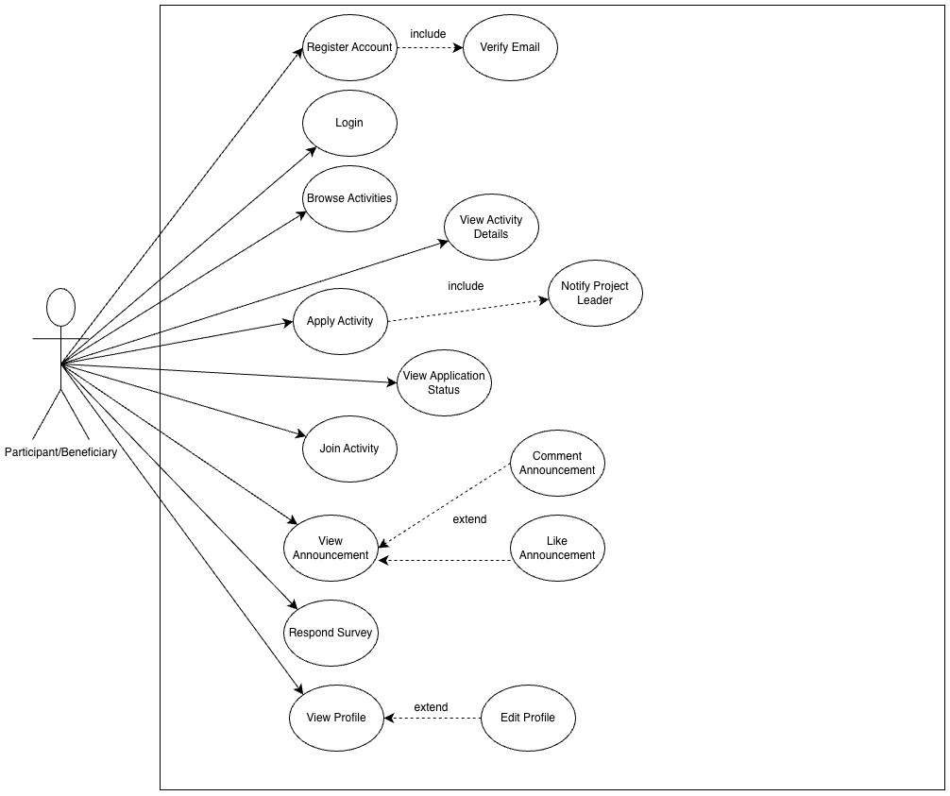

## Figure 9: PARTICIPANT/BENEFECIARY’S USE CASE DIAGRAM

The Participant/Beneficiary use case diagram for the UniHub system illustrates the user interaction capabilities available to participants and beneficiaries through nine primary use cases: Register Account, Login, Browse Activities, Apply Activity, View Application Status, Join Activity, View Announcement, Respond Survey, and View Profile. The

Participant/Beneficiary actor connects to all use cases via association relationships, enabling users to create accounts and authenticate into the system, discover and explore available activities, submit applications to join activities, monitor their application status, participate in approved activities, access announcements, complete satisfaction surveys, and manage their personal profile information. The diagram includes three mandatory include relationships where Register Account requires Verify Email to ensure account security, Browse Activities requires View Activity Details to provide comprehensive activity information, and Apply Activity requires Notify Project Leader to automatically inform organizers of new applications. Additionally, three optional extend relationships are present: Comment Announcement and Like Announcement both extend View Announcement, allowing participants to optionally engage with announcement content, while Edit Profile extends View Profile, providing participants with the flexibility to update their personal information when viewing their profile, thereby supporting interactive engagement and self-service profile management within the platform.

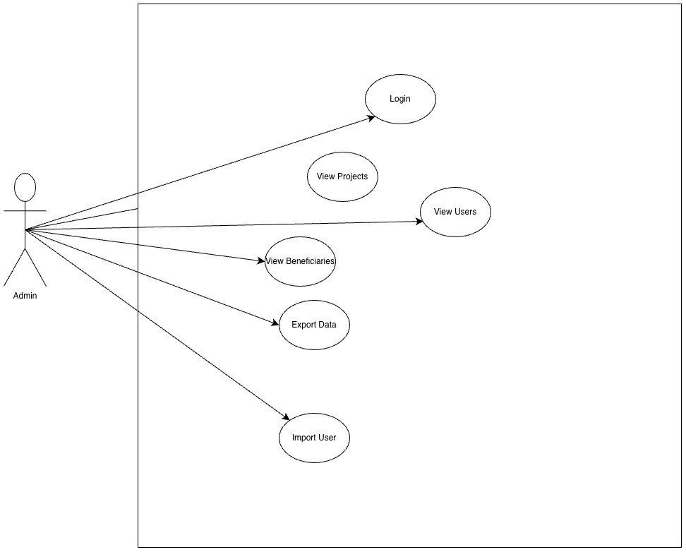

## Figure 10: ADMIN’S USE CASE DIAGRAM

The Admin use case diagram for the UniHub system illustrates the administrative role's interaction with the platform through six primary use cases: Login, View Activities, View Users, View Beneficiaries, Export Data, and Import Users. The Admin actor, represented as a stick figure outside the system boundary, connects to all use cases via association relationships, indicating that administrators can authenticate into the system, view all activities organized by projects, access comprehensive user information, monitor beneficiary participation across activities, export system data in multiple formats (CSV, PDF, DOCX), and perform bulk user imports from external files. The diagram emphasizes the read-only nature of the administrative role, where viewing and exporting capabilities are the primary functions, with user import being the sole data modification operation allowed, ensuring system oversight while maintaining data integrity and controlled access to system information.

**3 RESULTS AND DISCUSSION**

# DEVELOPMENT PROCESS

|  |  |
| --- | --- |
| **FRONT END** | **DESCRIPTION** |
| React 18 | A JavaScript library for building interactive and responsive user interfaces. |
| Vite | A fast build tool and development server for modern web projects. |
| Tailwind CSS | A utility-first CSS framework for rapid and consistent styling. |
| React Router | Handles navigation and routing between pages in a React application. |
| Framer Motion | A library for creating smooth animations and transitions in React. |
| Lucide React | Provides a set of customizable, lightweight icons for React projects. |
| jsPDF | Generates PDF documents directly from web pages or app data. |
| docx | Allows programmatic creation of Word documents (.docx) from JavaScript. |
| **BACK-END** | DESCRIPTION |
| Node.js | A JavaScript runtime for executing server-side code. |
| Express.js | A minimal and flexible web framework for building APIs and server applications. |
| PostgreSQL | A relational database for storing structured data reliably and securely. |
| Prisma | An Object-Relational Mapping (ORM) tool to interact with the database using JavaScript/TypeScript. |
| JWT | JSON Web Tokens used for secure user  authentication and session management. |
| Nodemailer | A Node.js library for sending emails programmatically. |
| bcrypt | A library for securely hashing and verifying passwords. |

## Table 1. DEVELOPMENT SOFTWARE PLATFORMS

This table outlines the technologies used in developing the mobile application interface and handling the system's logic, ensuring ease of use and efficient communication between the frontend and backend components.

|  |  |  |
| --- | --- | --- |
| **TOOL/ENVIRONMENT** | | **DESCRIPTION** |
| **Development Workstation** | | A computer (laptop or desktop) with minimum Intel Core i5 or AMD Ryzen 5 processor, 8GB RAM (16GB recommended), and 256GB SSD storage for coding, testing, and running development servers. |
| **Application Server** |  | Cloud server (AWS EC2, DigitalOcean, or similar) with minimum 2 CPU cores and 4GB RAM to host the Node.js backend application and serve API requests. |
| **Database Server** |  | PostgreSQL server with minimum 2 CPU cores, 4GB RAM, and 50GB storage for data persistence, ensuring reliable storage and retrieval of all system data. |
| **Network Infrastructure** |  | High-speed internet connection with SSL/TLS support for secure data transmission between clients and servers, enabling secure authentication and data exchange. |
| **Visual Studio Code Code)** | **(VS** | Code editor with extensions for React, JavaScript, and Prisma for writing and editing source code. |
| **Git** |  | Version control system for tracking code changes, managing branches, and coordinating team development. |
| **GitHub** |  | Cloud-based repository hosting service for storing code repositories, managing issues, and facilitating collaboration. |
| **Vite** |  | Frontend build tool and development server for fast development with hot module replacement. |
| **Modern Web Browsers** |  | Chrome, Firefox, Safari, or Edge for testing the frontend application and debugging. |

# Table 2. DEVELOPMENT ENVIRONMENTS, AND TOOLS

This table provides an overview of the software tools and development environments used to build, test, and deploy the UniHub web application system, ensuring efficient development workflow and reliable system operations.

**FEATURES OF THE DEVELOPED SYSTEM**

# FINAL GUI

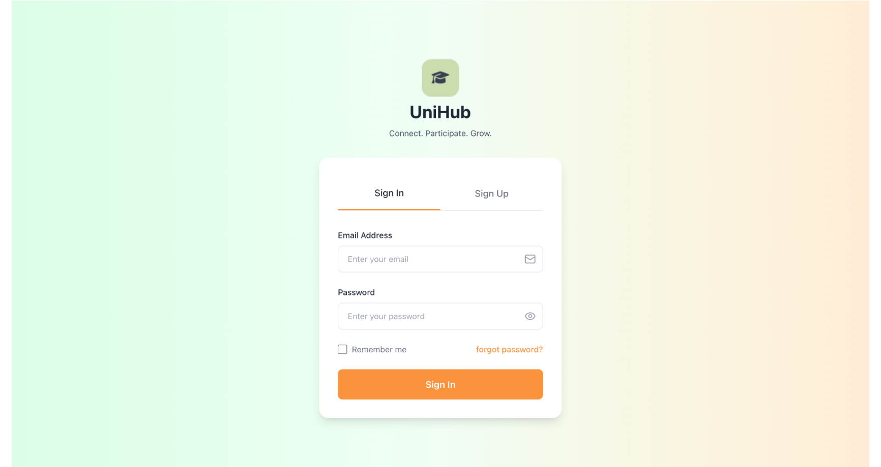

## Figure 11: LOGIN PAGE

The authentication module provides secure access to UniHub. Users log in with a valid email and password; invalid credentials show an error. New users can register with an email address, password, and role selection (Participant or Project Leader), enabling role-based access across the system.

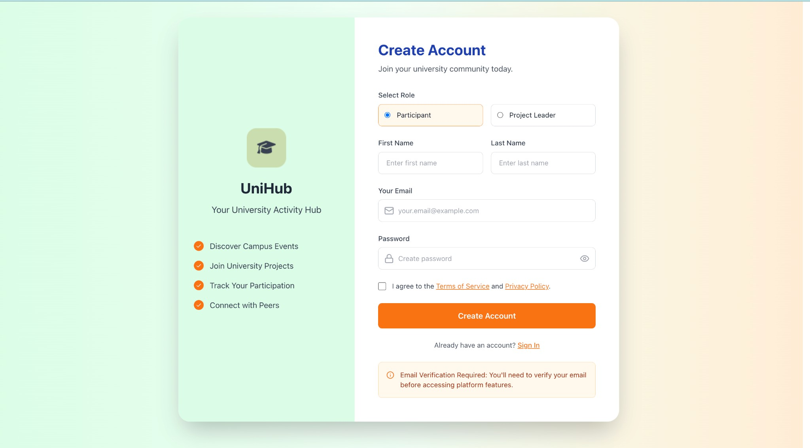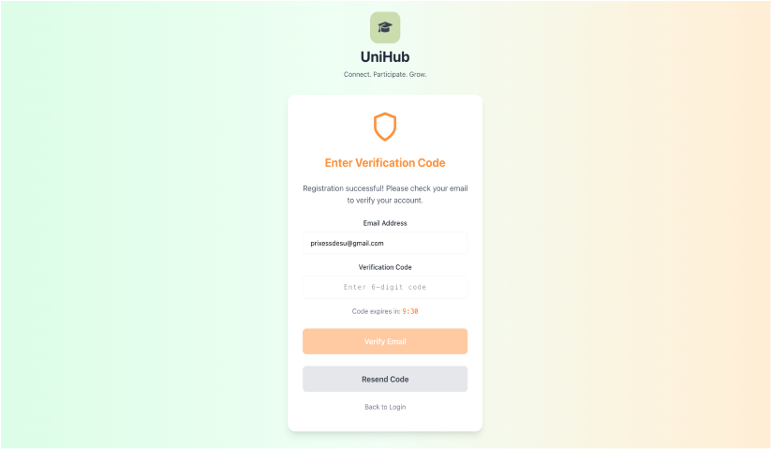

### Figure 12: REGISTER PAGE

The registration process validates email format and prevents duplicate email addresses to ensure data integrity. After registration, the system sends a 6-digit verification code to the user's email address. Users must verify their account by entering the correct code within 10 minutes, after which the code expires. This two-step verification ensures only valid email addresses are registered and helps maintain account security.

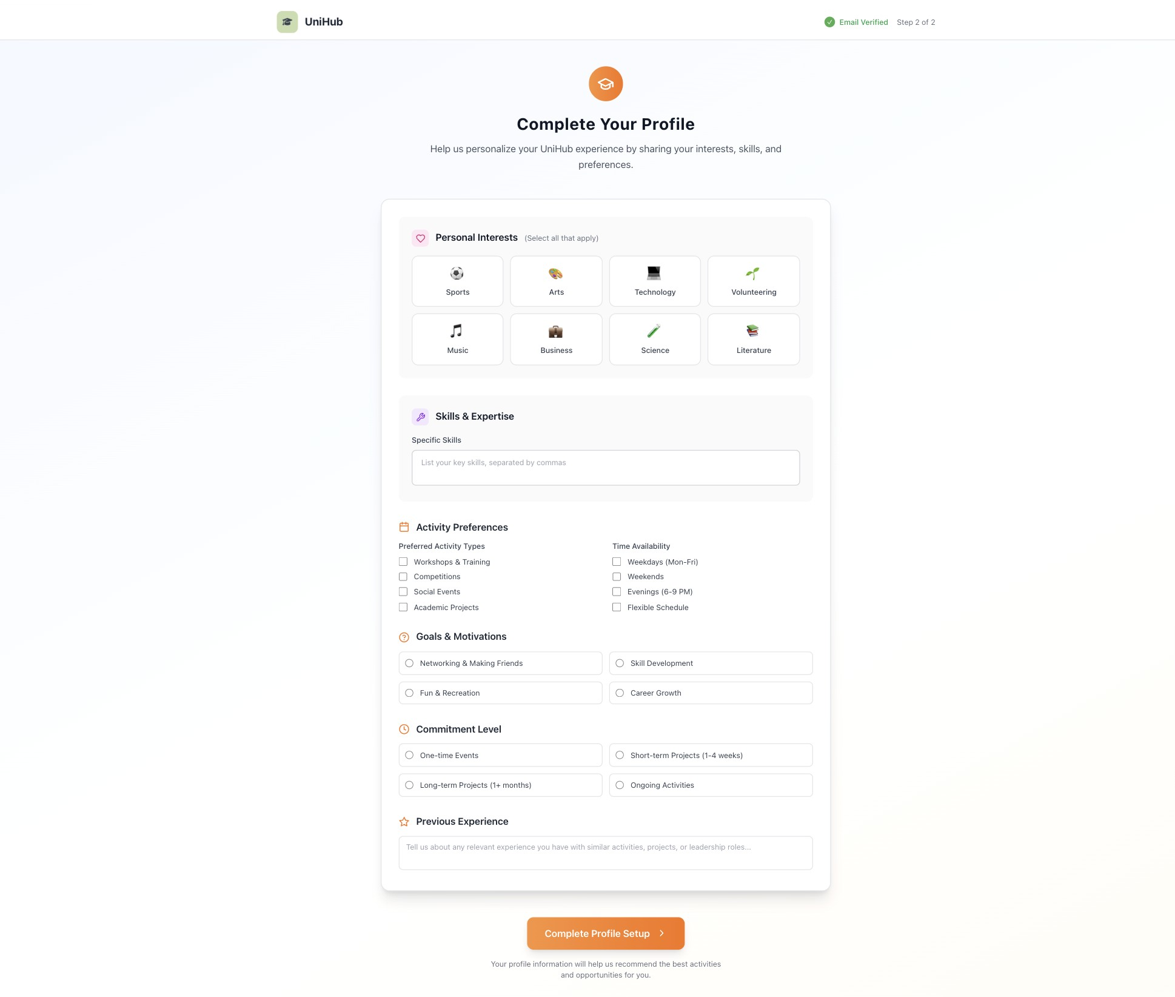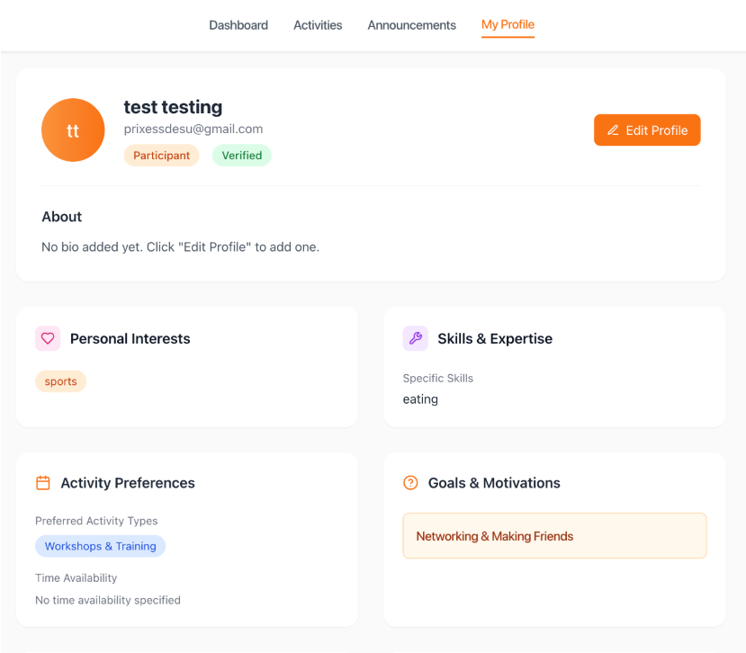

### Figure 13: USER MANAGEMENT

Users may modify their name, bio, and interests on the user management page. In order to tailor their experience and match them with relevant tasks and projects, new users fill out an onboarding form with their skills, availability, and goals.

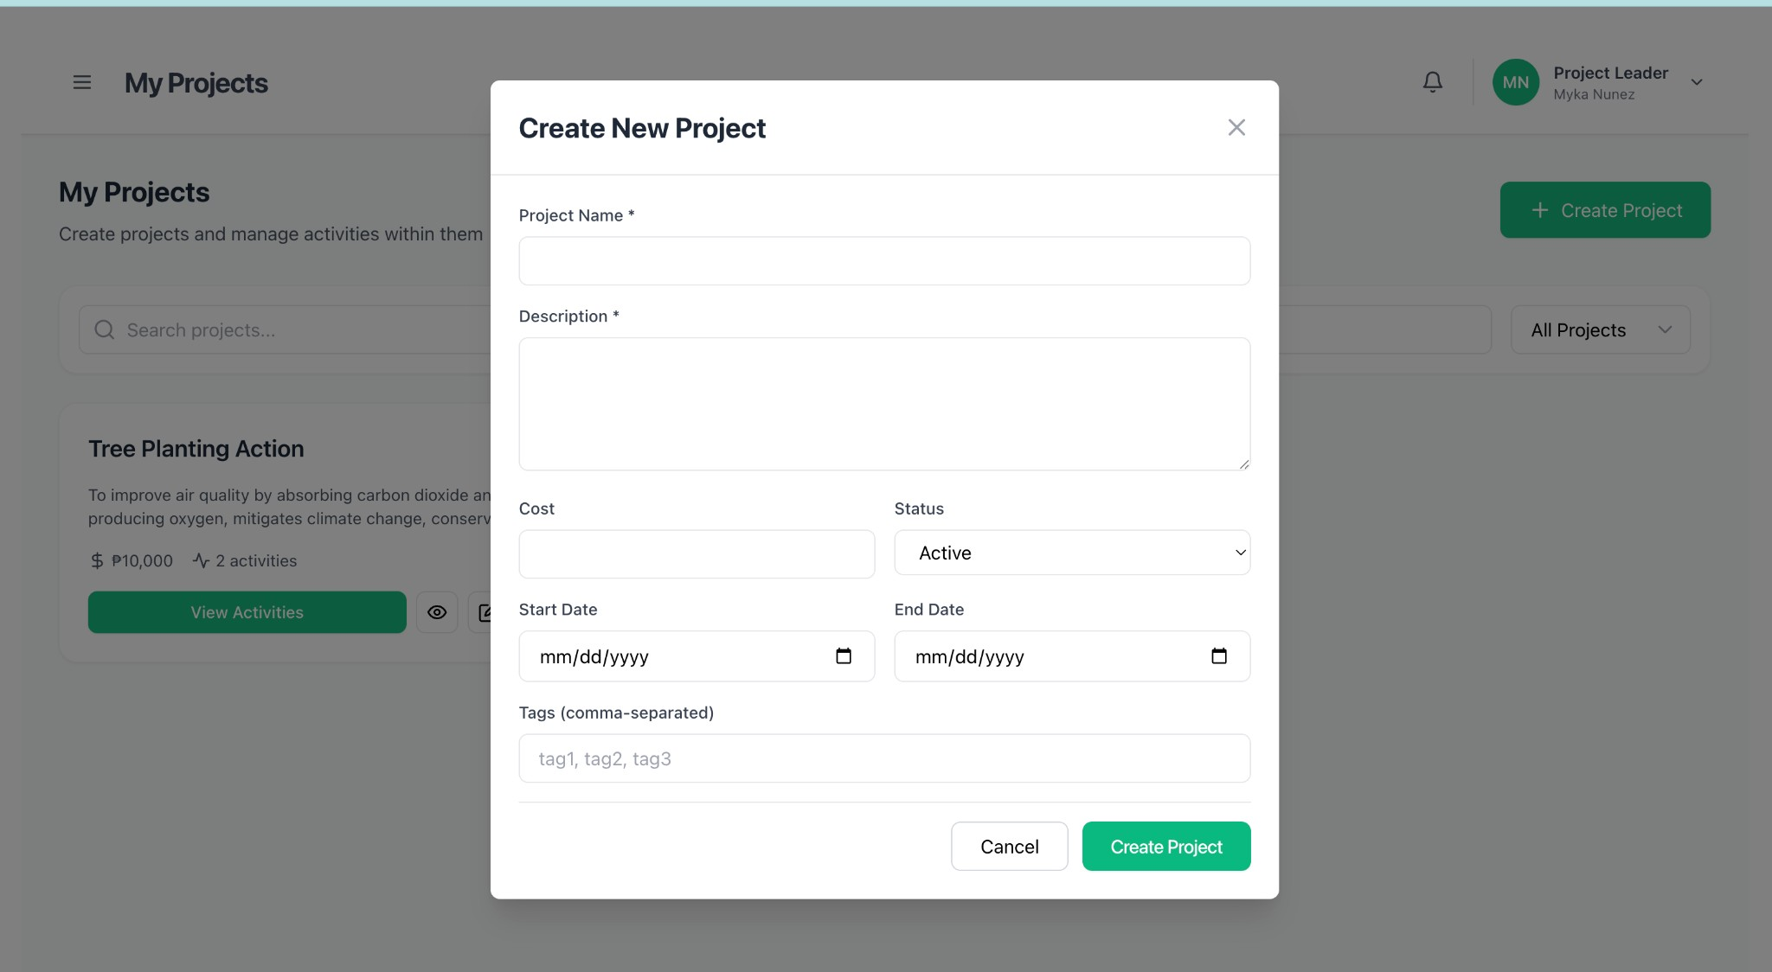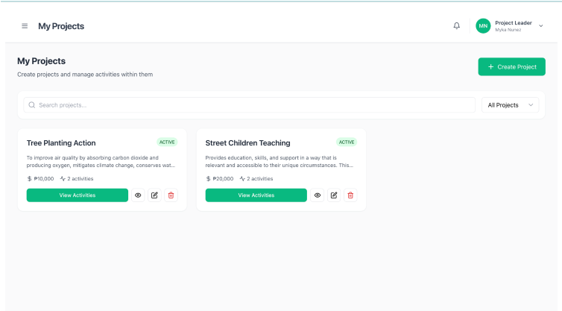

### Figure 14: CREATE/VIEW PROJECTS

Project leaders can create new extension projects with a name, description, and budget using the projects module. Every project is shown by the system along with its status, dates, and other information. To locate particular projects, users can filter them by status (DRAFT, ACTIVE) This aids in the planning and monitoring of extension projects over the course of their existence.

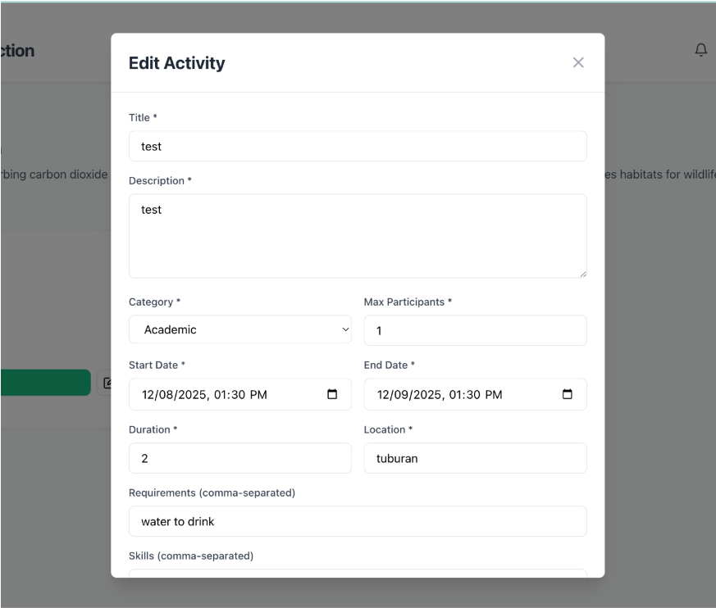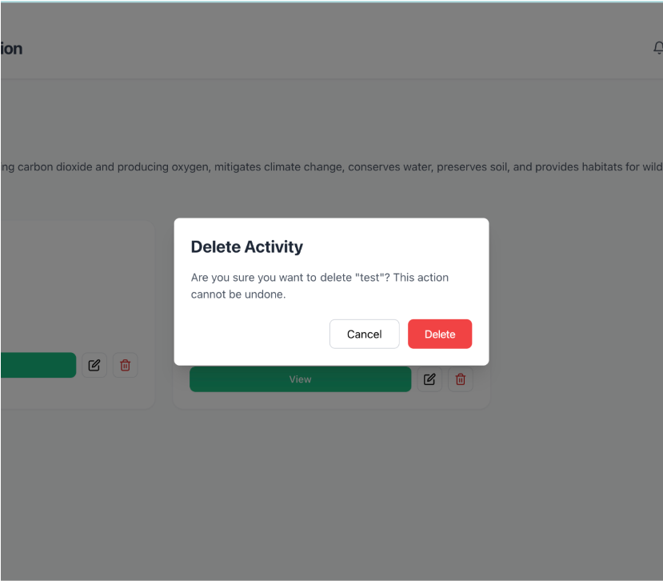

## Figure 15: UPDATE/DELETE PROJECTS

Users may modify their name, bio, and interests on the user management page. In order to tailor their experience and match them with relevant tasks and projects, new users fill out an onboarding form with their skills, availability, and goals.

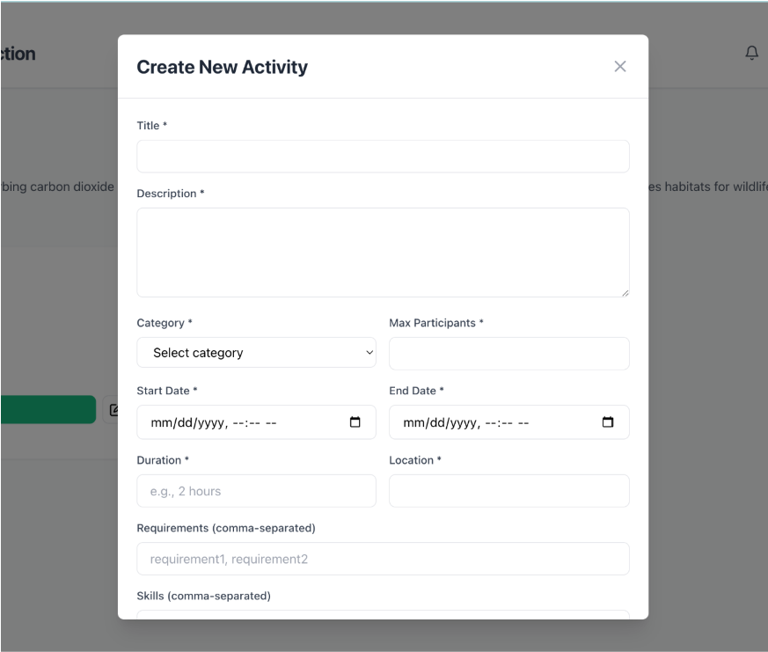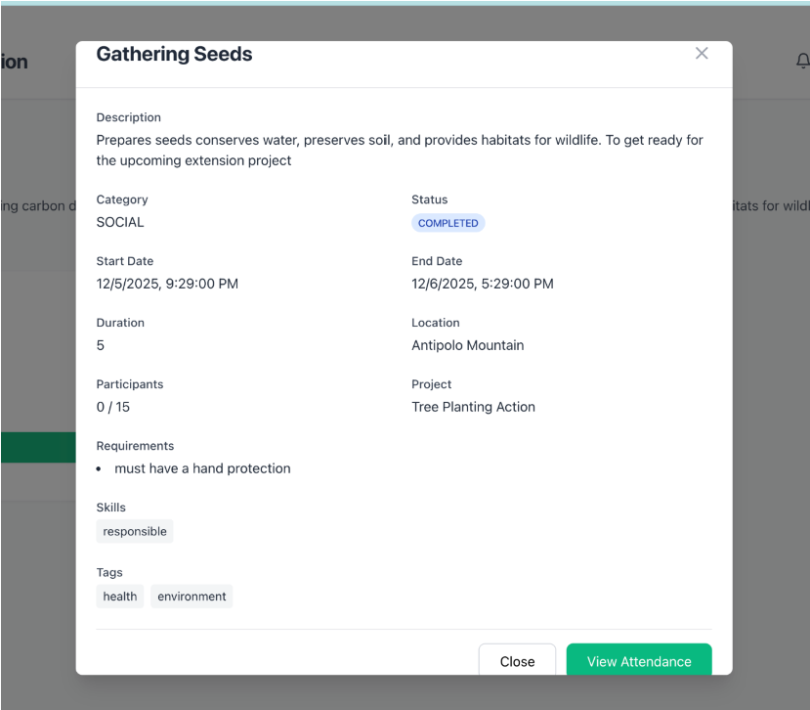

## Figure 16: CREATE/VIEW ACTIVITIES

The activities module lets project leaders create activities with title, category, dates, and location. Users can view all activities and filter by category and status to find relevant opportunities. This helps organize and discover activities and community extension projects.

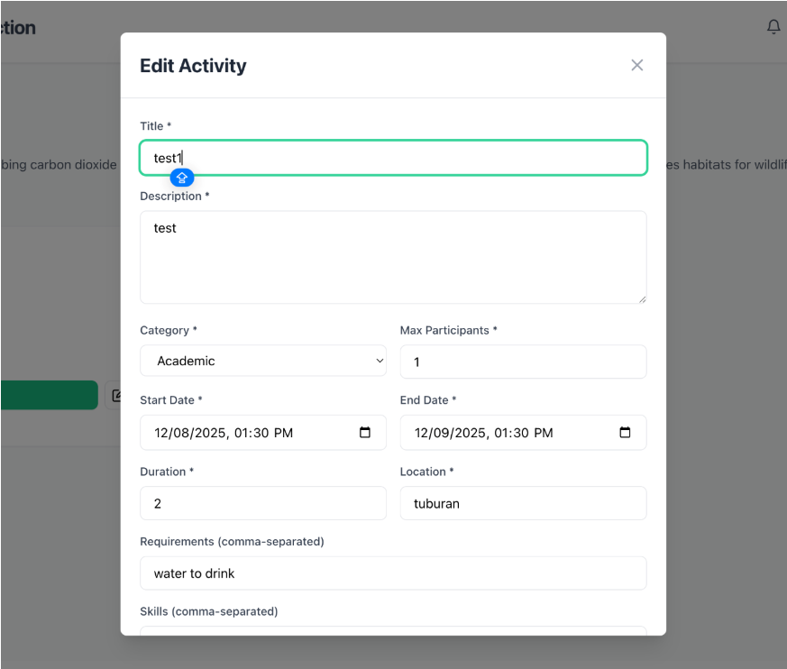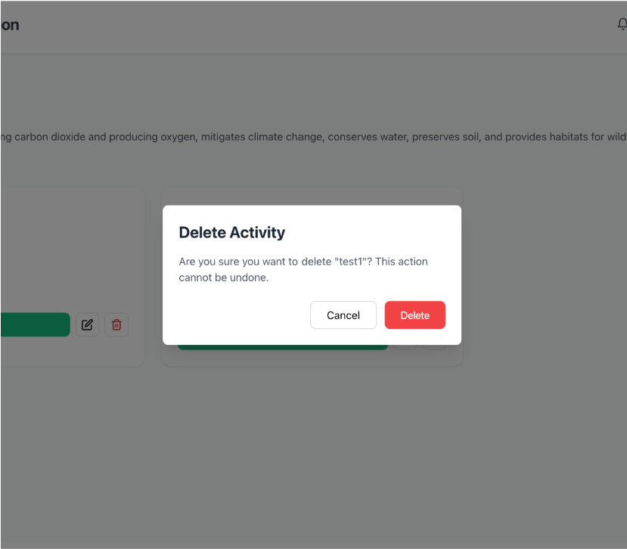

## Figure 17: UPDATE/DELETE ACTIVITIES

The activity management module lets project leaders update activity details, including title, category, dates, location, and other information. Project leaders can also delete activities when needed. These features help maintain accurate activity information and manage the activity lifecycle.

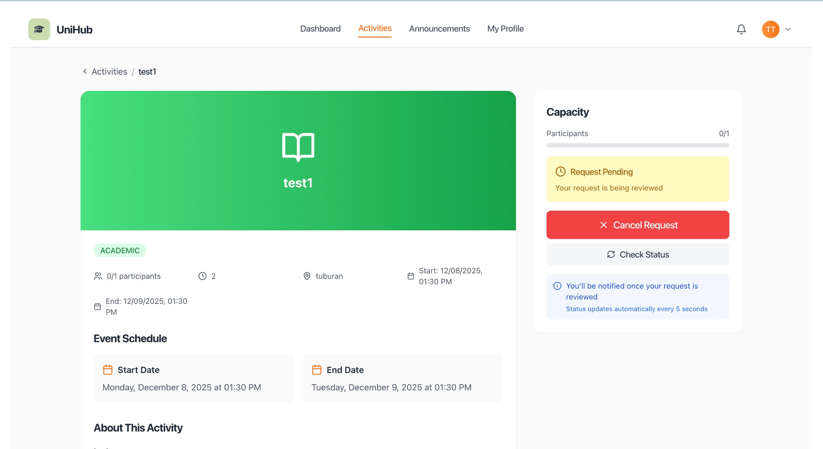

### Figure 18: JOIN/APPLY ACTIVITY

The activity participation module lets participants join activities directly or submit applications to join. When an activity requires approval, participants submit an application that project leaders can review and approve or reject. This supports both open participation and managed enrollment, giving project leaders control over participant selection while allowing participants to express interest in activities.

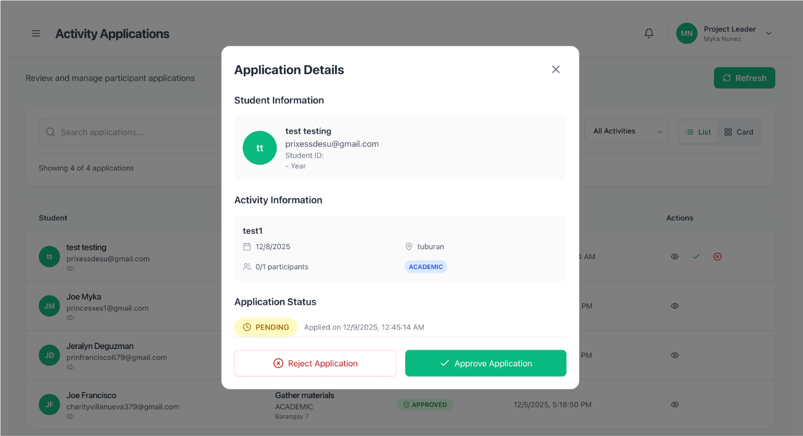

### Figure 19: MANAGE APPLICATIONS

The application management module lets project leaders view pending applications for their activities. They can approve or reject participant applications, thereby controlling enrollment. Approved participants are added to the activity, while rejected applicants are notified. This streamlines participant selection and keeps applicants informed of their status.

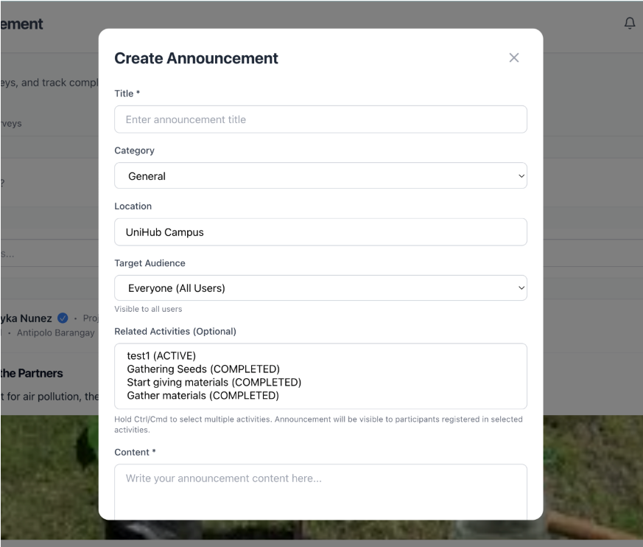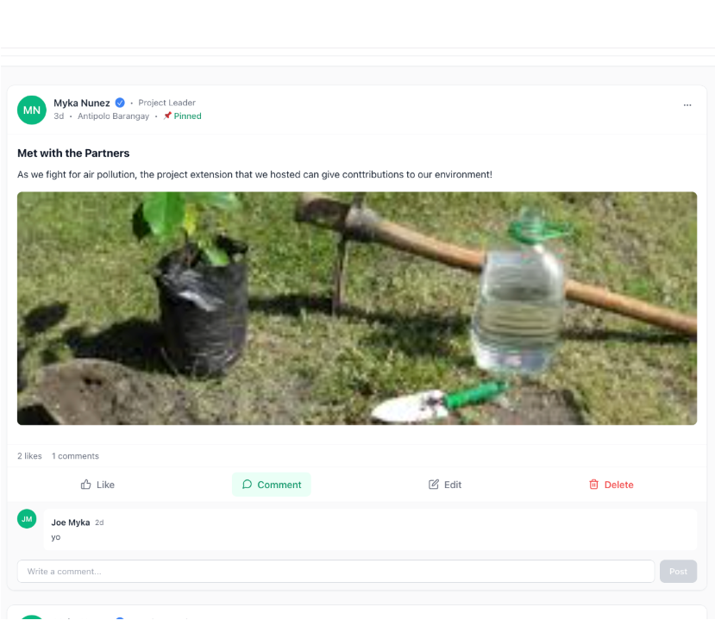

### Figure 20: MANAGE ANNOUNCEMENTS

The announcements management module lets project leaders create announcements with titles, descriptions, and categories. Users can view all announcements. Both participants and project leaders can comment on and like announcements. Project leaders can pin important announcements so they appear at the top. This supports communication and engagement across the platform.

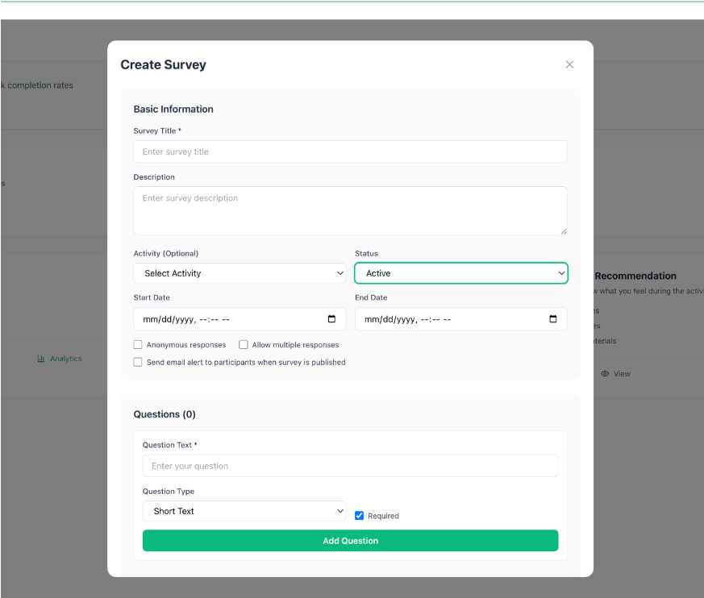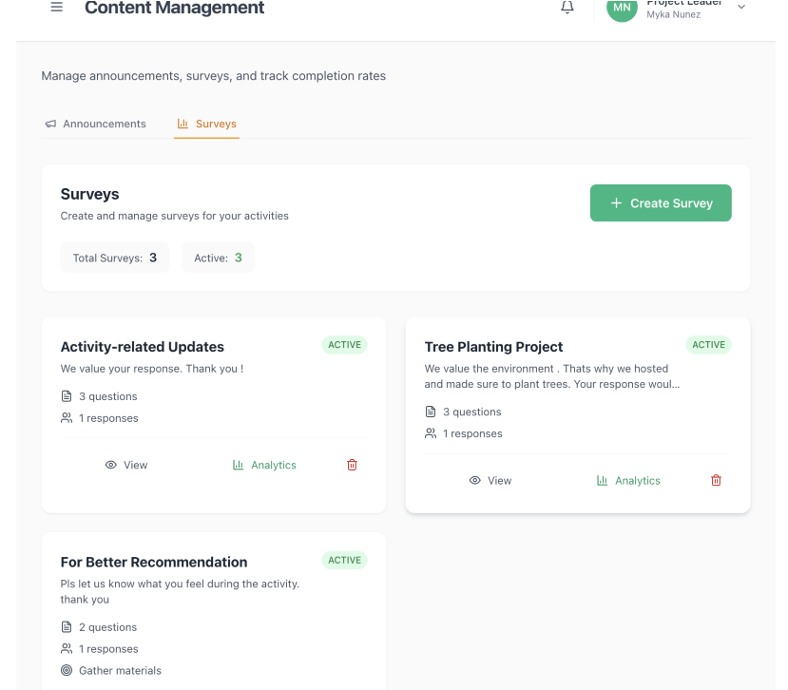

### Figure 21: MANAGE SURVEYS

The survey management module lets project leaders create surveys with questions and set a target audience. Surveys can be scheduled to auto-send when an activity ends, enabling timely feedback collection. Users can view all surveys with status and target information, helping track survey distribution and responses. This supports structured feedback collection and analysis for community extension projects.

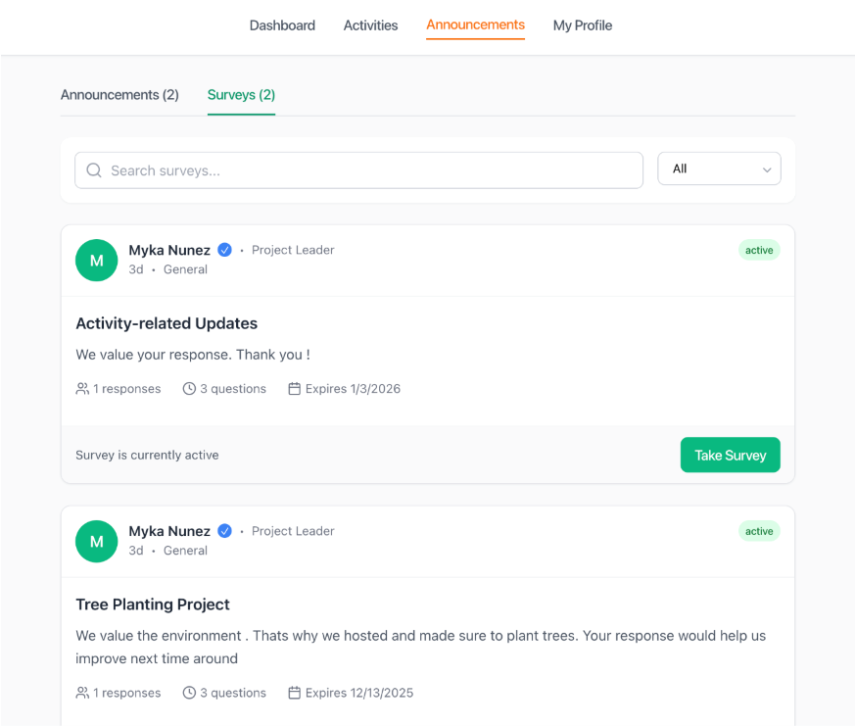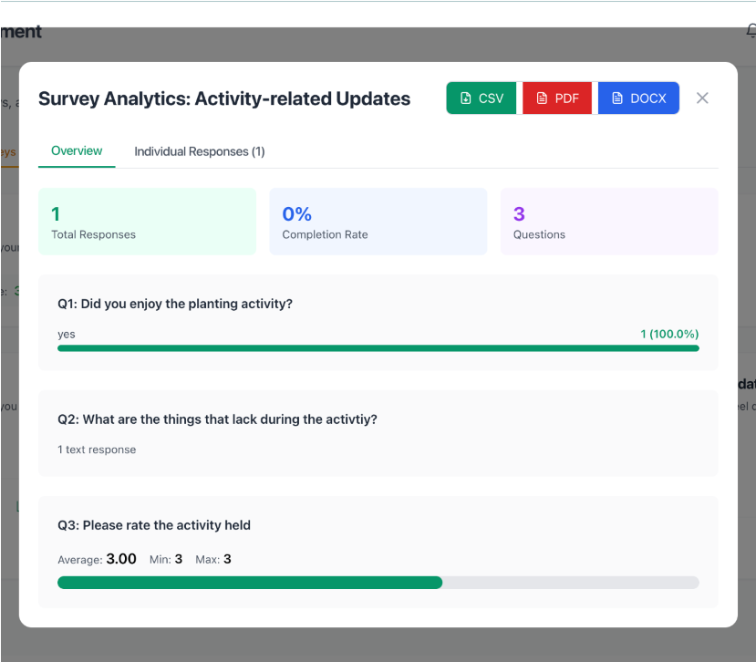

### Figure 22: RESPOND SURVEYS

The survey response and analytics module lets participants respond to survey questions. Project leaders can view survey responses and analytics to analyze feedback and improve future community extension efforts. This supports data-driven decision-making and continuous improvement of extension programs.

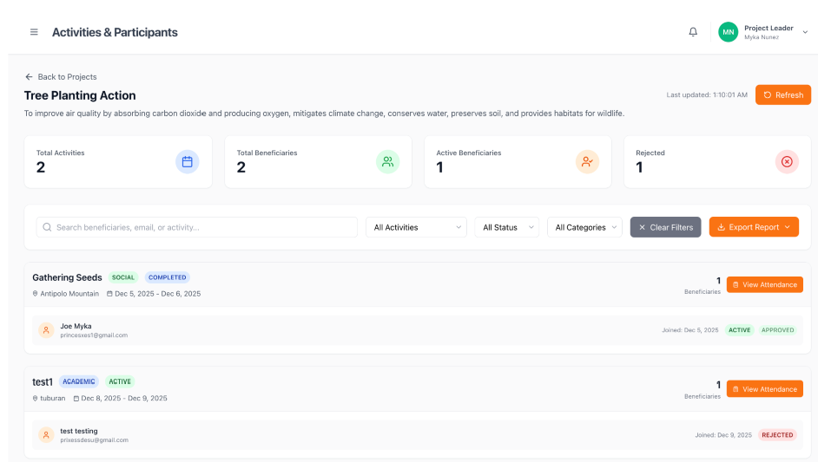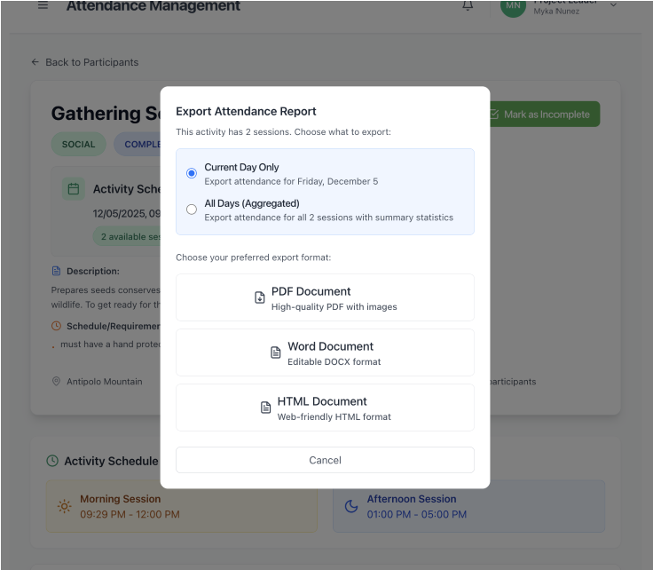

## Figure 23: MANAGE ATTENDANCE (MARK,VIEW,EXPORT)

The attendance management lets project leaders mark participants' attendance during project activities. They can view attendance records by date and participant to track participation. Attendance can be exported in CSV, PDF, or DOCX for reporting and record-keeping. This supports accurate tracking of beneficiary participation in extension projects.

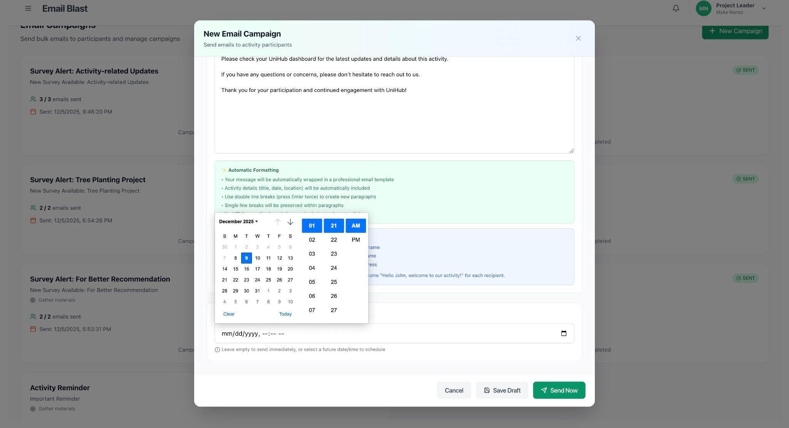

### Figure 24: CREATE/SCHEDULE EMAIL

The email campaign module lets project leaders create email campaigns with a subject and content to send announcements, reminders, and activity updates. Campaigns can be scheduled to send at a specific time, enabling automated communication with participants and beneficiaries. This supports timely and targeted communication for community extension projects.

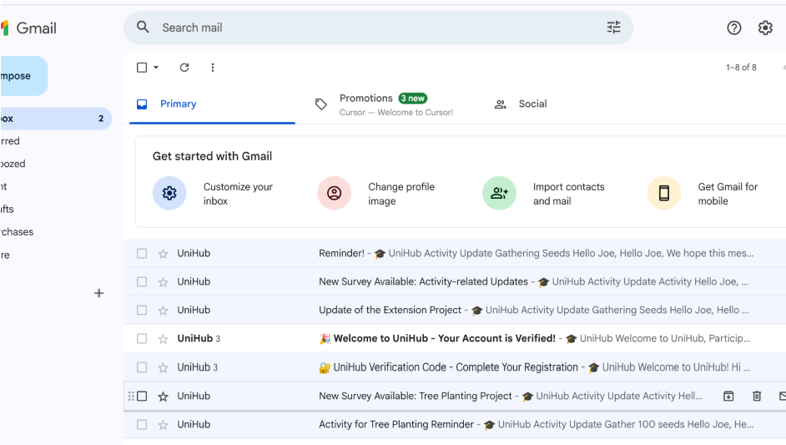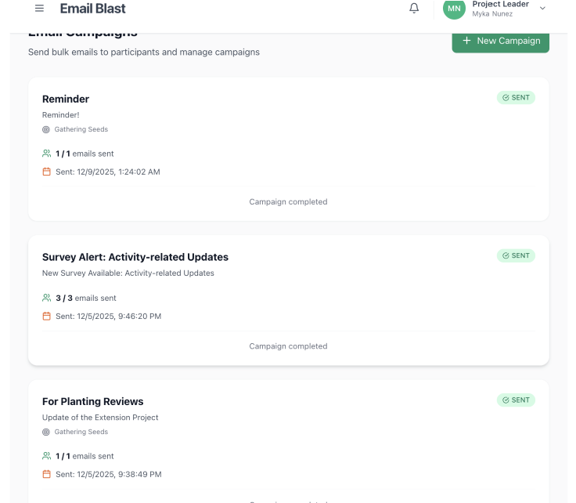

### Figure 25: SEND/VIEW STATUS EMAIL

The email campaign delivery and status module sends emails to the selected target audience (activity participants, all users, or specific groups). Project leaders can view campaign delivery status to track sent, delivered, opened, and failed emails. This provides visibility into campaign performance and helps ensure effective communication with beneficiaries and participants.

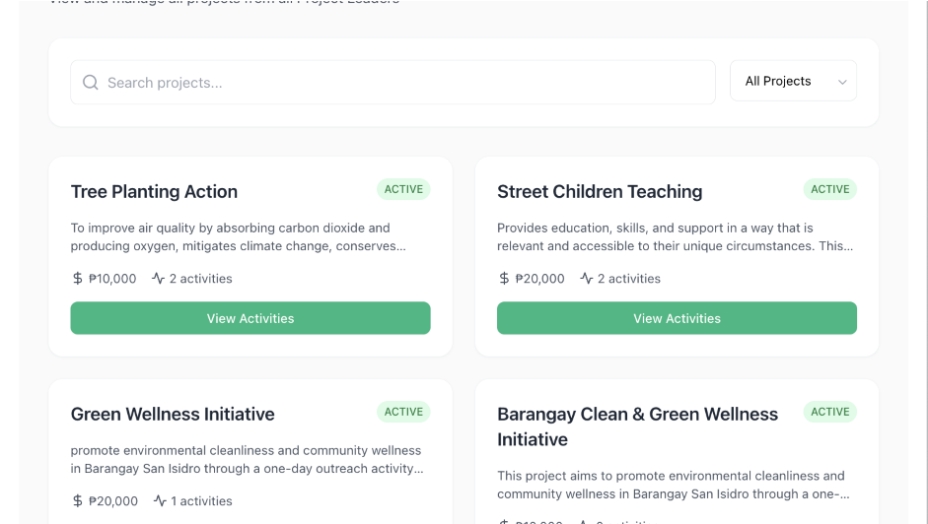

## Figure 26: VIEW ACTIVITIES/PARTICIPANTS

The admin data viewing module lets administrators view all activities grouped by project and all participants grouped by project and activity. This provides a system-wide overview for monitoring extension programs, tracking participation across projects, and analyzing engagement patterns. The grouped structure helps administrators understand project organization and participant distribution across activities.

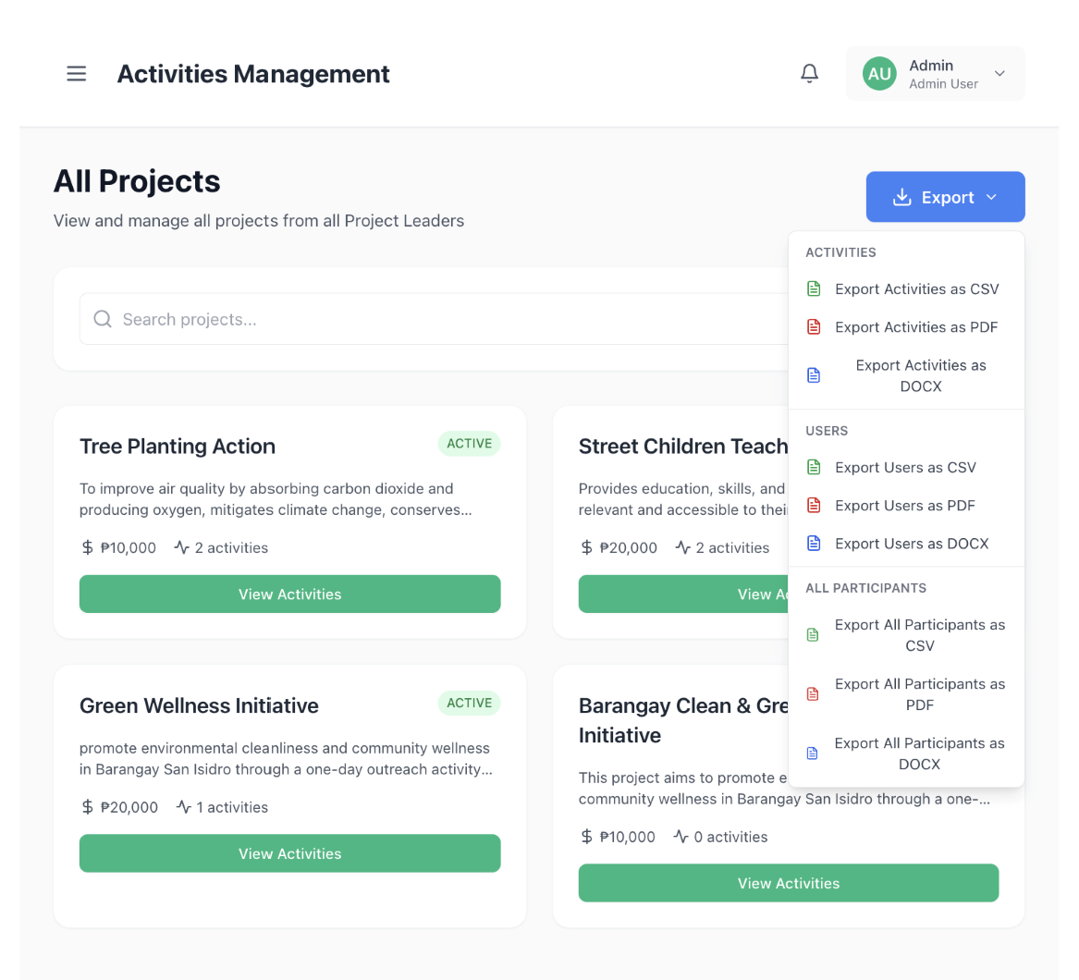

## Figure 27: EXPORT ACTIVITIES/PARTICIPANTS

The admin export module lets administrators export all activities data, all participants data, and participants for a specific activity in CSV, PDF, or DOCX. This supports reporting, record-keeping, and analysis of extension programs. Exports can be used for documentation, presentations, and compliance reporting.

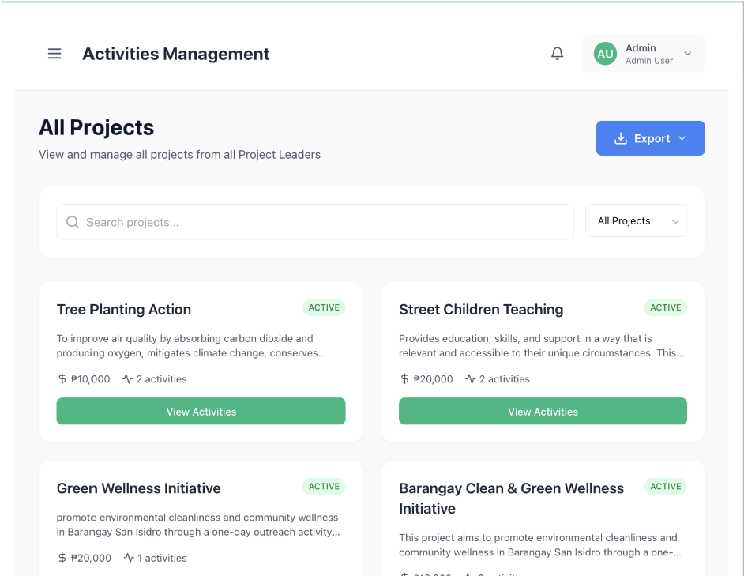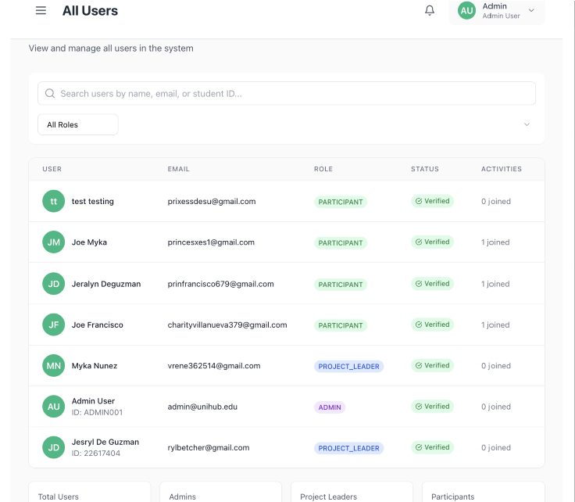

## Figure 28: VIEW ALL PROJECTS/USERS

The admin data viewing module lets administrators view all activities grouped by project and all participants grouped by project and activity. This provides a system-wide overview for monitoring extension programs, tracking participation across projects, and analyzing engagement patterns. The grouped structure helps administrators understand project organization and participant distribution across activities.

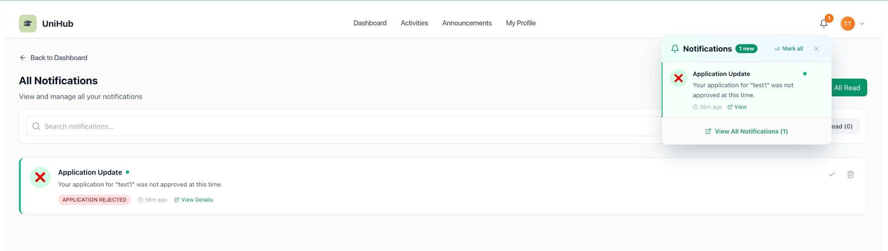

### Figure 29: NOTIFICATIONS

The notifications module keeps users informed of important events. Users can view all notifications in their dashboard and mark them as read. Participants receive notifications when their activity applications are approved or rejected, and when activities they're involved in are updated. Project leaders receive notifications when new applications are submitted for their activities. All users receive notifications when new announcements are published, ensuring timely communication across the platform.

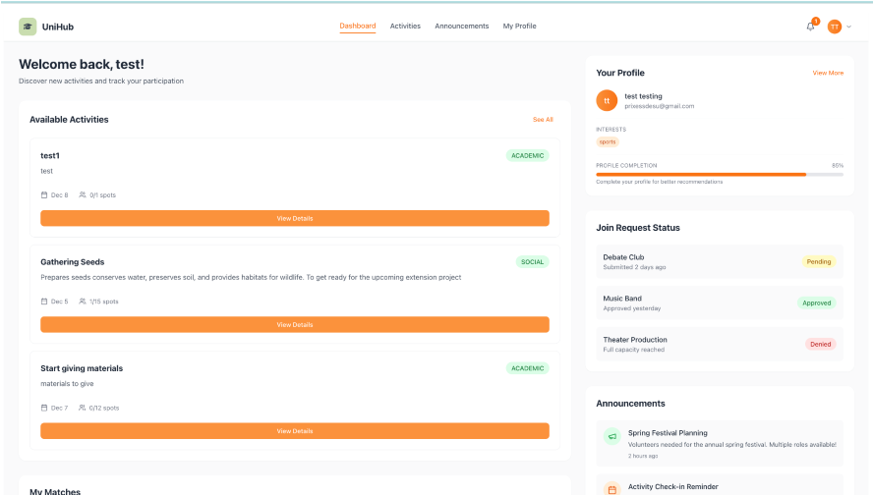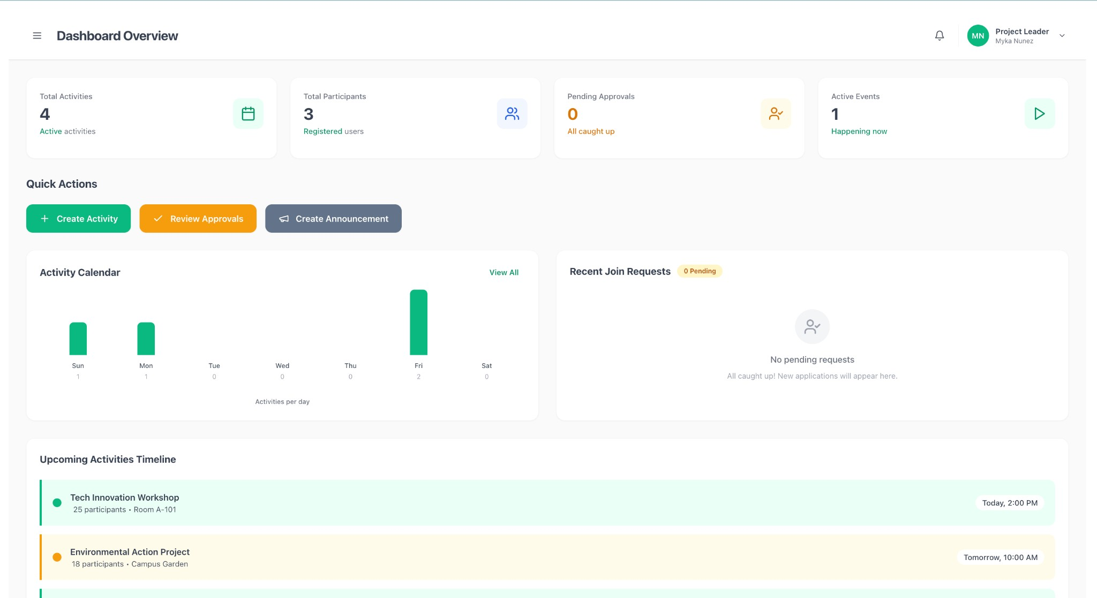

## Figure 30: PARTICIPANT’S/BENEFECIARY’S/PROJECT LEADER’S DASHBOARD

The participant dashboard provides an overview of upcoming activities, and announcements. It displays the participant's scheduled activities, application statuses, and recent announcements, and The project leader dashboard provides an overview of activity statistics, pending applications, and attendance records. It displays key metrics such as total activities, participant counts, and application statuses.

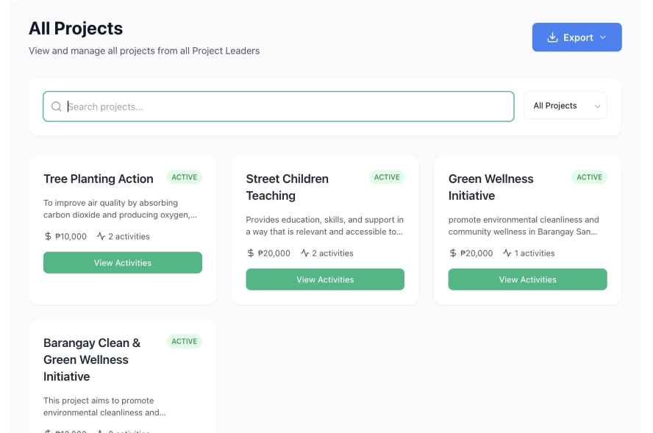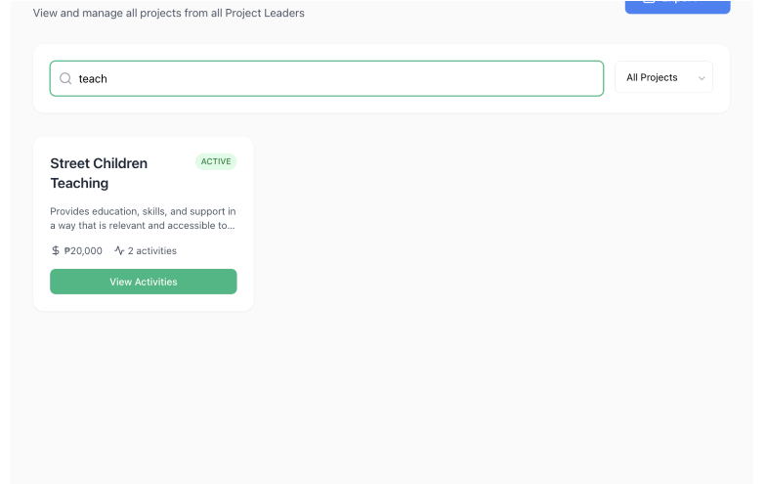

## Figure 31: SEARCH PROJECTS/ACTIVITIES

The search activities feature allows users to find activities by title and category. Users enter keywords in the search bar to filter activities and apply category filters to narrow results. The search projects feature allows users to find projects by name or description. This feature helps users quickly locate projects that align with their interests and goals, facilitating efficient project discovery across the platform.

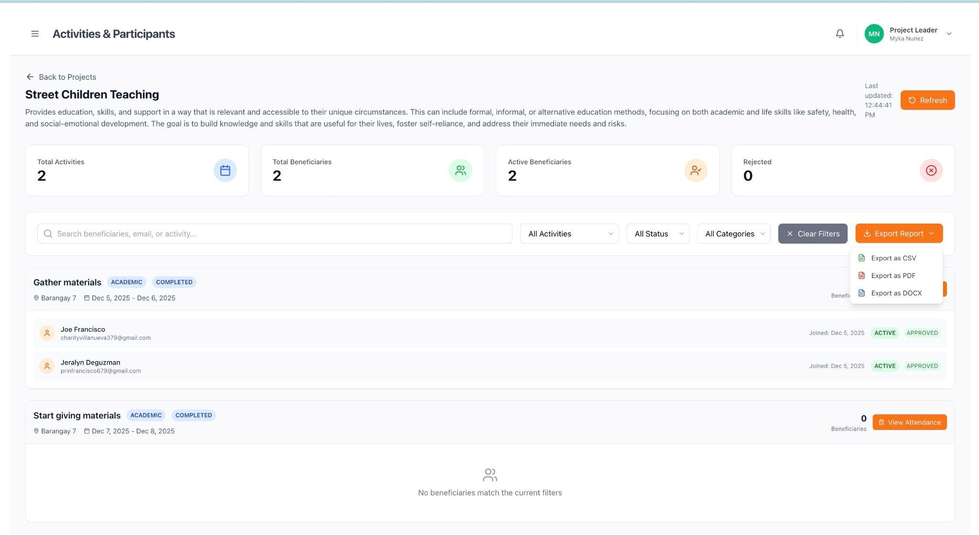

### Figure 32: EXPORT REPORTS

The reports and export module lets project leaders generate beneficiary reports grouped by project and activity, as well as activity reports with participant details. Reports can be exported in CSV, PDF, or DOCX for sharing and record-keeping. This supports analysis, documentation, and reporting needs.

### Data Dictionary

|  |  |  |  |  |
| --- | --- | --- | --- | --- |
| **Field Name** | **Data Type** | **Description** | **Allowed**  **Values** | **Example Values** |
| **Table Name: user** | |  |  |  |
| id | String  (CUID) | Unique identifier for each user | CUID format | clx123abc456def78  9 |
| firstName | String | User's first name | Alphanumeric,  1-50 characters | Joe, Myka, Gopio,  Angelyn |
| lastName | String | User's last name | Alphanumeric,  1-50 characters | Smith, Garcia, Dela  Cruz, Santos |
| email | String | User's email  address (unique) | Valid email  format | joe.smith@universi ty.edu, myka.garcia@unive  rsity.edu |
| password | String | Hashed password for  authentication | Bcrypt hash | $2b$10$... |
| interests | String[] | Array of user  interests | Array of strings | ["Sports",  "Technology"],  ["Arts", "Music"] |

|  |  |  |  |  |  |
| --- | --- | --- | --- | --- | --- |
| bio | String | User biography/descri ption | | Any text,  optional | "Passionate about community service" |
| isEmailVerifi ed | Boolean | Email verification status |  | true, false | false, true |
| role | Enum | User role system | in | PARTICIPANT,  PROJECT_LEAD  ER, ADMIN,  MODERATOR | PARTICIPANT,  PROJECT_LEADER |
| createdAt | DateTime | Account creation timestamp |  | ISO 8601  date-time | 2024-01-15T10:30:  00Z |
| updatedAt | DateTime | Last update  timestamp | | ISO 8601  date-time | 2024-01-20T14:45:  00Z |
| emailVerifica tionToken | String  (optional) | Email verification code | | 6-digit code, optional | "123456", null |
| emailVerifica tionExpires | DateTime  (optional) | Verification code expiry | | ISO 8601  date-time, optional | 2024-01-15T10:40:  00Z, null |
| specificSkills | String  (optional) | Specific skills possessed | | Any text,  optional | "Web  Development, |

|  |  |  |  |  |
| --- | --- | --- | --- | --- |
|  |  |  |  | Database Design",  null |
| activityTypes | String[] | Preferred activity types | Array of strings | ["ACADEMIC",  "VOLUNTEER"], [] |
| timeAvailabil  ity | String[] | Available time  slots | Array of strings | ["Morning",  "Afternoon"],  ["Weekend"] |
| goals | String  (optional) | User goals | Any text,  optional | "Learn new skills",  null |
| commitment  Level | String  (optional) | Commitment  level | Any text,  optional | "High", "Medium",  null |
| previousExp erience | String  (optional) | Previous experience | Any text,  optional | "5 years in  community  service", null |
| **Table: projects** | | | | |
| **Field Name** | **Data Type** | **Description** | **Allowed**  **Values** | **Example Values** |
| id | String  (CUID) | Unique identifier for each project | CUID format | clx789xyz123abc45  6 |

|  |  |  |  |  |
| --- | --- | --- | --- | --- |
| name | String | Project name | Alphanumeric,  1-200 characters | "Community Health  Outreach", "Digital  Literacy Program" |
| description | String | Project description | Any text | "A program to  improve community health awareness" |
| cost | Float  (optional) | Project cost/budget | Positive number, optional | 50000.00,  125000.50, null |
| organizerId | String (FK) | ID of user who created project | Valid user ID | clx123abc456def78  9 |
| status | Enum | Project status | DRAFT, ACTIVE,  COMPLETED,  CANCELLED | ACTIVE,  COMPLETED |
| image | String | Project image  URL | URL string or empty | "",  "[https://example.co m/project.jpg](https://example.com/project.jpg)" |
| tags | String[] | Project tags/categories | Array of strings | ["Health",  "Community"],  ["Education"] |

|  |  |  |  |  |
| --- | --- | --- | --- | --- |
| startDate | DateTime  (optional) | Project start  date | ISO 8601  date-time, optional | 2024-02-01T00:00:  00Z, null |
| endDate | DateTime  (optional) | Project end date | ISO 8601  date-time, optional | 2024-12-31T23:59:  59Z, null |
| createdAt | DateTime | Project creation timestamp | ISO 8601  date-time | 2024-01-15T10:30:  00Z |
| updatedAt | DateTime | Last update  timestamp | ISO 8601  date-time | 2024-01-20T14:45:  00Z |
| **Table: activities** | | | | |
| **Field Name** | **Data Type** | **Description** | **Allowed**  **Values** | **Example Values** |
| id | String  (CUID) | Unique identifier for  each activity | CUID format | clx456def789ghi01  2 |
| title | String | Activity title | Alphanumeric,  1-200 characters | "Health Check-up  Day", "Computer  Training Workshop" |
| description | String | Activity description | Any text | "Free health check-up for |

|  |  |  |  |  |
| --- | --- | --- | --- | --- |
|  |  |  |  | community members" |
| category | Enum | Activity category | ACADEMIC,  SOCIAL,  VOLUNTEER,  SPORTS,  CULTURAL,  TECHNICAL | VOLUNTEER,  TECHNICAL |
| startDate | DateTime | Activity start date and time | ISO 8601  date-time | 2024-03-15T09:00:  00Z |
| endDate | DateTime | Activity end date and time | ISO 8601  date-time | 2024-03-15T17:00:  00Z |
| duration | String | Activity duration | Any text | "8 hours", "Full day", "2 weeks" |
| location | String | Activity location | Any text | "Community  Center", "University  Campus, Room  101" |
| maxParticipa nts | Integer | Maximum  number of  participants | Positive integer | 50, 100, 25 |

|  |  |  |  |  |
| --- | --- | --- | --- | --- |
| currentPartic ipants | Integer | Current number  of participants | Non-negative integer | 0, 35, 100 |
| requirement  s | String[] | Activity requirements | Array of strings | ["Valid ID",  "Medical clearance"], [] |
| skills | String[] | Required skills | Array of strings | ["First Aid",  "Communication"],  [] |
| organizerId | String (FK) | ID of user who  created activity | Valid user ID | clx123abc456def78  9 |
| projectId | String (FK, optional) | ID of parent  project | Valid project ID or null | clx789xyz123abc45  6, null |
| image | String | Activity image  URL | URL string or empty | "",  "[https://example.co m/activity.jpg](https://example.com/activity.jpg)" |
| status | Enum | Activity status | DRAFT, ACTIVE,  COMPLETED,  CANCELLED | ACTIVE,  COMPLETED |
| isRecurring | Boolean | Whether activity repeats | true, false | false, true |
| recurringPat tern | Enum  (optional) | Recurring pattern | DAILY, WEEKLY,  MONTHLY, null | WEEKLY, null |

|  |  |  |  |  |
| --- | --- | --- | --- | --- |
| tags | String[] | Activity tags | Array of strings | ["Health", "Free"],  ["Training"] |
| averageRatin  g | Float | Average rating from reviews | 0.0 to 5.0 | 0.0, 4.5, 3.8 |
| ratingCount | Integer | Number of  ratings received | Non-negative integer | 0, 15, 42 |
| createdAt | DateTime | Activity creation timestamp | ISO 8601  date-time | 2024-01-15T10:30:  00Z |
| updatedAt | DateTime | Last update  timestamp | ISO 8601  date-time | 2024-01-20T14:45:  00Z |
| **Table Name: activity_reviews** | | | | |
| **Field Name** | **Data Type** | **Description** | **Allowed**  **Values** | **Example Values** |
| id | String  (CUID) | Unique identifier for review | CUID format | clx777ggg888hhh99  9 |
| activityId | String (FK) | ID of the activity being reviewed | Valid activity ID | clx456def789ghi01  2 |
| userId | String (FK) | ID of user who  wrote the  review | Valid user ID | clx123abc456def78  9 |

|  |  |  |  |  |
| --- | --- | --- | --- | --- |
| rating | Integer | Rating given to  activity | 1–5 | 4 |
| comment | String  (optional) | Review comment text | Any text,  optional | "Great activity!" |
| createdAt | DateTime | Review creation timestamp | ISO 8601  date-time | 2024-03-20T14:30:  00Z |
| **Table: activity_applications** | | | | |
| **Field Name** | **Data Type** | **Description** | **Allowed**  **Values** | **Example Values** |
| id | String  (CUID) | Unique identifier for application | CUID format | clx222bbb333ccc44  4 |
| activityId | String (FK) | ID of the activity applied to | Valid activity ID | clx456def789ghi01  2 |
| userId | String (FK) | ID of the  applicant user | Valid user ID | clx123abc456def78  9 |
| appliedAt | DateTime | When application was submitted | ISO 8601  date-time | 2024-01-20T14:30:  00Z |
| status | Enum | Application status | PENDING,  APPROVED, | PENDING,  APPROVED |

|  |  |  |  |  |
| --- | --- | --- | --- | --- |
|  |  |  | REJECTED,  SAVED |  |
| message | String  (optional) | Application message/notes | Any text,  optional | "I'm interested in volunteering", null |
| **Table: announcements** | | | | |
| **Field Name** | **Data Type** | **Description** | **Allowed**  **Values** | **Example Values** |
| id | String  (CUID) | Unique identifier for announcement | CUID format | clx333ccc444ddd55  5 |
| title | String | Announcement  title | Alphanumeric,  1-200 characters | "Important  Update", "New  Activity Available" |
| description | String | Announcement content | Any text | "Please be  informed of the  schedule change" |
| category | Enum | Announcement category | ACADEMIC,  CAMPUS_LIFE,  CAREER,  TECHNICAL,  SAFETY,  GENERAL | GENERAL,  ACADEMIC |

|  |  |  |  |  |
| --- | --- | --- | --- | --- |
| authorId | String (FK) | ID of user who created announcement | Valid user ID | clx123abc456def78  9 |
| authorName | String | Author's display name | Any text | "Joe Smith", "Myka  Garcia" |
| location | String | Related location | Any text | "UniHub Campus",  "Community  Center" |
| targetAudien ce | Enum | Target audience | ALL,  PARTICIPANTS,  FACULTY,  STAFF,  SPECIFIC_MAJ  OR,  SPECIFIC_YEAR | ALL, PARTICIPANTS |
| targetDetails | JSON  (optional) | Target audience  details | JSON object,  optional | {"major":  "Computer  Science"}, null |
| attachments | JSON[] | Array of  attachments | Array of JSON objects | [], [{"name":  "file.pdf", "url":  "..."}] |

|  |  |  |  |  |
| --- | --- | --- | --- | --- |
| image | String | Announcement image URL | URL string or empty | "",  "[https://example.co m/announcement.j pg](https://example.com/announcement.jpg)" |
| status | Enum | Publication status | DRAFT,  PUBLISHED,  ARCHIVED | PUBLISHED, DRAFT |
| publishDate | DateTime | When announcement was published | ISO 8601  date-time | 2024-01-15T10:30:  00Z |
| expiryDate | DateTime  (optional) | Announcement  expiry date | ISO 8601  date-time, optional | 2024-12-31T23:59:  59Z, null |
| isPinned | Boolean | Whether announcement  is pinned | true, false | false, true |
| tags | String[] | Announcement  tags | Array of strings | ["Important"],  ["Update"] |
| readCount | Integer | Number of  times read | Non-negative integer | 0, 150, 342 |
| likeCount | Integer | Number of likes | Non-negative integer | 0, 25, 89 |

|  |  |  |  |  |  |
| --- | --- | --- | --- | --- | --- |
| contactInfo | JSON  (optional) | Contact information | | JSON object,  optional | {"email":  "joe.myka@gmail.c om"}, null |
| relatedActivi ties | String[] | Related activity  IDs | | Array of  activity IDs | ["clx456def789ghi0  12"], [] |
| createdAt | DateTime | Creation timestamp | | ISO 8601  date-time | 2024-01-15T10:30:  00Z |
| updatedAt | DateTime | Last update  timestamp | | ISO 8601  date-time | 2024-01-20T14:45:  00Z |
| **Table: surveys** | | | | | |
| **Field Name** | **Data Type** | **Description** | | **Allowed**  **Values** | **Example Values** |
| id | String  (CUID) | Unique  identifier survey | for | CUID format | clx444ddd555eee6  66 |
| title | String | Survey title |  | Alphanumeric,  1-200 characters | "Activity  Satisfaction  Survey",  "Community  Feedback" |
| description | String  (optional) | Survey description |  | Any text,  optional | "Please provide  your feedback", null |

|  |  |  |  |  |
| --- | --- | --- | --- | --- |
| activityId | String (FK, optional) | ID of related  activity | Valid activity ID or null | clx456def789ghi01  2, null |
| createdBy | String (FK) | ID of user who created survey | Valid user ID | clx123abc456def78  9 |
| status | Enum | Survey status | DRAFT, ACTIVE,  CLOSED,  ARCHIVED | ACTIVE, DRAFT |
| startDate | DateTime  (optional) | Survey start date | ISO 8601  date-time, optional | 2024-03-01T00:00:  00Z, null |
| endDate | DateTime  (optional) | Survey end date | ISO 8601  date-time, optional | 2024-03-31T23:59:  59Z, null |
| isAnonymou  s | Boolean | Whether responses are anonymous | true, false | false, true |
| allowMultipl e | Boolean | Allow multiple responses per  user | true, false | false, true |
| autoSendEm  ailOnActivity  End | Boolean | Auto-send email when activity ends | true, false | false, true |

|  |  |  |  |  |  |
| --- | --- | --- | --- | --- | --- |
| targetType | Enum | Target audience type | | ALL_USERS,  ALL_PARTICIPA  NTS,  ALL_PROJECT_  LEADERS,  ACTIVITY_PART ICIPANTS,  ACTIVITY_APPL  ICANTS,  SPECIFIC_USER  S | ALL_PARTICIPANTS,  ACTIVITY_PARTICIP  ANTS |
| targetIds | String[] | Target  (activity user IDs) | IDs  IDs, | Array of strings | ["clx456def789ghi0  12"], [] |
| createdAt | DateTime | Creation timestamp |  | ISO 8601  date-time | 2024-01-15T10:30:  00Z |
| updatedAt | DateTime | Last update  timestamp | | ISO 8601  date-time | 2024-01-20T14:45:  00Z |
| **Table: attendance_records** | | | | | |
| **Field Name** | **Data Type** | **Description** | | **Allowed**  **Values** | **Example Values** |

|  |  |  |  |  |  |
| --- | --- | --- | --- | --- | --- |
| id | String  (CUID) | Unique identifier for attendance record | | CUID format | clx555eee666fff777 |
| activityId | String (FK) | ID of the activity | | Valid activity ID | clx456def789ghi01  2 |
| participantId | String | ID of  ActivityParticipa nt | | Valid participant ID | clx111aaa222bbb33  3 |
| date | DateTime | Date attendance (date only) | of | ISO 8601 date | 2024-03-15T00:00:  00Z |
| morningStat us | Enum | Morning attendance status |  | PRESENT,  ABSENT, LATE,  NOT_MARKED | PRESENT, ABSENT |
| afternoonSt atus | Enum | Afternoon attendance status |  | PRESENT,  ABSENT, LATE,  NOT_MARKED | PRESENT,  NOT_MARKED |
| markedBy | String (FK, optional) | ID of user who marked attendance | | Valid user ID or null | clx123abc456def78  9, null |

|  |  |  |  |  |
| --- | --- | --- | --- | --- |
| createdAt | DateTime | Creation timestamp | ISO 8601  date-time | 2024-03-15T09:00:  00Z |
| updatedAt | DateTime | Last update  timestamp | ISO 8601  date-time | 2024-03-15T17:00:  00Z |
| **Table: email_campaigns** | | | | |
| **Field Name** | **Data Type** | **Description** | **Allowed**  **Values** | **Example Values** |
| id | String  (CUID) | Unique identifier for email campaign | CUID format | clx666fff777ggg888 |
| title | String | Campaign title | Alphanumeric,  1-200 characters | "Activity  Reminder",  "Important Update" |
| subject | String | Email subject  line | Any text | "Reminder: Activity  Tomorrow", "New  Announcement" |
| content | String | HTML email  content | HTML string | "Dear participants..." |
| template | Enum  (optional) | Email template type | ACTIVITY_REMI  NDER,  APPLICATION_  UPDATE, | ACTIVITY_REMINDE  R, null |

|  |  |  |  |  |
| --- | --- | --- | --- | --- |
|  |  |  | ANNOUNCEME  NT, WELCOME,  CUSTOM, null |  |
| targetType | Enum | Target audience type | ALL_USERS,  ALL_PARTICIPA  NTS,  ALL_PROJECT_  LEADERS,  ACTIVITY_PART ICIPANTS,  ACTIVITY_APPL  ICANTS,  SPECIFIC_USER  S, ROLE_BASED | ACTIVITY_PARTICIP  ANTS,  ALL_PARTICIPANTS |
| targetIds | String[] | Target IDs | Array of strings | ["clx456def789ghi0  12"], [] |
| status | Enum | Campaign status | DRAFT,  SCHEDULED,  SENDING,  SENT, FAILED,  CANCELLED | DRAFT, SCHEDULED,  SENT |

|  |  |  |  |  |
| --- | --- | --- | --- | --- |
| scheduledAt | DateTime  (optional) | Scheduled send time | ISO 8601  date-time, optional | 2024-03-20T10:00:  00Z, null |
| sentAt | DateTime  (optional) | When campaign was sent | ISO 8601  date-time, optional | 2024-03-20T10:05:  00Z, null |
| createdBy | String (FK) | ID of user who created campaign | Valid user ID | clx123abc456def78  9 |
| activityId | String (FK, optional) | ID of related  activity | Valid activity ID or null | clx456def789ghi01  2, null |
| createdAt | DateTime | Creation timestamp | ISO 8601  date-time | 2024-01-15T10:30:  00Z |
| updatedAt | DateTime | Last update  timestamp | ISO 8601  date-time | 2024-01-20T14:45:  00Z |
| **Table Name: announcement_reads** | | | | |
| **Field Name** | **Data Type** | **Description** | **Allowed**  **Values** | **Example Values** |
| id | String  (CUID) | Unique identifier for read record | CUID format | clx888hhh999iii000 |

|  |  |  |  |  |
| --- | --- | --- | --- | --- |
| announcem  entId | String (FK) | ID of the  announcement | Valid  announcement  ID | clx333ccc444ddd55  5 |
| userId | String (FK) | ID of user who  read the  announcement | Valid user ID | clx123abc456def78  9 |
| readAt | DateTime | When announcement was read | ISO 8601  date-time | 2024-01-16T09:15:  00Z |
| **Table Name: announcement_likes** | | | | |
| **Field Name** | **Data Type** | **Description** | **Allowed**  **Values** | **Example Values** |
| id | String  (CUID) | Unique  identifier for like record | CUID format | clx999iii000jjj111 |
| announcem  entId | String (FK) | ID of  announcement | Valid  announcement  ID | clx333ccc444ddd55  5 |
| userId | String (FK) | ID of user who  liked | Valid user ID | clx123abc456def78  9 |

|  |  |  |  |  |
| --- | --- | --- | --- | --- |
| likedAt | DateTime | When announcement  was liked | ISO 8601  date-time | 2024-01-16T10:20:  00Z |
| **Table Name: announcement_comments** | | | | |
| **Field Name** | **Data Type** | **Description** | **Allowed**  **Values** | **Example Values** |
| id | String  (CUID) | Unique identifier for comment | CUID format | clx000jjj111kkk222 |
| announcem  entId | String (FK) | ID of the  announcement | Valid  announcement  ID | clx333ccc444ddd55  5 |
| userId | String (FK) | ID of user who commented | Valid user ID | clx123abc456def78  9 |
| content | String | Comment  content | Any text | "Thanks for the  update!" |
| createdAt | DateTime | Comment  creation timestamp | ISO 8601  date-time | 2024-01-16T11:00:  00Z |
| isEdited | Boolean | Whether comment was  edited | true, false | FALSE |

|  |  |  |  |  |
| --- | --- | --- | --- | --- |
| editedAt | DateTime  (optional) | When comment  was edited | ISO 8601,  optional | 2024-01-16T12:00:  00Z |
| **Table Name: notifications** | | | | |
| **Field Name** | **Data Type** | **Description** | **Allowed**  **Values** | **Example Values** |
| id | String  (CUID) | Unique  identifier | CUID format | clx111kkk222lll333 |
| userId | String (FK) | ID of receiving user | Valid user ID | clx123abc456def78  9 |
| type | Enum | Notification type | APPLICATION_  APPROVED,  APPLICATION_  REJECTED,  NEW_APPLICA  TION,  ACTIVITY_UPD  ATED,  ACTIVITY_COM PLETED,  ANNOUNCEME  NT_PUBLISHED  , | NEW_APPLICATION |

|  |  |  |  |  |
| --- | --- | --- | --- | --- |
|  |  |  | ATTENDANCE_  REMINDER,  SYSTEM_ANNO  UNCEMENT |  |
| title | String | Notification title | Any text | "New Application  Received" |
| message | String | Notification message | Any text | "You have a new application to  review" |
| link | String  (optional) | Link to related page | URL string,  optional | "/projectleader/app rovals" |
| isRead | Boolean | Whether read | true, false | FALSE |
| readAt | DateTime  (optional) | When read | ISO 8601,  optional | 2024-01-17T08:00:  00Z |
| metadata | JSON  (optional) | Additional data | JSON object,  optional | {"activityId":  "clx456def789ghi01  2"} |
| createdAt | DateTime | When created | ISO 8601  date-time | 2024-01-16T15:30:  00Z |
| **Table Name: email_campaign_recipients** | | | | |
| **Field Name** | **Data Type** | **Description** | **Allowed**  **Values** | **Example Values** |

|  |  |  |  |  |
| --- | --- | --- | --- | --- |
| id | String  (CUID) | Unique  identifier | CUID format | clx222lll333mmm4  44 |
| campaignId | String (FK) | Email campaign  ID | Valid campaign  ID | clx666fff777ggg888 |
| userId | String (FK) | Recipient user ID | Valid user ID | clx123abc456def78  9 |
| email | String | Email address | Valid email  format | joe.myka@gmail.co m |
| status | Enum | Delivery status | PENDING,  SENT,  DELIVERED,  OPENED,  CLICKED,  FAILED,  BOUNCED | SENT |
| sentAt | DateTime  (optional) | When sent | ISO 8601,  optional | 2024-03-20T10:05:  00Z |
| openedAt | DateTime  (optional) | When opened | ISO 8601,  optional | 2024-03-20T10:30:  00Z |
| clickedAt | DateTime  (optional) | When clicked | ISO 8601,  optional | 2024-03-20T11:00:  00Z |

|  |  |  |  |  |
| --- | --- | --- | --- | --- |
| errorMessag  e | String  (optional) | Error reason | Any text,  optional | "Invalid email  address" |
| **Table Name: survey_responses** | | |  |  |
| **Field Name** | **Data Type** | **Description** | **Allowed**  **Values** | **Example Values** |
| id | String  (CUID) | Unique response  ID | CUID format | clx444nnn555ooo6  66 |
| surveyId | String (FK) | Survey ID | Valid survey ID | clx444ddd555eee6  66 |
| userId | String (FK, optional) | Responding user  ID | Valid user ID or null | clx123abc456def78  9 |
| submittedAt | DateTime | Submission timestamp | ISO 8601 | 2024-03-15T14:00:  00Z |
| **Table Name: survey_answers** | | |  |  |
| **Field Name** | **Data Type** | **Description** | **Allowed**  **Values** | **Example Values** |
| id | String  (CUID) | Unique answer  ID | CUID format | clx555ooo666ppp7  77 |
| responseId | String (FK) | Survey response  ID | Valid response  ID | clx444nnn555ooo6  66 |
| questionId | String (FK) | Question ID | Valid question  ID | clx333mmm444nnn  555 |
| answer | JSON | Answer value | Any JSON type  (string,  number, array, object) | "Very satisfied", 5,  ["Option 1"] |
| createdAt | DateTime | Creation timestamp | ISO 8601 | 2024-03-15T14:00:  00Z |

**Table 2:** **DATA DICTIONARY**

# TESTING OF THE SYSTEM

|  |  |  |  |  |
| --- | --- | --- | --- | --- |
| Modules | Test Items | Expected Result | Remarks | |
| Passed | Failed |
| Authentication | Login | Enter valid email and password to log in successfully. | ✔ |  |
| Login | Display error message for invalid credentials. | ✔ |  |
| Register | Create new account with email, password, and role selection. | ✔ |  |
| Register | Validate email format and prevent duplicate emails. | ✔ |  |
| Email Verification | Send 6-digit verification code to user's email. | ✔ |  |
| Email Verification | Verify account with correct 6-digit code within 10 minutes. | ✔ |  |
| User Management | Profile Update | Update user profile information (name, bio, interests). | ✔ |  |
| Onboarding | Complete onboarding form with skills, availability, and goals. | ✔ |  |
| Projects | Create Project | Project leader creates new project with name, description, and cost. | ✔ |  |
| View Projects | Display all projects with status, dates and others | ✔ |  |

|  |  |  |  |  |
| --- | --- | --- | --- | --- |
|  | View Projects | Filter projects by status  (DRAFT, ACTIVE, COMPLETED, CANCELLED). | ✔ |  |
| Update Project | Project leader updates project details (name, description, status). | ✔ |  |
| Delete Project | Project leader deletes project (cascades to activities). | ✔ |  |
| Activities | Create Activity | Project leader creates activity with title, category, dates, and location. | ✔ |  |
| View Activities | Filter activities by category and status. | ✔ |  |
| View Activity  Details | Display complete activity information including requirements and skills. | ✔ |  |
| Update Activity | Project leader updates activity details. | ✔ |  |
| Delete Activity | Project leader deletes activity. | ✔ |  |
| Join Activity | Participant joins activity d | ✔ |  |
| Apply to Activity | Participant submits application to join activity. | ✔ |  |
| View  Applications | Project leader views pending applications for their activities. | ✔ |  |
| Approve  Application | Project leader approves participant application. | ✔ |  |
| Reject  Application | Project leader rejects participant application. | ✔ |  |

|  |  |  |  |  |
| --- | --- | --- | --- | --- |
|  | Save Activity | Participant saves activity for later viewing. | ✔ |  |
| Announcements | Create  Announcement | Project leader creates announcement with  title, description, and category. | ✔ |  |
| View  Announcements | Display all  announcements with category, and publish date. | ✔ |  |
| View  Announcements | Filter announcements by category. | ✔ |  |
| Comment on  Announcement | Participant and project leader add comments to announcements. | ✔ |  |
| Like  Announcement | Participant and project leader like announcements. | ✔ |  |
| Pin  Announcement | Project leader pins important announcements. | ✔ |  |
| Surveys | Create Survey | Project leader creates survey with questions and target audience. | ✔ |  |
| Schedule Survey | Project leader schedules survey to auto-send when activity ends. | ✔ |  |
| View Surveys | Display all surveys with status and target information. | ✔ |  |
| Respond to  Survey | Participant responds to survey questions. | ✔ |  |
| View Survey  Results | Project leader views survey responses and analytics. | ✔ |  |

|  |  |  |  |  |
| --- | --- | --- | --- | --- |
| Attendance | Mark Attendance | Project leader marks attendance | ✔ |  |
| View Attendance  Records | Project leader views attendance records by date and participant. | ✔ |  |
| Export  Attendance | Project leader exports attendance data in CSV, PDF, or DOCX format. | ✔ |  |
| Email Campaigns | Create Email  Campaign | Project leader creates email campaign with subject and content. | ✔ |  |
| Schedule Email  Campaign | Project leader schedules email to send at specific time. | ✔ |  |
| Send Email  Campaign | System sends email to target audience. | ✔ |  |
| View Campaign  Status | Project leader views email campaign delivery status. | ✔ |  |
| Admin | View All  Activities | Admin views all activities grouped by project. | ✔ |  |
| View All  Participants | Admin views all participants grouped by project and activity. | ✔ |  |
| Export Activities | Admin exports all activities data in CSV,  PDF, or DOCX format. | ✔ |  |
| Export  Participants | Admin exports all participants data in CSV, PDF, or DOCX format. | ✔ |  |
| Export Activity  Participants | Admin exports participants for specific activity. | ✔ |  |
| Import Users | Admin imports users from CSV file. | ✔ |  |
| View All Projects | Admin views all projects | ✔ |  |

|  |  |  |  |  |
| --- | --- | --- | --- | --- |
|  |  | in the system. |  |  |
| View All Users | Admin views all users with their roles and status. | ✔ |  |
| Notifications | View  Notifications | User views all notifications in dashboard. | ✔ |  |
| Mark as Read | User marks notification as read. | ✔ |  |
| Application  Approved | Participant receives notification when application is approved. | ✔ |  |
| Application  Rejected | Participant receives notification when application is rejected. | ✔ |  |
| New Application | Project leader receives notification when new application is submitted. | ✔ |  |
| Activity Updated | Participant receives notification when activity is updated. | ✔ |  |
| Announcement  Published | User receives notification when new announcement is published. | ✔ |  |
| Dashboard | Participant  Dashboard | Participant views upcoming activities, announcements, and recommendations. | ✔ |  |
| Project Leader  Dashboard | Project leader views activity statistics, applications, and attendance. | ✔ |  |
| Admin  Dashboard | Admin views system overview and statistics. | ✔ |  |
| Search | Search Activities | User searches activities | ✔ |  |
|  |  | by title, and category. |  |  |
| Search Projects | User searches projects by name or description. | ✔ |  |
| Reports | Beneficiary  Report | Project leader generates beneficiary report grouped by project and activity. | ✔ |  |
| Activity Report | Project leader generates activity report with participant details. | ✔ |  |
| Export Reports | Project leader exports reports (CSV, PDF, docx) | ✔ |  |

**Table 3. USER ACCEPTANCE TEST RESULTS**

Table 3 outlines the results of the user acceptance testing conducted to validate the system's functionality and ensure it meets user expectations. It includes key system features such as authentication, project and activity management, participant registration, application processing, announcement management, survey deployment, attendance tracking, email campaigns, administrative functions, and reporting capabilities. Each function was tested against its expected outcomes, recording both success and failure scenarios. As indicated, all functions have been successfully validated, confirming the system's reliability and user satisfaction across all user roles (Participant, Project Leader, and Admin).

# USABILITY AND SATISFACTION OF SYSTEM USERS

The proponents utilized the USE (Usefulness, Satisfaction, and Ease of Use) questionnaire by Lund, A.M. (2001) to evaluate the feedback and insights of respondents regarding the developed **UniHub: University Community Extension Hub with Client Satisfaction Survey**. The questionnaire was intended for participants, project leaders, and administrators, providing valuable perspectives based on their expertise and needs in managing and participating in campus activities and community extension projects. USEFULNESS: Evaluates how effectively the system supports essential tasks and fulfills user needs. EASE OF USE:

Assesses whether the system is intuitive and straightforward, enabling users to perform tasks with minimal effort. EASE OF LEARNING: Measures how quickly users can understand and begin using the system with little or no training. SATISFACTION: Explores the overall user experience, focusing on how content and pleased users feel while interacting with the system.

|  |  |  |
| --- | --- | --- |
| **Weigh/Scale** | **Mean range** | **Verbal interpretation** |
| 5 | 4.51-5.00 | STRONGLY AGREE |
| 4 | 3.51-4.50 | AGREE |
| 3 | 2.51-3.50 | NEUTRAL |
| 2 | 1.51-2.50 | DISAGREE |
| 1 | 1.00-1.50 | STRONGLY DISAGREE |

# Table 4: NUMERIC RATING INTERPRETATION TABLE

This table assigns verbal interpretations to numerical score ranges, simplifying the analysis of survey results. For instance, a mean score between 4.51 and 5.00 is labeled "Strongly Agree," reflecting very positive feedback, while a score from 1.00 to 1.50 is categorized as "Strongly Disagree," indicating dissatisfaction. This structured approach ensures consistent interpretation of findings, accurately reflecting user experiences and perceptions. It helps evaluate various aspects such as effectiveness, ease of use, and overall satisfaction.

|  |  |  |  |  |  |  |  |  |  |  |  |  |  |  |
| --- | --- | --- | --- | --- | --- | --- | --- | --- | --- | --- | --- | --- | --- | --- |
| **USEFULNESS** | **Stron gly**  **Agree** | | **Agre e** | | **Neutr al** | **Disagr ee** | **Strongl y**  **Disagre e** | | **TM** | **TW** | | **Verbal**  **Interpretati on** | | |
| **5** | | **4** | | **3** | **2** | **1** | |
| It helps me  1be more  effective. | 16 | | 4 | |  |  |  | | 20 | 4.8 | | STRONGLY AGREE | | |
| It helps me  2be more productive. | 15 | | 3 | | 2 |  |  | | 20 | 4.65 | | STRONGLY AGREE | | |
| 3It is useful. | 17 | | 2 | | 1 |  |  | | 20 | 4.8 | | STRONGLY AGREE | | |
| It gives me  4more control over the | 18 | | 2 | |  |  |  | | 20 | 4.9 | | STRONGLY AGREE | | |
| activities in my life | | |  | |  | | | |  | | |  | |  |
| It makes the  5things I want to accomplish easier to get done. | | | 18 | | 2 | | | | 20 | | | 4.9 | | STRONGLY AGREE |
| It saves me  6time when I use it | | | 19 | | 1 | | | | 20 | | | 4.95 | | STRONGLY AGREE |
| It meets my 7needs. | | | 17 | | 2 1 | | | | 20 | | | 4.8 | | STRONGLY AGREE |
| It does  8everything I would expect  it to do | | | 16 | | 2 2 | | | | 20 | | | 4.7 | | STRONGLY AGREE |
| **Weighted Mean** | | |  | |  | | | | **Average** | | | 4.81 | | STRONGLY AGREE |

## Table 5: USEFULNESS RESPONSES

Table 5 presents the observations on respondents' ratings regarding the system's usefulness. With an overall average weighted mean of 4.81, interpreted as "Strongly Agree," the responses reflect a highly positive perception of the system. The majority of respondents consistently selected the highest scale (5), demonstrating strong agreement with statements about the system’s effectiveness in managing attendance and the system

|  |  |  |  |  |  |  |  |  |  |
| --- | --- | --- | --- | --- | --- | --- | --- | --- | --- |
| **EASE OF USE** | | **Strongl y**  **Agree** | **Agre e** | **Neutr al** | **Disagr ee** | **Strongl y**  **Disagr ee** | **TM** | **T**  **W** | **Verbal**  **Interpretat ion** |
|  |  |  |  |  |
|  | | **5** | **4** | **3** | **2** | **1** |  |  |  |
| 9 | It is easy to use. | 19 | 1 |  |  |  | 20 | 4.9  5 | STRONGLY AGREE |

|  |  |  |  |  |  |  |
| --- | --- | --- | --- | --- | --- | --- |
| It is simple 10to use. | 18 |  | 2 | 20 | 4.8 | STRONGLY AGREE |
| It is user 11friendly. | 16 | 2 | 2 | 20 | 4.7 | STRONGLY AGREE |
| It requires  12the fewest steps possible to accomplish what I want to do with it. | 15 | 3 | 2 | 20 | 4.6  5 | STRONGLY AGREE |
| It is flexible. 13 | 15 | 3 | 2 | 20 | 4.6  5 | STRONGLY AGREE |
| Using it is 14effortless | 15 | 2 | 3 | 20 | 4.6 | STRONGLY AGREE |
| I can use it  15without  written instruction. | 17 | 2 | 1 | 20 | 4.8 | STRONGLY AGREE |
| I don't  16notice any inconsistenc ies as I use it. | 12 | 6 | 2 | 20 | 4.5 | AGREE |
| Both  17occasional and regular users would like it. | 16 | 4 |  | 20 | 4.8 | STRONGLY AGREE |
| I can  18recover from mistakes quickly and easily.. | 15 | 1 | 4 | 20 | 4.5  5 | STRONGLY AGREE |
| I can use it  19 successfully every time. | 16 | 2 | 2 |  | 20 | 4.7  STRONGLY AGREE |
|  |  |  |  |  | 4.7 | STRONGLY AGREE |

### Average Weighted Mean

# Table 6: EASE OF USE RESPONSE

Table 6 presents the survey data on the ease of use of UniHub. Respondents provided highly positive feedback, resulting in an average weighted mean of 4.7, which is interpreted as STRONGLY AGREE. Participants highlighted the system's straightforward navigation and user-friendly interface, making it accessible to both beginners and experienced users. They appreciated its intuitive design, which minimizes the steps required to browse activities, submit applications, and manage projects. The highest-rated statement emphasized that users could operate the system without consulting a manual, showcasing its simplicity and practicality.

The system's consistency and reliability were also noted, though slightly lower ratings for operational consistency suggest minor improvements could enhance user confidence further. Overall, the respondents found the system highly effective in simplifying their tasks, ensuring ease and convenience in their participation in campus activities and management of community extension projects.

|  |  |  |  |  |  |  |  |  |  |
| --- | --- | --- | --- | --- | --- | --- | --- | --- | --- |
| **EASE OF**  **LEARNING** | | **Strong ly**  **Agree** | **Agre e** | **Neutr al** | **Disagre e** | **Strongl y**  **Disagre e** | **TM** | **TW** | **Verbal**  **Interpretat ion** |
| **5** | **4** | **3** | **2** | **1** |
| 20 | I learned to use Unihub quickly. | 15 | 3 | 2 |  |  | 20 | 4.5  5 | STRONGLY AGREE |
| 21 | I easily  remember how to use it. | 14 | 5 | 1 |  |  | 20 | 4.6  5 | STRONGLY AGREE |
| 22 | It is easy to learn to use it. | 17 | 3 |  |  |  | 20 | 4.8  5 | STRONGLY AGREE |
| 23 | I quickly  became  skillful with it. | 13 | 5 | 2 |  |  | 20 | 4.5  5 | STRONGLY AGREE |
| **Average**  **Weighted Mean** | | | | | | | |  |  |

# Table 7: EASE OF LEARNING RESPONSE

Table 7 highlights the respondents' feedback on how easily they learned to use UniHub, with an average weighted mean of 4.55, interpreted as STRONGLY AGREE. Most users agreed that the system was intuitive, easy to remember, and quick to master. The highest-rated statement emphasized the short time required to become proficient, showcasing the system's ability to cater to a wide range of users without extensive training. This indicates that UniHub offers a straightforward and accessible experience, particularly beneficial for participants who are new to the platform and project leaders managing their first extension projects. The clear navigation structure and logical workflow design contributed to users' ability to quickly understand and effectively utilize the system's features.

|  |  |  |  |  |  |  |  |  |  |
| --- | --- | --- | --- | --- | --- | --- | --- | --- | --- |
| **STAISFACTION** | | **Strongl y Agree** | **Agre e** | **Neutr al** | **Disagre e** | **Strongly Disagree** | **TM** | **TW** | **Verbal**  **Interpretati on** |
| **5** | **4** | **3** | **2** | **1** |
| 24 | I am satisfied with Unihub's performanc  e. | 15 | 3 | 2 |  |  | 20 | 4.6  5 | STRONGLY AGREE |
| 25 | I would  recommen  d Unihub to project leaders and participants  . | 20 |  |  |  |  | 20 | 5.0 | STRONGLY AGREE |
| 26 | Using the Unihub is fun to use. | 18 | 1 | 1 |  |  | 20 | 4.6  4.8  5 | STRONGLY AGREE |
| 27 | It works the way I want it to work. | 14 | 6 |  |  |  | 20 | 4.7  0 | STRONGLY AGREE |
| 28 | It is wonderful. | 18 |  | 2 |  |  | 20 | 4.9 | STRONGLY AGREE |
| 29 | I feel I need to have it. | 19 |  | 1 |  |  | 20 | 4.9 5 | STRONGLY AGREE |
| 30 | Unihub is pleasant to use. | 16 | 4 |  |  |  | 20 | 4.8 | STRONGLY AGREE |
| **Average**  **Weighted Mean** | | | | | | | | 4.8 4 |  |

## Table 8: SATISFACTION RESPONSES

Table 8 reflects respondents' satisfaction with UniHub, with an average weighted mean of 4.84, interpreted as STRONGLY AGREE. Most participants expressed positive feedback, noting that the system met their expectations and performed reliably. Users found it enjoyable and easy to use, with many agreeing it was a valuable addition to their campus and community engagement activities. The results also indicate that respondents would recommend UniHub to other participants and project leaders, demonstrating their approval of its overall functionality. Participants particularly appreciated the system's ability to streamline activity discovery, application processes, and project management, while project leaders valued the comprehensive tools for managing participants, tracking attendance, and generating reports. The platform's role in facilitating effective communication through announcements and notifications further contributed to high satisfaction levels among all user groups.

### 4 CONCLUSION

UniHub: University Community Extension Hub with Client Satisfaction Survey successfully addressed common challenges in managing campus activities and community extension projects through digitalization. The system was designed to (1) allow Project Leaders to create and manage extension project profiles, (2) allow participants to view and register as beneficiaries in extension projects, and enable administrators to generate and manage a list of beneficiaries for each project, (3) implement an email blast feature that enables the sending of announcements, reminders, and activity-related updates to specific groups of beneficiaries or registered users, (4) integrate a client satisfaction survey tool that collects structured participant feedback, supports real-time analysis, and helps organizers improve future community extension efforts, and (5) provide attendance tracking of beneficiaries during project activities.

System testing and survey results confirmed that all objectives were met, demonstrating its effectiveness and reliability. The system integrates a modern web application built with React and Vite for the frontend, Node.js and Express.js for the backend, and PostgreSQL database managed through Prisma ORM. A comprehensive dashboard interface allows users to manage activities, track attendance, schedule surveys, send email campaigns, and generate reports. The platform supports role-based access control, ensuring appropriate functionality for participants, project leaders, and administrators. User testing confirmed the system consistently handles activity applications, manages participant attendance, generates comprehensive reports, and delivers timely notifications.

Multiple tests validated its accuracy in data management, export functionality, and user interactions, ensuring all functions worked as intended. Survey results showed high user satisfaction, with ratings of 4.81 for usefulness, 4.7 for ease of use, 4.55 for ease of learning, and 4.84 for overall satisfaction. With its intuitive design and reliable performance, UniHub is a valuable tool for both new and experienced users in managing campus activities and community extension projects. Future improvements could focus on enhancing mobile responsiveness, adding advanced analytics and reporting features, integrating real-time collaboration tools, and expanding notification capabilities to further optimize user experience and system functionality. Overall, UniHub successfully combines digitalization with user-centric design, making activity management, participation tracking, and community engagement easier and more efficient for universities and their extension programs.

**APPENDICES**

# BIBLIOGRAPHY

Aquino, J., Alarcón, R., Guevara, L., Bravo-Jaico, J., et al. (2025). Impact of digital transformation: Assessing the knowledge and adoption of disruptive technologies in a higher

education institution. *Frontiers in Computer Science*. Available from.

<https://doi.org/10.3389/fcomp.2025.1611952>

Banawa, J. A., & De Jesus, M. J. T. (2025). *Client Satisfaction Analysis for Delivery of Services with Natural Language Processing and Decision Support System.* *International Journal of Research and Innovation in Social Science*, *9*(5), 3733–3745. Available from. <https://doi.org/10.47772/IJRISS.2025.905000283>

Ching, G. E. M., & Orozco, M. M. (2025). *Local community e-services: An online application*

*for streamlining community transactions and services.* Available from.

<https://doi.org/10.5281/zenodo.15206165>

Esteban, A. P. (2025). Assessing the impact of community extension program in a Philippines state university: A comprehensive framework and analysis. *Edelweiss Applied Science and*

*Technology*, *9*(2), 1659-1675. Available from. <https://doi.org/10.55214/25768484.v9i2.4853>

J. E. E. Goh, M. L. I. Goh, L. P. Abad, M. C. F. Raguro, T. J. S. Awat and K. Cyndee Marqueses,

"Web-Based Clinic Management System with Patient Satisfaction Analysis Using Sentiment Analysis," *2025 16th International Conference on E-Education, E-Business, E-Management*

*and E-Learning (IC4e)*, Tokyo, Japan, 2025, pp. 258-263, doi:

10.1109/IC4e65071.2025.11075489. Available from <https://doi.org/10.1109/IC4e65071.2025.11075489> Othen, R., Padberg, J., Möbitz, C., & Gries, T. (2025). Digital transformation in the paper industry: Assessing maturity, challenges, and opportunities. *Sustainability, 17*(2), 770. Available from.<https://doi.org/10.3390/su17020770>

Sablawon, H. I. C., Urmeneta, J. A. A., Clemente, R. D., Polinio, C. F. D., Guino, G. H., & Alberca, L. D. A. (2025). Design and development of a web-based extension services management information system for state universities and colleges. *International Journal of Research and Innovation in Social Science, 9*(9), 3695–3706. [Available from. https://doi.org/10.47772/IJRISS.2025.909000307](https://doi.org/10.47772/IJRISS.2025.909000307)

Urmeneta, J. A. A., Clemente, R. D., Polinio, C. F. D., Guino, G. H., Sablawon, H. I. C., & Alberca, L. D. A. (2025). Design and development of a web-based extension services management information system for state universities and colleges. *International Journal of Research and Innovation in Social Science, 9*(09), 3695–3706. Available from. <https://doi.org/10.47772/IJRISS.2025.909000307>

Liotta, L. A. (2023). Digitalization and social inclusion: Bridging the digital divide in underprivileged communities. *Global International Journal of Innovative Research, 1*(1),

7–14. [Available](https://pdfs.semanticscholar.org/27e9/9507e20fd297695a7d91b2fac13170256670.pdf)  [from.](https://pdfs.semanticscholar.org/27e9/9507e20fd297695a7d91b2fac13170256670.pdf)

<https://pdfs.semanticscholar.org/27e9/9507e20fd297695a7d91b2fac13170256670.pdf>

# DEFINITION OF TERMS

**Activity -** A scheduled event under an extension project that participants may join. Each activity includes details such as title, category, schedule, location, requirements, and status.

**Activity Application -** A request submitted by a participant to join an activity, subject to approval or rejection by the project leader.

**Activity Review -** Feedback or ratings provided by participants after completing an activity to help evaluate the quality and effectiveness of the activity.

**Client Satisfaction Survey -** A structured digital form used to collect participant feedback on project activities, service quality, facilitator performance, and overall user experience.

**Community Extension Program -** A university-led initiative that delivers services, training, and outreach activities to partner communities as part of institutional social responsibility.

**Email Campaign -** An email blast scheduled or an immediate email message sent to selected recipients for project-related updates, announcements, reminders, or survey invitations, with delivery and engagement tracking.

**Participant/Beneficiary -** A community member or student who registers for and engages in extension activities, receives announcements, and submits feedback through surveys.

**PostgreSQL -** A relational database management system used by UniHub to store, organize, and manage all system data such as users, activities, attendance logs, surveys, announcements, and analytics.

**Prisma ORM -** A database management tool that enables secure and structured access to PostgreSQL and ensures consistent database migrations within UniHub.

**Project Leader -** A UniHub user authorized to create and manage extension projects and activities, approve applications, track attendance, deploy surveys, send email campaigns, and publish announcements.

**Role-Based Access Control (RBAC) -** A security mechanism that restricts system access based on user roles—such as Participant, Project Leader, or Admin—ensuring appropriate permissions and data protection.

**UniHub -** A centralized web-based platform designed to streamline the management of community extension programs, integrating project creation, activity coordination, participant registration, attendance tracking, announcements, surveys, email campaigns, and reporting tools.

# SYSTEM USER’S MANUAL

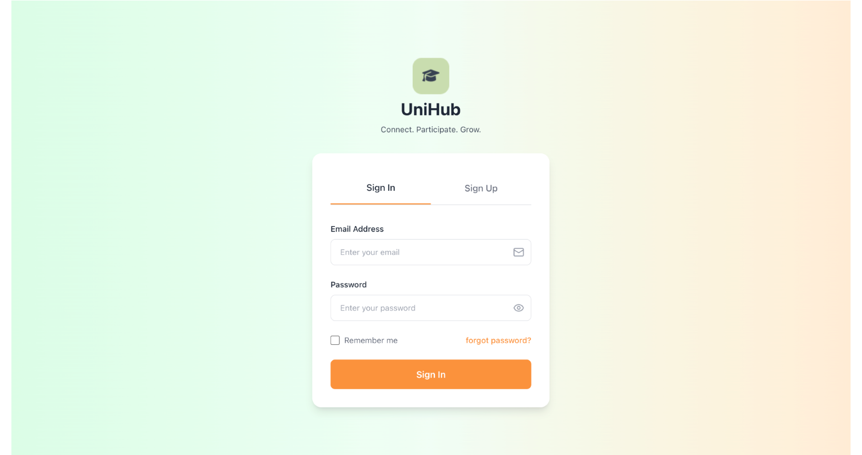

## Figure 33. LOGIN FORM

1. Input email address in the "Email" field.
2. Input the password in the "Password" field.
3. Click the "Login" button to access your account.

Figure 33 shows the system's login form, which serves as the gateway to the application. To log in, users must enter their registered email address and password in the field. After providing the correct credentials, clicking the "Login" button grants access to the system.

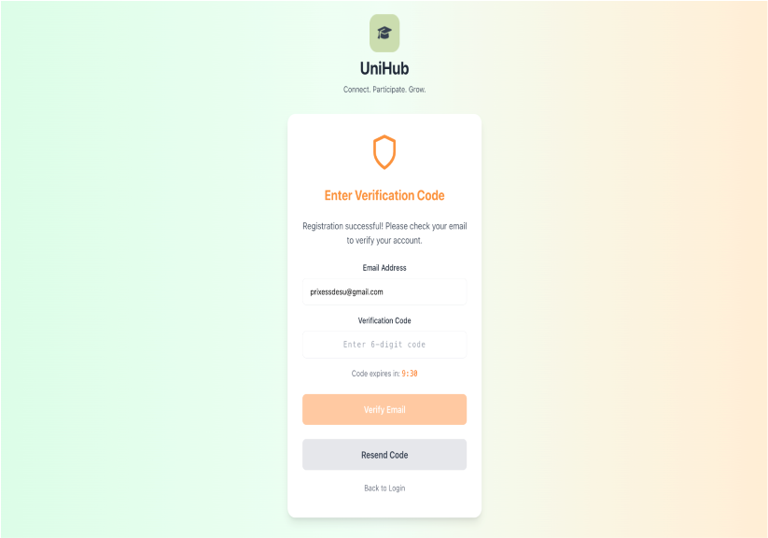

### Figure 34: REGISTER PAGE

1. Select role (Participant, Project Leader) from the "Role" dropdown.
2. Enter first name in the "First Name" field.
3. Enter last name in the "Last Name" field.
4. Enter email address in the "Email" field.
5. Enter the password in the "Password" field.
6. Click “Create Account”
7. Check your email inbox for the 6-digit verification code.
8. Input email verification code
9. Click the "Verify Email" button to verify your account.

Figure 34 illustrates the registration form where new users can create an account in the system. Users must provide their personal information, select their role, and set a secure password. The system validates the email format and prevents duplicate email registrations to ensure data integrity.



## Figure 35: ONBOARDING FORM/USER MANAGEMENT

1. Select interests from the available options.
2. Enter specific skills in the "Skills" field.
3. Select preferred activity types from the dropdown.
4. Choose time availability slots.
5. Enter goals in the "Goals" field (optional).
6. Select commitment level from the dropdown (optional).
7. Enter previous experience (optional).
8. Click the "Complete Onboarding" button to save your profile.

Figure 35 illustrates the onboarding form that helps users set up their profile preferences. This form collects information about user' interests, skills, availability, and goals to personalize their experience and match them with relevant activities and projects in the system.

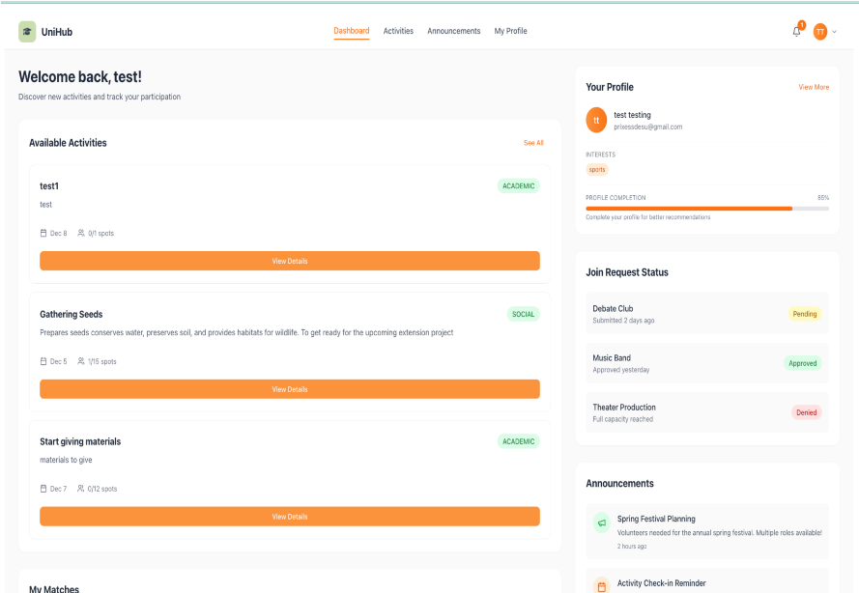

## Figure 36: PARTICIPANT’S/BENEFECIARY’S/PROJECT LEADER’S DASHBOARD

1. View upcoming activities in the "My Activities" section.
2. Check application status in the "My Applications" section.
3. View recent announcements in the "Announcements" section.
4. Access notifications, clicking the bell icon.
5. Navigate to different sections using the sidebar menu.

Figure 36 illustrates the participant dashboard, which serves as the central hub for participants. The dashboard displays an overview of their activities, application statuses, recent announcements, and notifications, providing quick access to all relevant information and features.

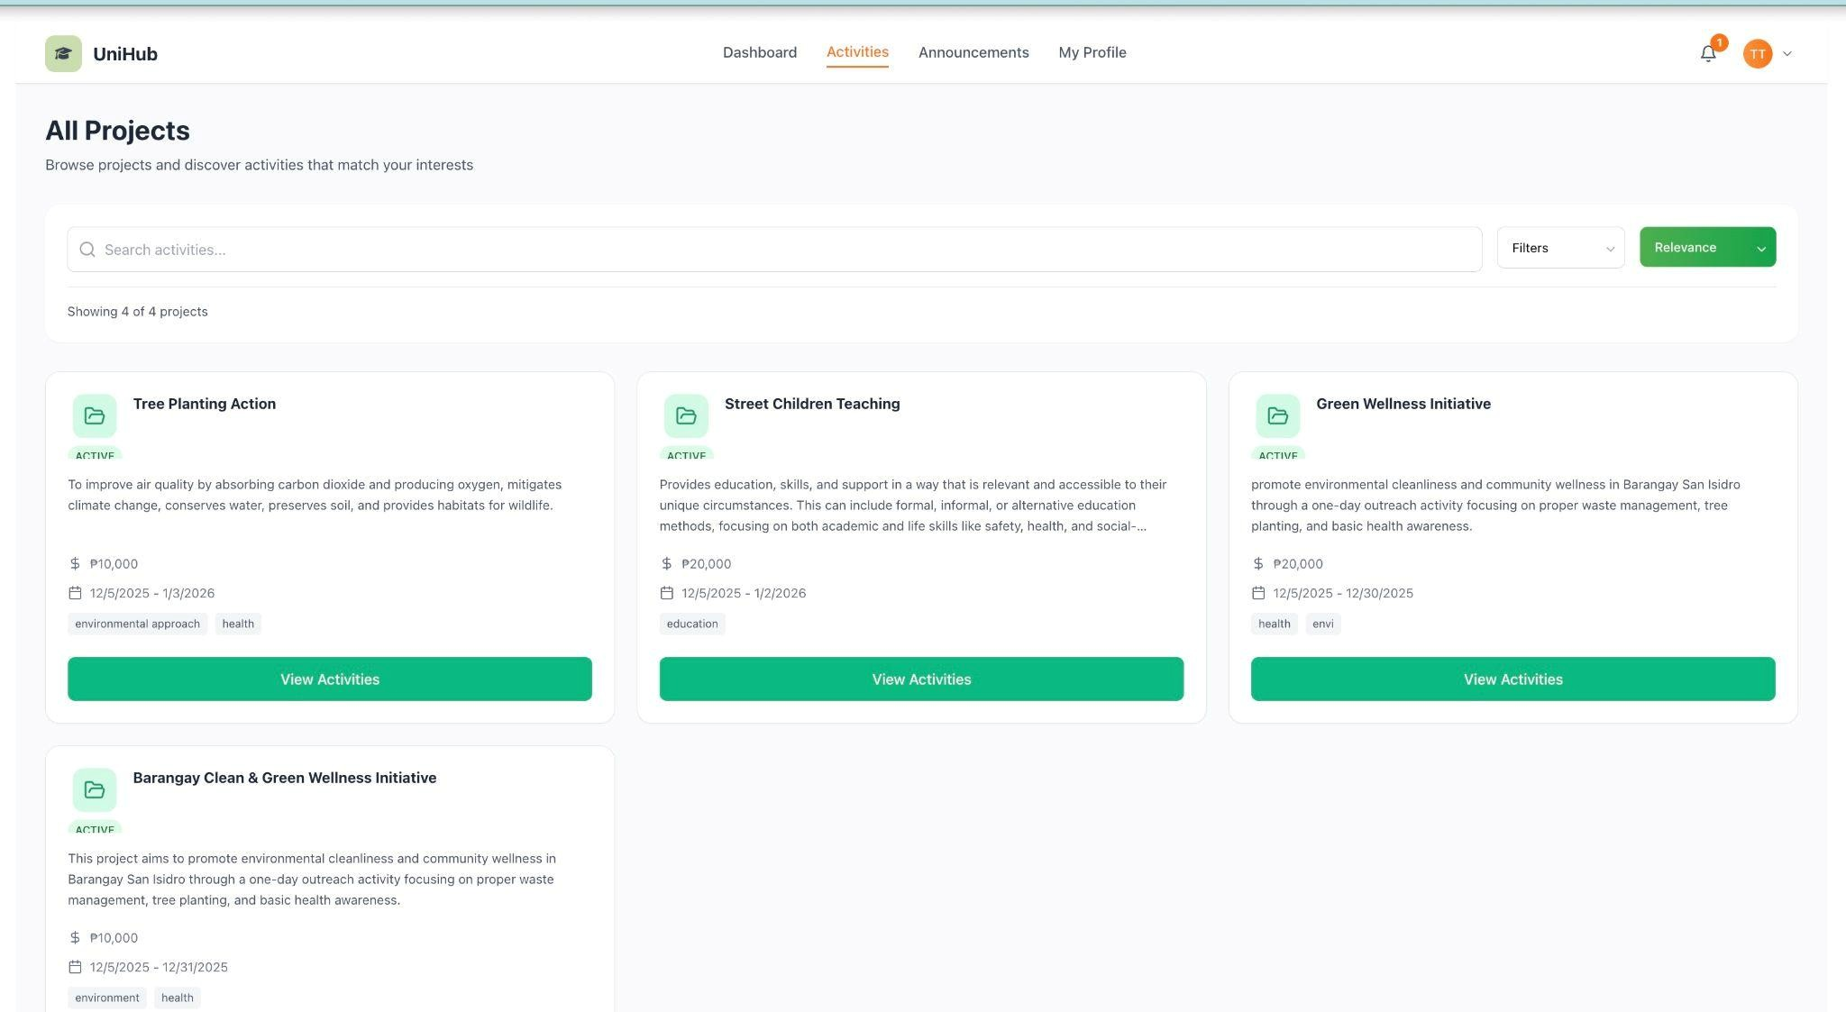

### Figure 37: VIEW ACTIVITIES

1. Browse the list of available activities displayed on the page.
2. Use the filter options to narrow down activities by category, status, or date.
3. Use the search bar to find specific activities by title or description.
4. Click on an activity card to view detailed information.

Figure 37 illustrates the activities listing page where participants can browse all available activities in the system. The page includes filtering and search capabilities to help users find activities that match their interests and availability.

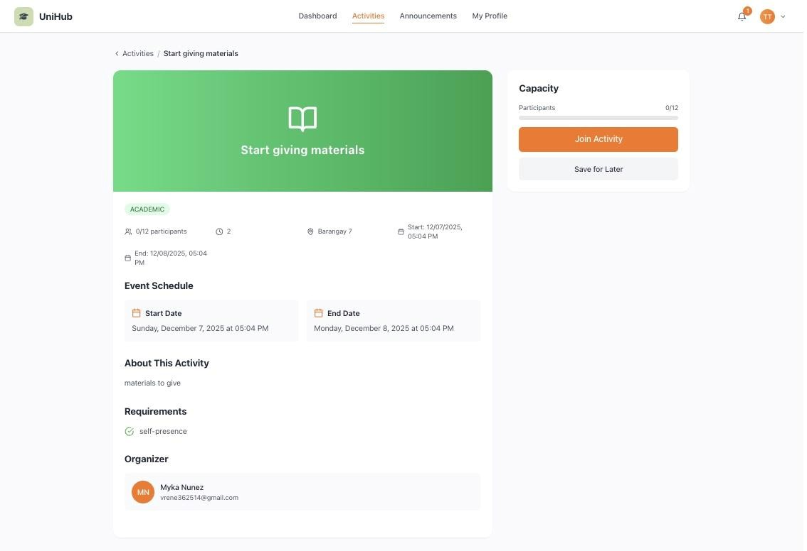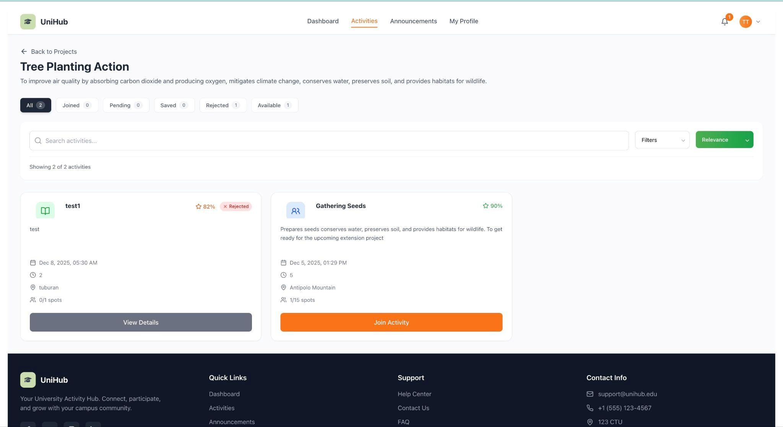

### Figure 38: ACTIVITY DETAILS

1. Review the activity title, description, and category.
2. Check the start date, end date, and location information.
3. View the maximum participants and current participant count.
4. Review the required skills and requirements.
5. Click the "Join Activity" button to apply/request to join.

Figure 38 illustrates the activity details page that provides comprehensive information about a specific activity. This page displays all relevant details, including schedule, location, participant limits, and requirements, helping users make informed decisions about participation.

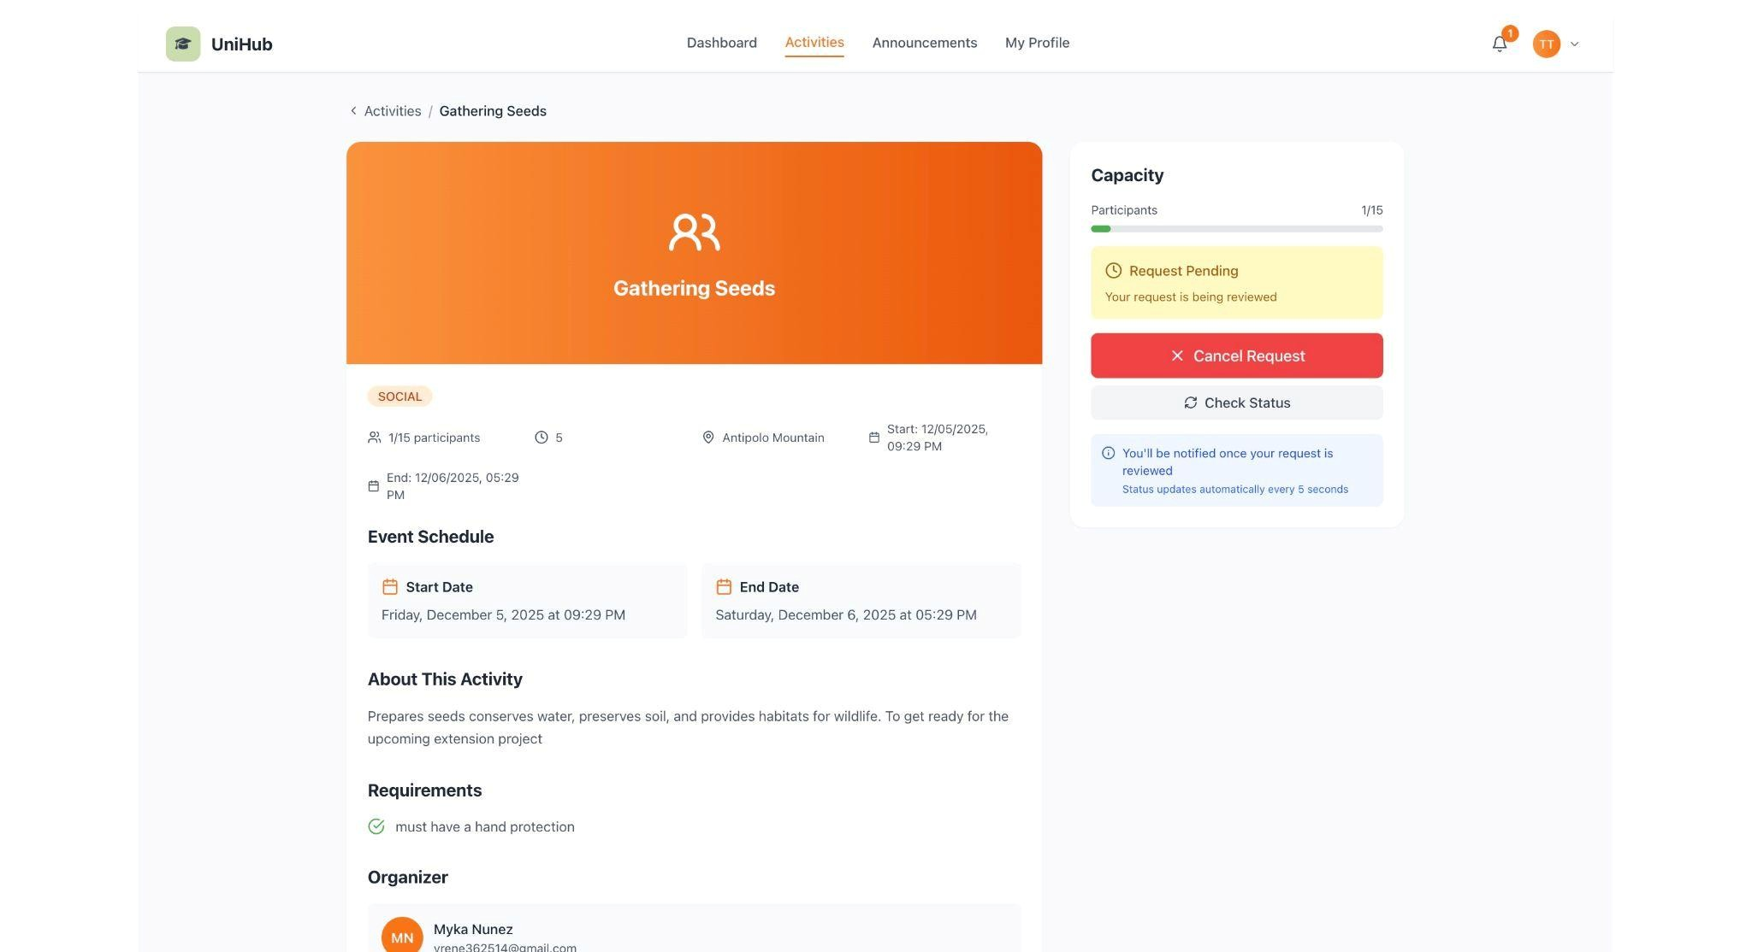

## Figure 39: APPLY/REQUEST JOIN TO ACTIVITY

1. Review the activity information displayed on the application form.
2. Wait for the project leader to review and approve your application.

Figure 39 illustrates the activity application form, where participants can submit applications to join activities that require approval. The system will notify them once their application is reviewed.

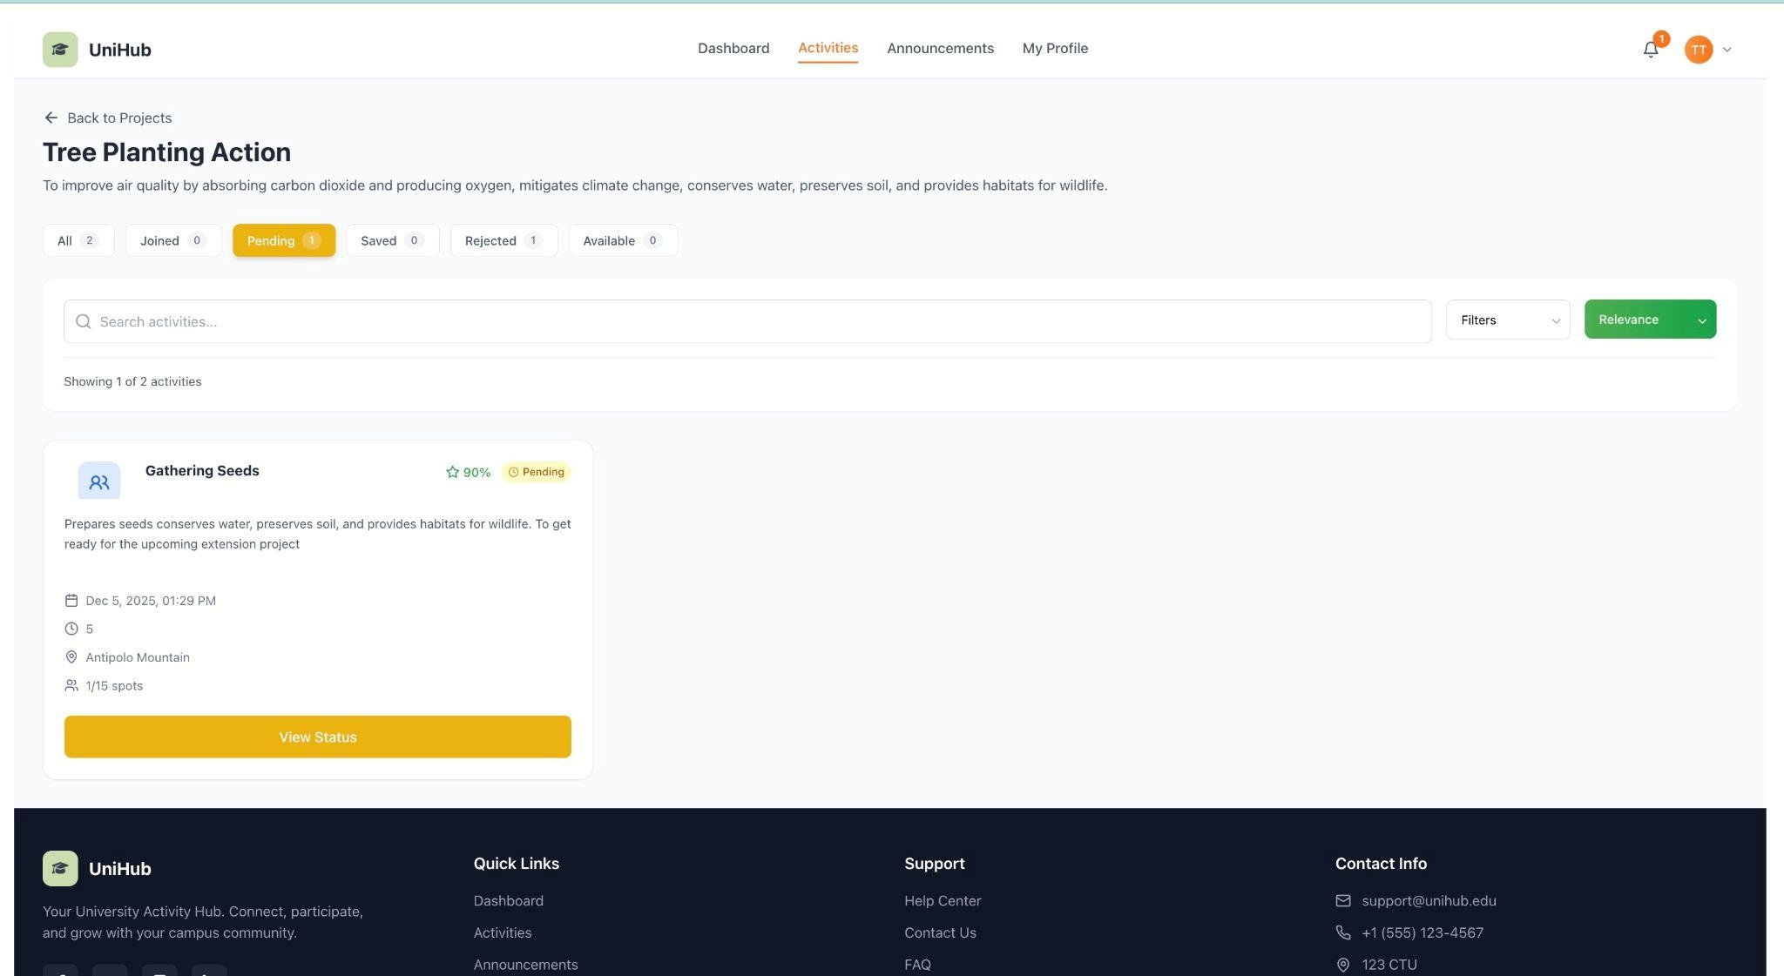

## Figure 40: PARTICIPANT’S APPLICATIONS

1. View all submitted applications in the list.
2. Check the status of each application (Pending, Approved, or Rejected).
3. Click on an application to view details.

Figure 40 illustrates the applications management page, where participants can track all their activity applications. The page displays the current status of each application, allowing users to monitor their approval progress and manage their submissions.

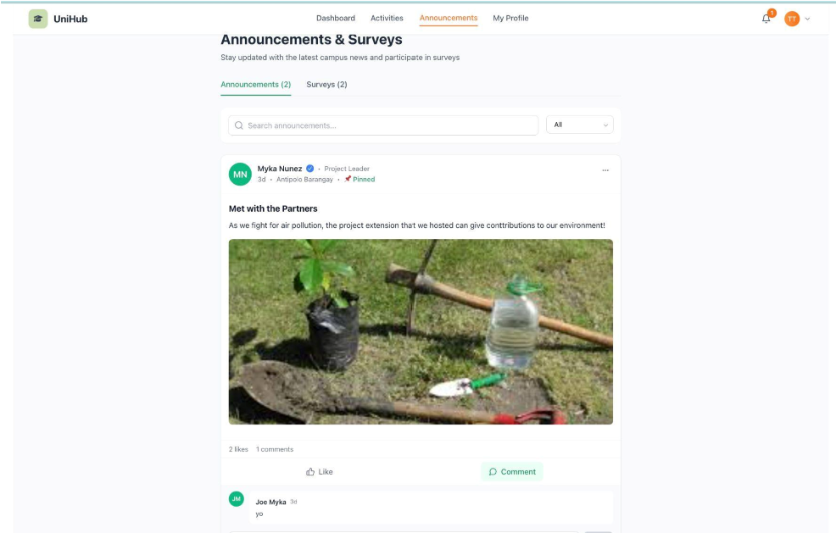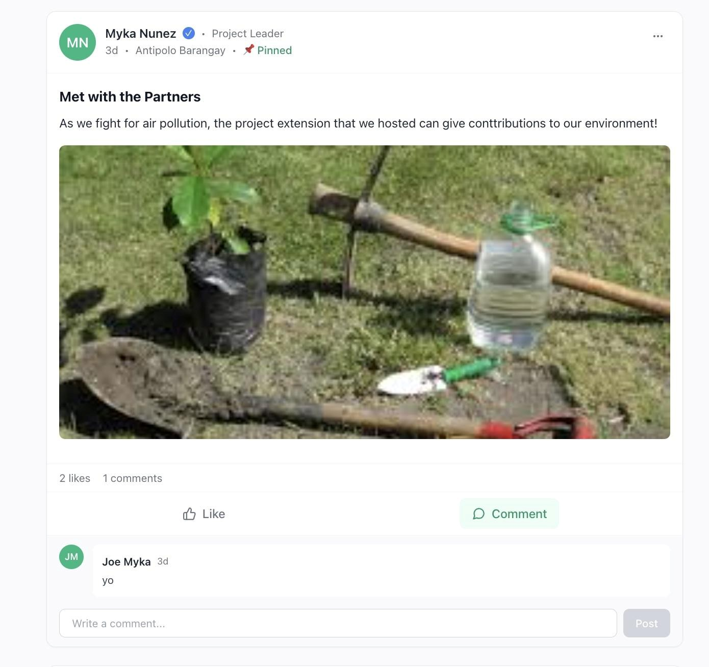

### Figure 41: VIEW ANNOUNCEMENTS

1. Browse the list of announcements displayed on the page.
2. Click on an announcement card to read the full content.
3. View pinned announcements at the top of the list.
4. Read the full announcement content displayed on the page.
5. View the announcement category, priority, and publish date.
6. Click the "Like" button to like the announcement.
7. Scroll down to view existing comments.
8. Enter your comment in the "Add Comment" field.
9. 6. Click the "Post Comment" button to submit your comment.

Figure 42 illustrates the announcements listing page where users can view all published announcements. The page organizes announcements by priority and category, with pinned announcements displayed prominently for important updates.

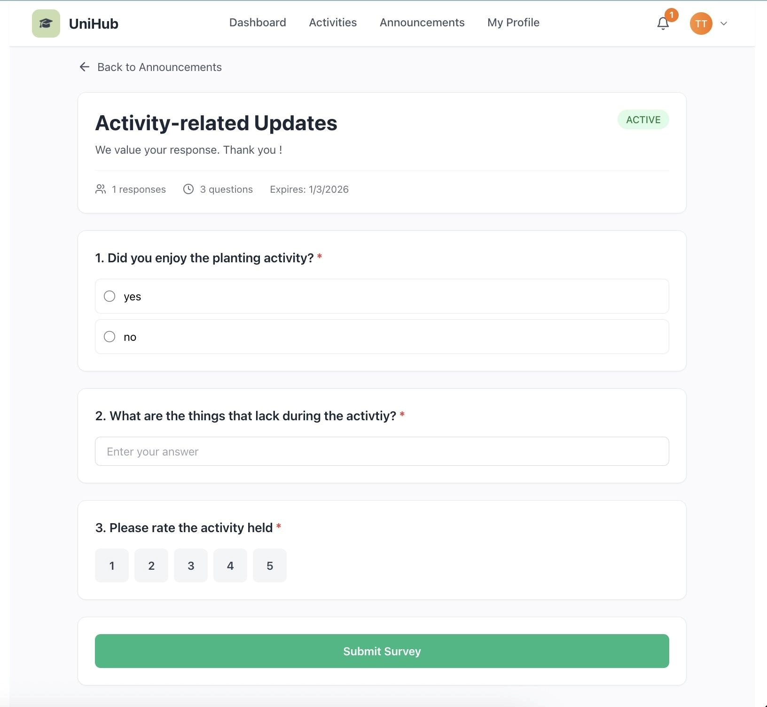

### Figure 43: RESPOND TO SURVEY

1. Read the survey title and description.
2. Answer each question according to its type (text, multiple choice, rating, etc.).
3. Complete all required questions marked with an asterisk (*).
4. Review responses before submitting.
5. Click the "Submit Survey" button to submit your responses.

Figure 43 illustrates the survey response form, which allows participants to provide feedback on activities or general system surveys. The form supports various question types and ensures all required questions are answered before submission.

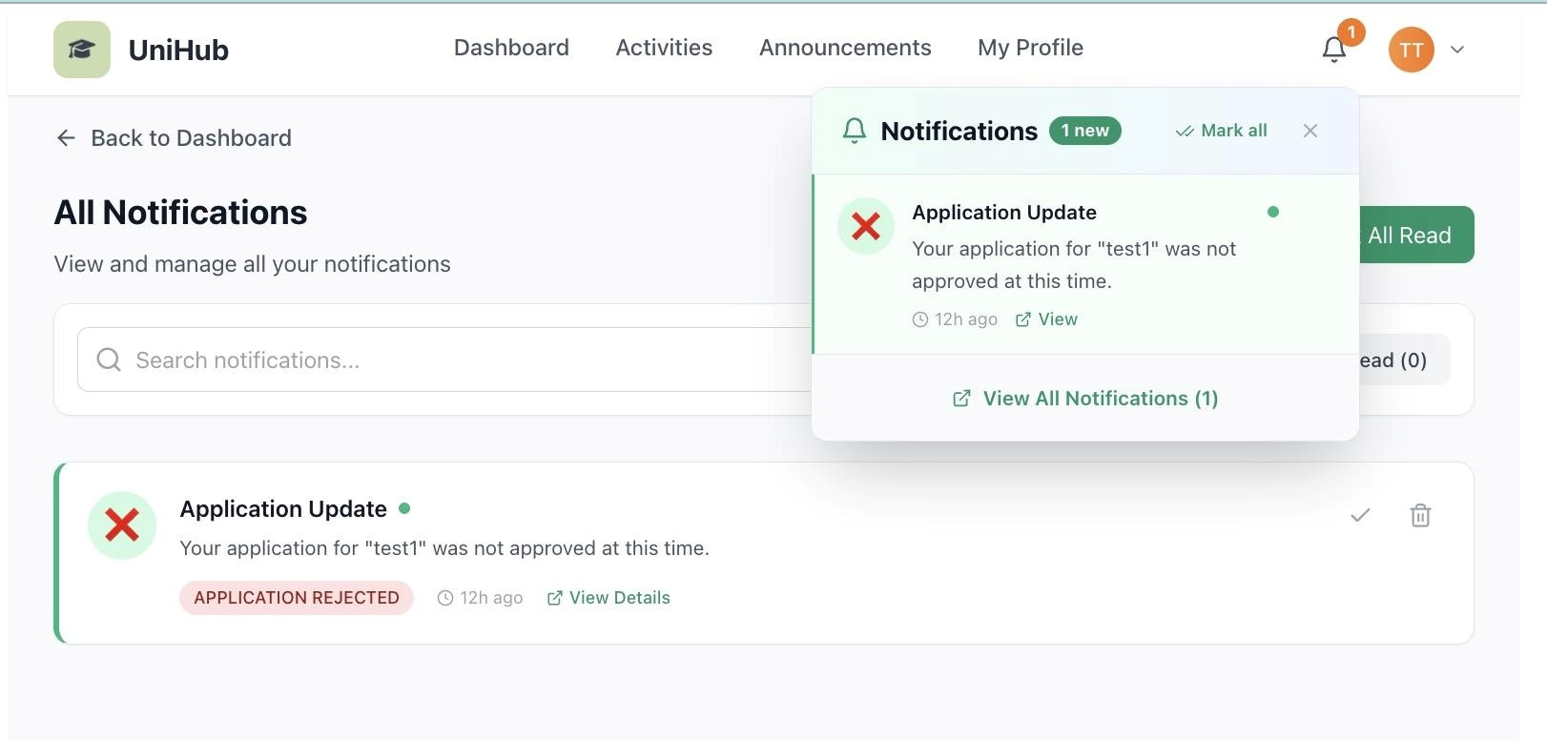

### Figure 44: VIEW NOTIFICATIONS

1. Click the bell icon in the navigation bar to open the notifications panel.
2. View all notifications listed in chronological order.
3. Click on a notification to view details or navigate to the related page.
4. Click the "Mark as Read" button to mark individual notifications as read.
5. Click "Mark All as Read" to clear all unread notifications.

Figure 44 shows the notifications panel, which displays all system notifications for the user. This feature keeps users informed about important events, such as application approvals, activity updates, and new announcements, ensuring they stay up to date with relevant information.

# PROJECT LEADER FEATURES

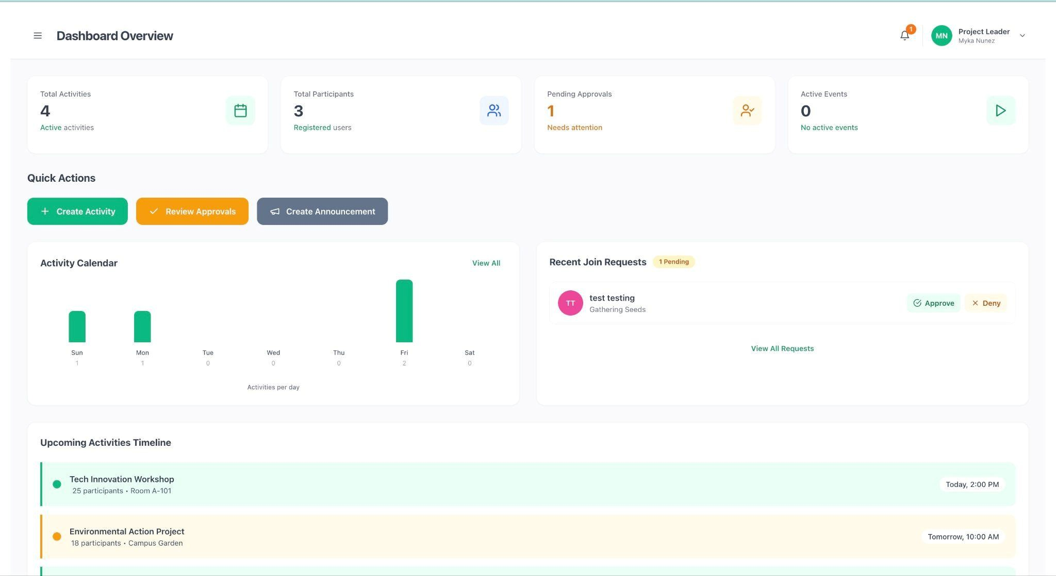

## Figure 45: PROJECT LEADER DASHBOARD

1. View created projects in the "My Projects" section.
2. Check activities in the "My Activities" section.
3. Review pending applications in the "Pending Applications" section.
4. View activity statistics and participant counts.
5. Access quick actions to create new projects or activities.

Figure 45 illustrates the project leader dashboard that provides an overview of all projects and activities managed by the user. The dashboard displays key metrics, pending tasks, and quick access to common actions for efficient project and activity management.

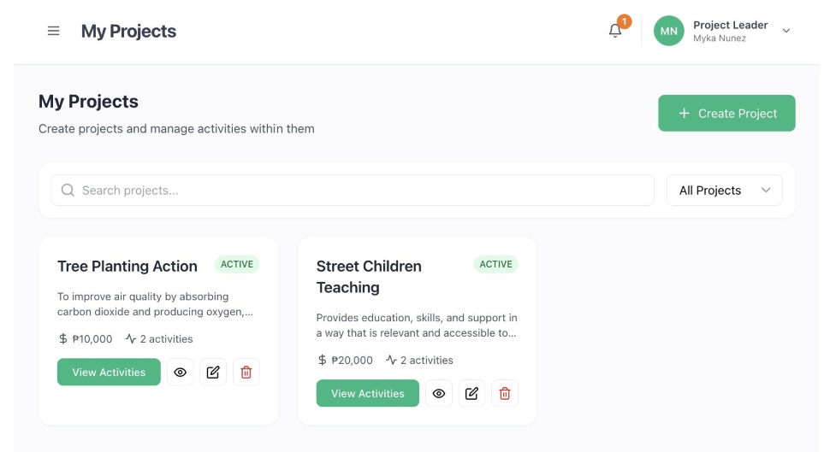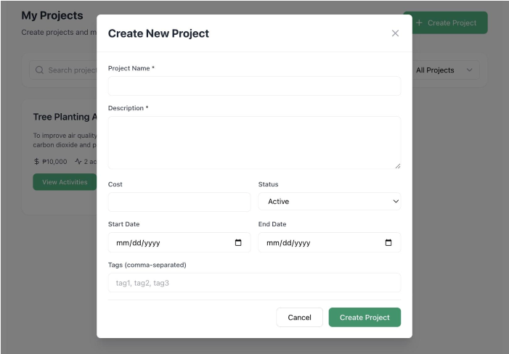

### Figure 46: CREATE PROJECT

1. Enter the project name in the "Project Name" field.
2. Enter a detailed description in the "Description" field.
3. Enter the project cost/budget in the "Cost" field (optional).
4. Select the project status from the "Status" dropdown.
5. Set the start date and end date using the date pickers.
6. Add project tags in the "Tags" field.
7. Click the "Create Project" button to save the project.

Figure 46 illustrates the project creation form, where project leaders can create new projects in the system. The form collects essential project information, including name, description, budget, timeline, and visual elements, to establish a comprehensive project profile.

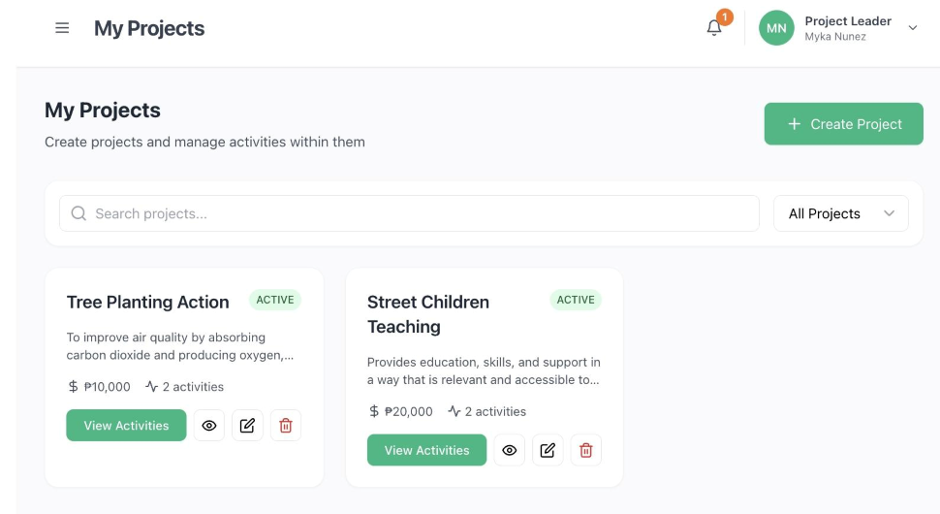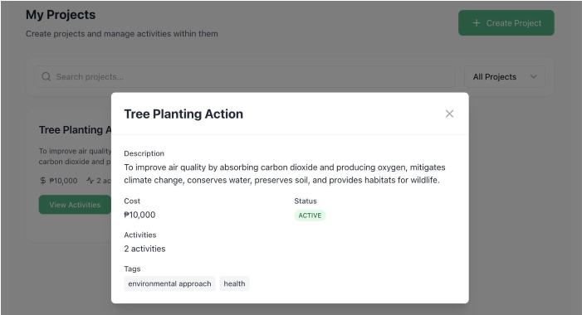

### Figure 47: VIEW PROJECTS

1. Browse all your created projects in the list.
2. Use the filter options to view projects by status (Draft, Active, Completed, Cancelled).
3. Click on a project card to view detailed information.
4. Click the "Edit" button to modify project details.
5. Click the "Delete" button to remove a project.

Figure 47 illustrates the project management page where project leaders can view and manage all their created projects. The page includes filtering capabilities and allows editing or deleting projects as needed.

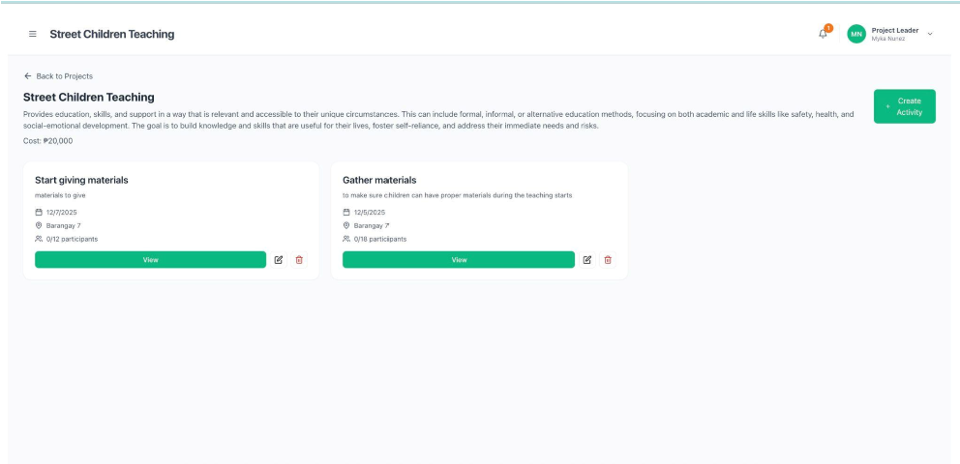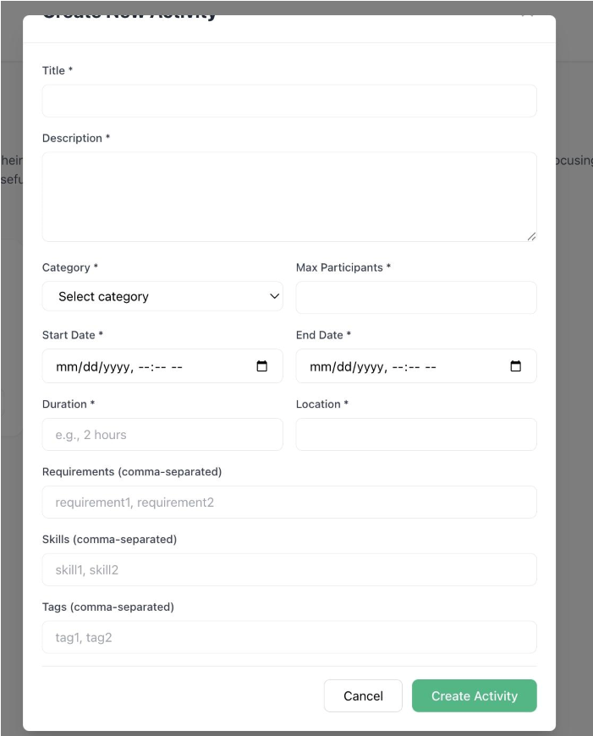

### Figure 48: CREATE ACTIVITY

1. Enter the activity title in the "Title" field.
2. Enter a detailed description in the "Description" field.
3. Select the activity category from the "Category" dropdown.
4. Set the start date and end date using the date and time pickers.
5. Enter the activity duration in the "Duration" field.
6. Enter the location in the "Location" field.
7. Set the maximum number of participants.
8. Select the parent project from the "Project" dropdown (optional).
9. Add required skills and requirements.
10. Upload an activity image (optional).
11. Click the "Create Activity" button to save the activity.

Figure 48 illustrates the activity creation form, where project leaders can create new activities within their projects. The form collects comprehensive information about the activity, including the schedule, location, participant limits, and requirements, to ensure proper activity setup.

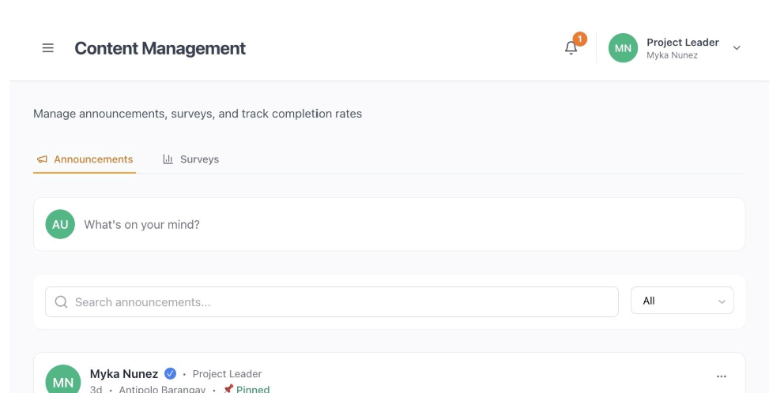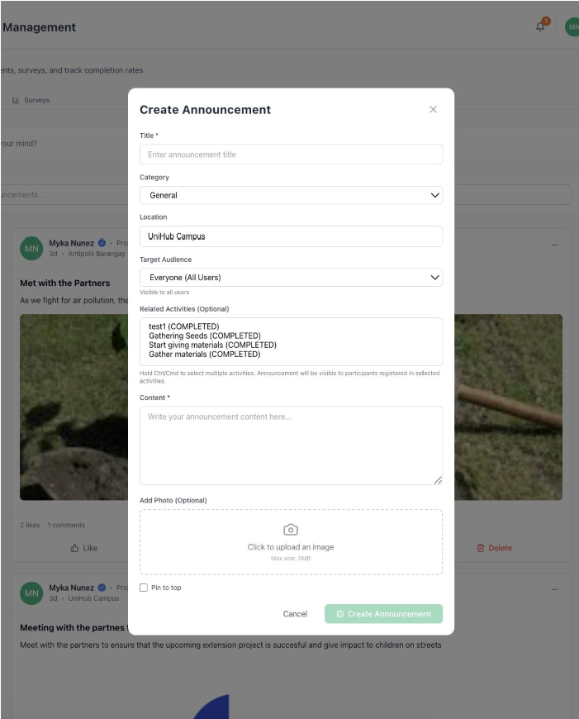

### Figure 49: CREATE ANNOUNCEMENT

1. Click “Whats on your mind”
2. Enter the announcement title in the "Title" field.
3. Enter the announcement content in the "Description" field.
4. Select the announcement category from the "Category" dropdown.
5. Choose the target audience from the "Target Audience" dropdown.
6. Check the "Pin Announcement" checkbox to pin important announcements.
7. Upload an image or attachment (optional).
8. Click the "Create Announcement" button to publish the announcement

Figure 49 illustrates the announcement creation form, where project leaders can create and publish announcements to communicate with participants. The form allows customization of content, priority, target audience, and scheduling to ensure effective communication.

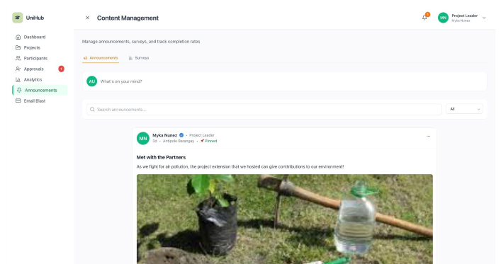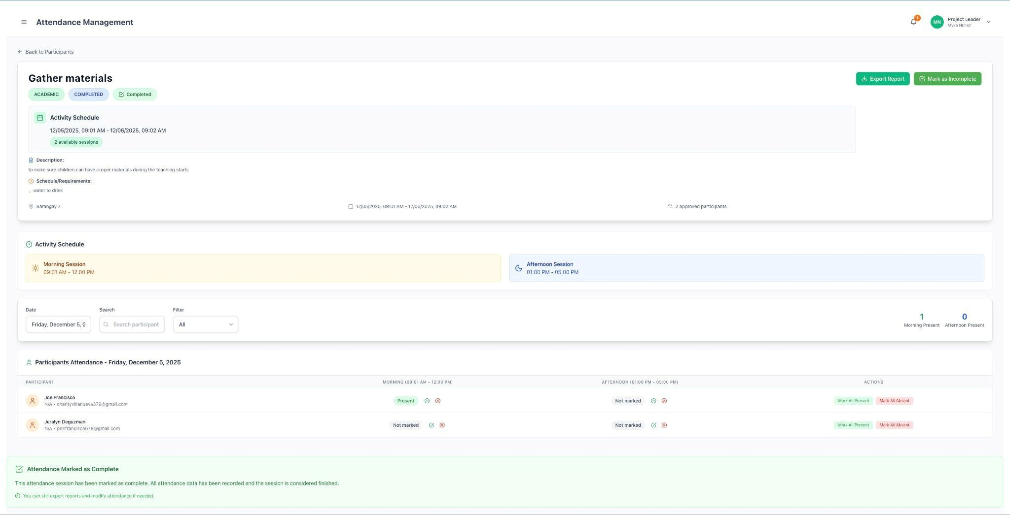

## Figure 50: ATTENDANCE MANAGEMENT

1. Navigate to the "Participant" section from the sidebar.
2. Select the activity.
3. Select the date for attendance marking.
4. Mark the morning and afternoon status (Present, Absent, or Late) for each participant.
5. Click the "Export" button to export records.
6. View all attendance records displayed in a table format.
7. Filter records by date range using the date pickers.
8. Search for specific participants using the search bar.
9. Click the "Export" button to export attendance data.
10. Select the export format (CSV, PDF, or DOCX) from the dropdown.

Figure 50 illustrates the attendance management interface where project leaders can record, view, and export participant attendance for activities. The interface allows marking both morning and afternoon attendance statuses, viewing attendance records with filtering and search capabilities, and exporting data in multiple formats for reporting and record-keeping purposes.

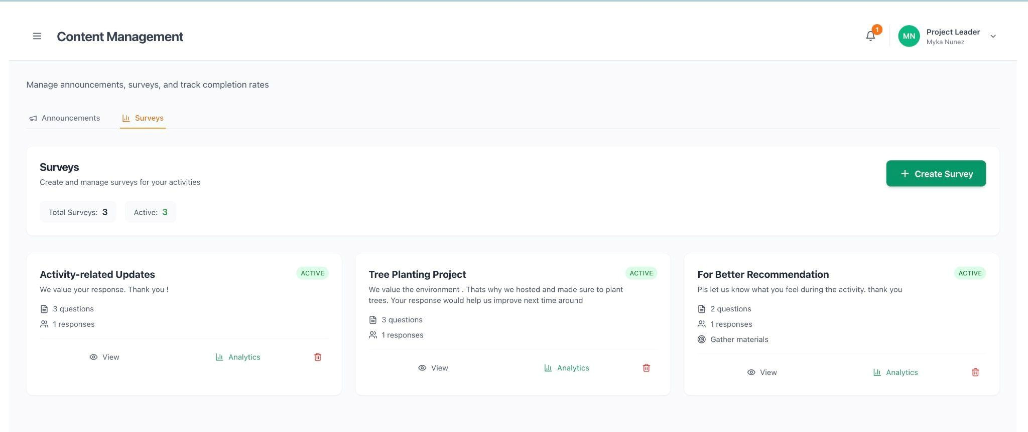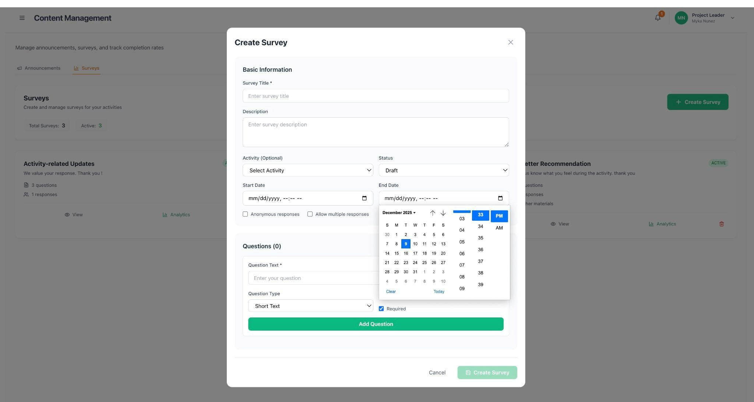

### Figure 51: CREATE SURVEY

1. Click “Create Survey”
2. Enter the survey title in the "Title" field.
3. Enter a survey description in the "Description" field (optional).
4. Select the related activity from the "Activity" dropdown (optional).
5. Choose the target audience type from the "Target Audience" dropdown.
6. Set the survey start date and end date.
7. Check "Auto-send when activity ends" if the project leader wants automatic distribution.
8. Add survey questions by clicking "Add Question."
9. For each question, enter the question text, select the question type, and mark if required.
10. Click the "Create Survey" button to save the survey.

Figure 51 illustrates the survey creation form, where project leaders can create surveys to collect feedback from participants. The form supports various question types, target audience selection, and automatic scheduling to streamline the feedback collection process.

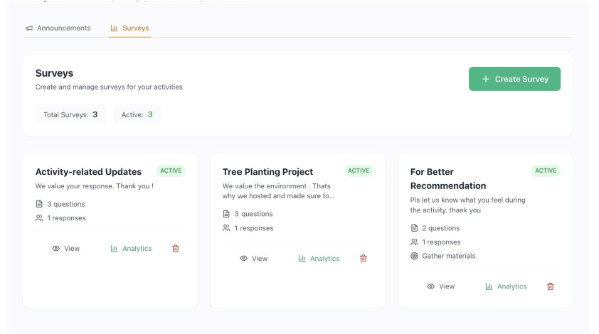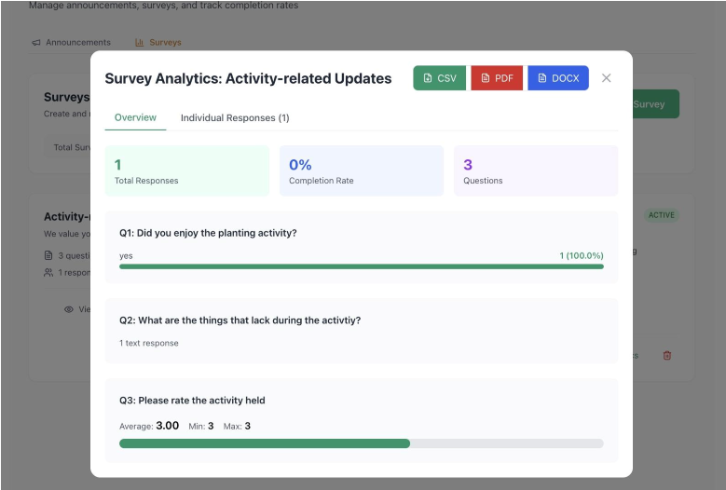

**Figure 52: VIEW SURVEY RESULTS** 1. Navigate to the "Survey" section from the Announcement sidebar.

1. Click on a survey to view its results.
2. Review response statistics and analytics.
3. View individual responses by clicking on response entries. 5. Export survey results using the "Export" button if needed.

Figure 52 illustrates the survey results page that displays collected survey responses and analytics. Project leaders can analyze participant feedback, view response statistics, and export data for further analysis and reporting.

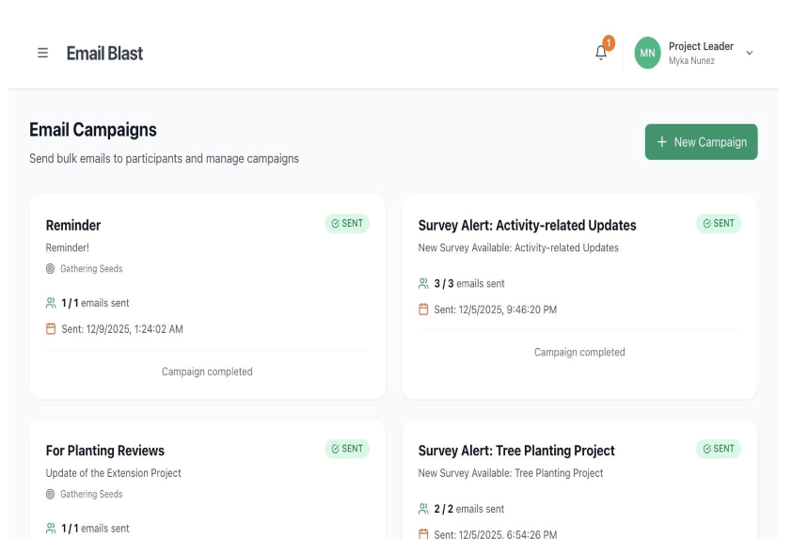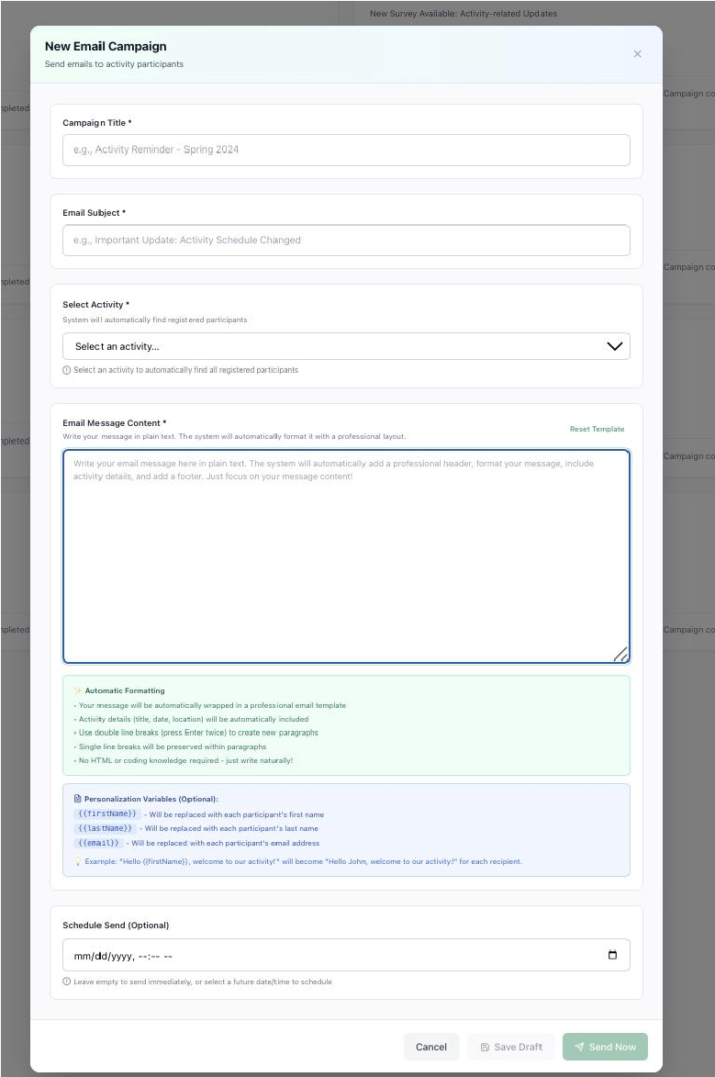

## Figure 53: EMAIL BLASTS MANAGEMENT

1. Click “New Campaign” to create new email blasts.
2. Enter the campaign title in the "Title" field.
3. Enter the email subject line in the "Subject" field.
4. Compose the email content in the "Content" editor.
5. Select an email template from the "Template" dropdown (optional).
6. Choose the target audience type from the "Target Audience" dropdown.
7. Select the related activity (optional).
8. Click the "Create Campaign" button to save the campaign.
9. Click the "Schedule" button to schedule the email for future delivery.
10. Select the date and time for sending using the date-time picker.
11. Review the campaign details and target audience. 12. Click the "Schedule Campaign" button to confirm.

Figure 53 illustrates the email campaign creation form, where project leaders can create email campaigns to communicate with participants. The form supports template selection, audience targeting, and rich content editing to create effective communication campaigns.

# GRAMMARIAN CERTIFICATE PLAGIARISM TEST CERTIFICATE USABILITY AND SATISFACTION SURVEY QUESTIONNAIRE

Dear Respondent,

*We are fourth-year Information Technology students from CTU-Tuburan Campus conducting a user experience survey for our Capstone Project titled* ***“*UniHub: University Community Extension Hub with Client Satisfaction Survey** ***”****. The purpose of this survey is to evaluate the Usefulness, Ease of use, Ease of learning, and Satisfaction of the system. Your participation is highly valued, and we assure you that all information provided will be treated with strict confidentiality and used solely for academic purposes.*

**Instructions:**

Please rate your agreement with the following statements based on your experience with the Unihub Web-based system. Place a “✓” mark in the box of your answer.

**Name:** _______________

## Age: __

|  |  |  |  |  |  |
| --- | --- | --- | --- | --- | --- |
| **USEFULNESS** | **Strongly** **Agree** | **Agree** | **Neutral** | **Disagree** | **Strongly Disagree** |
| 5 | 4 | 3 | 2 | 1 |
| The Unihub helps me be more effective. |  |  |  |  |  |
| It helps me save time in finding extension projects. |  |  |  |  |  |
| The Unihub helps me be more productive. |  |  |  |  |  |
| Unihub is useful. |  |  |  |  |  |
| Unihub gives me more control over the activities in my life. |  |  |  |  |  |
| It makes the things I want to accomplish easier to get done. |  |  |  |  |  |
| Unihub saves me time when I use it. |  |  |  |  |  |
| Unihub meets my needs. |  |  |  |  |  |
| Unihub does everything I would expect it to do |  |  |  |  |  |

|  |  |  |  |  |  |
| --- | --- | --- | --- | --- | --- |
| **EASE OF USE** | **Strongly Agree** | **Agree** | **Neutral** | **Disagree** | **Strongly Disagree** |
| The Unihub is easy to set up and use. |  |  |  |  |  |
| Unihub is simple to use. |  |  |  |  |  |
| Unihub is user friendly. |  |  |  |  |  |
| It minimizes the steps needed to schedule the extension projects and activities. |  |  |  |  |  |
| It requires the fewest steps possible to accomplish what I want to do with it. |  |  |  |  |  |
| It is flexible. |  |  |  |  |  |
| Using it is effortless |  |  |  |  |  |
| I can use it without written instruction |  |  |  |  |  |
| I don't notice any inconsistencies as I use it. |  |  |  |  |  |
| Both occasional and regular users of Unihub would like it. |  |  |  |  |  |
| I can recover from mistakes quickly and easily.. |  |  |  |  |  |
| I can use Unihub successfully every time. |  |  |  |  |  |

|  |  |  |  |  |  |
| --- | --- | --- | --- | --- | --- |
| **EASE OF LEARNING** | **Strongly Agree** | **Agree** | **Neutral** | **Disagree** | **Strongly Disagree** |
| I learned to use Unihub quickly. |  |  |  |  |  |
| I easily remember how to use it. |  |  |  |  |  |
| It is easy to learn to use it.. |  |  |  |  |  |
| I quickly became skillful with it. |  |  |  |  |  |

|  |  |  |  |  |  |
| --- | --- | --- | --- | --- | --- |
| **SATISFACTION** | **Strongly Agree** | **Agree** | **Neutral** | **Disagree** | **Strongly Disagree** |
| I am satisfied with Unihub's performance. |  |  |  |  |  |
| I would recommend Unihub to project leaders and participants |  |  |  |  |  |
| Using the Unihub is fun to use. |  |  |  |  |  |
| It works the way I want it to work. |  |  |  |  |  |
| It is wonderful. |  |  |  |  |  |
| I feel I need to have it. |  |  |  |  |  |
| Unihub is pleasant to use. |  |  |  |  |  |

**Qualitative Feedback:**

1. **List the negative aspect(s):**

**_______________________________________________________________**

**_______________________________________________________________**

**_______________________________________________________________**

**_______________________________________________________________**

**_______________________________________________________________**

1. **List the positive aspect(s):**

**_______________________________________________________________**

**_______________________________________________________________**

**_______________________________________________________________**

**_______________________________________________________________**

## _______________________________________________________________





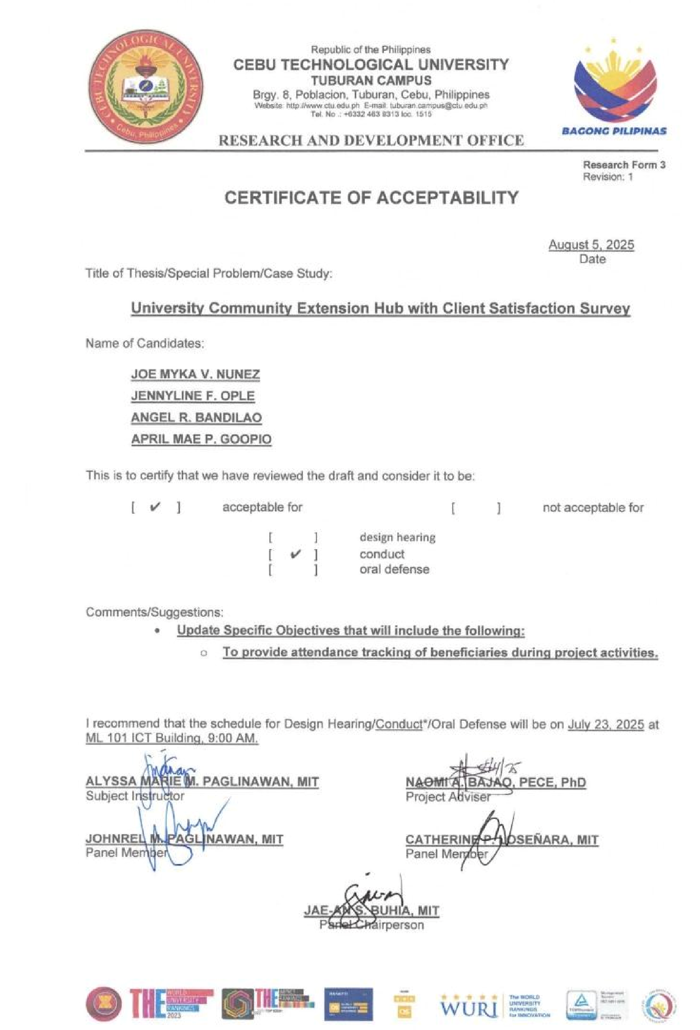













# CURRICULUM VITAE

ANGEL R. BANDILAO

Brgy. 2, Tuburan, Cebu, Philippines

Contact Number: 09668224018

Email Address: angelbandilao@gmail.com

# PERSONAL INFORMATION

|  |  |  |  |
| --- | --- | --- | --- |
| **Gender:** Female |  |  | **Civil Status:** Single |
| **Date of Birth:** June 17,2003 |  |  | **Nationality:** Filipino |
| **Age:** 22  **EDUCATIONAL BACKGROUND** |  |  | **Religion:** Roman Catholic |
| **TERTIARY** |  |  | CEBU TECHNOLOGICAL UNIVERSITY -  TUBURAN CAMPUS  Bachelor of Science in Information  Technology  S. Y. (2022-2026) |
| **SECONDARY** |  |  | TUBURAN, NATIONAL, HIGH SCHOOL S. Y.  (2021-2022) |
| **PRIMARY** |  |  | TUBURAN CENTRAL ELEMENTARY SCHOOL  S. Y. (2015-2016) |
| **Seminar or Training Attended** |  |  |  |
| **Enhancing IT Readiness** |  |  | **Intellectual Property**  Cebu Technological University - Tuburan  Campus  April 28,2025  Naomi A. Bajao, PECE, Ph.D |
| Cebu Technological University - Tuburan  Campus  August 22,2025  Mr. Rey Reroma | | |

# CURRICULUM VITAE

APRIL MAE P. GOOPIO

Cogon Tuburan, Cebu, Philippines

Contact Number: 09916546116

Email Address: aprilmaepanogoopio@gmail.com

# PERSONAL INFORMATION

**Gender:** Female **Civil Status:** Single **Date of Birth:** June 17,2003 **Nationality:** Filipino

**Age:** 22 **Religion:** Roman Catholic

# EDUCATIONAL BACKGROUND

**Tertiary** CEBU TECHNOLOGICAL UNIVERSITY -

## TUBURAN CAMPUS

Bachelor of Science in Information

Technology

S. Y. (2023-2026)

**SECONDARY** MONTEALEGRE, NATIONAL, HIGH SCHOOL

S. Y. (2017-2022)

**PRIMARY** MONTEALEGRE ELEMENTARY SCHOOL

S. Y. (2011-2016)

# CURRICULUM VITAE

JOE MYKA V. NUÑEZ

Montealegre, Tuburan, Cebu, Philippines

Contact Number: 09682006014

Email Address: marilynnunez806@gmail.com

# PERSONAL INFORMATION

|  |  |  |  |
| --- | --- | --- | --- |
| **Gender:** Female |  |  | **Civil Status:** Single |
| **Date of Birth:** April 16,2004 |  |  | **Nationality:** Filipino |
| **Age:** 21    **EDUCATIONAL BACKGROUND** |  |  | **Religion:** Roman Catholic |
| **Tertiary** |  |  | CEBU TECHNOLOGICAL UNIVERSITY -  TUBURAN CAMPUS  Bachelor of Science in Information  Technology  S. Y. (2022-2026) |
| **SECONDARY** |  |  | MONTEALEGRE, NATIONAL, HIGH SCHOOL  S. Y. (2017-2022) |
| PRIMARY |  |  | MONTEALEGRE ELEMENTARY SCHOOL  S. Y. (2011-2016) |
| **Seminar or Training Attended** |  |  |  |
| **Enhancing IT Readiness** |  |  | **Intellectual Property**  Cebu Technological University - Tuburan  Campus  April 28,2025  Naomi A. Bajao, PECE, Ph.D |
| Cebu Technological University - Tuburan  Campus  August 22,2025  Mr. Rey Reroma | | |

# CURRICULUM VITAE

JENNYLINE F. OPLE

New.Bago, Asturias, Cebu, Philippines

Contact Number: 09633889340

Email Address: jennylineople184@gmail.com

# PERSONAL INFORMATION

|  |  |  |  |
| --- | --- | --- | --- |
| **Gender:** Female |  |  | **Civil Status:** Single |
| **Date of Birth:** January 27,2004 |  |  | **Nationality:** Filipino |
| **Age:** 21    **EDUCATIONAL BACKGROUND** |  |  | **Religion:** Roman Catholic |
| **Tertiary** |  |  | CEBU TECHNOLOGICAL UNIVERSITY -  TUBURAN CAMPUS  Bachelor of Science in Information  Technology  S. Y. (2022-2026) |
| **SECONDARY** |  |  | STA. RITA, NATIONAL, HIGH SCHOOL  S. Y. (2021-2022) |
| **PRIMARY** |  |  | STA.RITA ELEMENTARY SCHOOL  S. Y. (2015-2016) |
| **Seminar or Training Attended** |  |  |  |
| **Enhancing IT Readiness** |  |  | **Intellectual Property**  Cebu Technological University - Tuburan  Campus  April 28,2025  Naomi A. Bajao, PECE, Ph.D |
| Cebu Technological University - Tuburan  Campus  August 22,2025  Mr. Rey Reroma | | |